Tender dossier
Works contract

MITRA - FP6 - STREP (511361)

Version | 1.0
Edition date | 14 September 2009

Written by | Kirsten Ruiberriz de Torres, Project Manager, ACPP  Amjad Assi and Abdel Latif Khalid, PHG

Letter of invitation to tender

Ramallah, 14 September 2009

Our ref.: ECHO/-ME/BUD/2009/01038

Dear Madam/Sir,

SUBJECT: INVITATION TO TENDER FOR URGENT INTERVENTION TO SECURE THE ACCESS OF THE POPULATION IN THE OCCUPIED PALESTINIAN TERRITORIES TO WATER

Further to your enquiry regarding the publication of the above-mentioned invitation to tender, please find enclosed the following documents, included in the table of contains, which constitute the tender dossier:

Table of Contents
1 VOLUME 1 9
1.1 SECTION 1: INSTRUCTIONS TO TENDERERS 9
1.2 SECTION 2: TENDER FORM 31
1.3 SECTION 3: TENDER GUARANTEE FORM 32
1.4 SECTION 4: QUESTIONNAIRE 33
1.5 SECTION 6: EVALUATION GRID 57
2 VOLUME 2 58
2.1 SECTION 1: CONTRACT FORM 58
2.2 SECTION 2: GENERAL CONDITIONS 61
2.3 SECTION 3: SPECIAL CONDITIONS 104
2.4 SECTION 4: SPECIMEN PERFORMANCE GUARANTEE 109
3 VOLUME 3 113
3.1 DRAWINGS PROVIDED BY THE CONTRACTING AUTHORITHY 113
3.2 CONTRACTOR’S DESIGN DOCUMENTS, INCLUDING DRAWINGS 113
4 VOLUME 4 116

Acronyms

Term: | Description.
ACPP | Asamblea de Cooperación por la Paz
EC | European Commission
ECHO | European Commission’s Humanitarian Aid department
NA | Not Applicable
NC | National Currency
PHG | Palestinian Hydrology Group

Glossary
Administrative order: Any instruction or order issued by the Program manager and Project Co-ordinator to the Contractor in writing regarding the execution of the works.
Breakdown of the overall price: A heading-by-heading list of the rates and costs making up the price for a lump-sum contract.
Candidate: Any natural or legal person or group thereof applying to take part in a restricted or negotiated procedure.
Commission: The Commission of the European Communities.
Conflict of interest: Any event influencing the capacity of a candidate, tenderer or supplier to give an objective and impartial professional opinion, or preventing him, at any moment, from giving priority to the interests of the Contracting Authority. Any consideration relating to possible contracts in the future or conflict with other commitments, past or present, of a candidate, tenderer or supplier, or any conflict with his/her own interests. These restrictions also apply to subcontractors and employees of the candidate, tenderer or supplier.
There is a conflict of interests within the meaning of Article 52 of the Financial Regulation where the impartial and objective exercise of the functions of a player in the implementation of the budget or an internal auditor is compromised for reasons involving family, emotional life, political or national affinity, economic interest or any other shared interest with the beneficiary.
Contract price: The sum stated in the contract representing the initial estimate payable for carrying out the works, or such other sum as ascertained at the end of the contract as due under the contract.
Contracting Authority (Employer as per FIDIC rules) The Commission, the state or the public or private legal person concluding the contract, as provided for in the financing agreement.
Contractor: The tenderer selected at the end of the procedure for the award of the contract. The successful tenderer, once all parties have signed the contract.
Day: Calendar day.
Drawings: Drawings provided by the Contracting Authority and/or the Program manager and Project Co-ordinator, and/or drawings provided by the Contractor and approved by the Program manager and Project Co-ordinator, for the carrying out of the works.
Equipment: Machinery, apparatus, components and any other articles intended for use in the works
Evaluation committee: a committee made up of an odd number of voting members (at least three) appointed by the Contracting Authority and possessing the technical, linguistic and administrative capacities necessary to give an informed opinion on tenders.
Execution period: The period from contract signature until 18 months after the provisional acceptance of the works. This period includes the warranty and the final acceptance of the works.
Final acceptance certificate: Certificate(s) issued by the Program manager and Project Co-ordinator to the Contractor at the end of the maintenance period stating that the Contractor has completed his/her obligations to construct, complete, and maintain the works concerned.
General conditions: The general contractual provisions setting out the administrative, financial, legal and technical clauses governing the execution of contracts.
General damages: The sum not stated beforehand in the contract, which is awarded by a court or an arbitration tribunal, or agreed between the parties, as compensation payable to an injured party for a breach of the contract by the other party.
Implementation period: The period from contract signature, or alternative date if specified in the Special Conditions, until the provisional acceptance of the works.
In writing: This includes any hand-written, typed or printed communication, including telex, cable, e-mail and fax transmissions.
Liquidated damages: The sum stated in the contract as compensation payable by the Contractor to the Contracting Authority for failure to complete the contract or part thereof within the periods under the contract, or as payable by either party to the other for any specific breach identified in the contract.
Maintenance period: The period stated in the contract immediately following the date of provisional acceptance, during which the Contractor is required to complete the works and to remedy defects or faults as instructed by the Program manager and Project Co-ordinator.
Modification: An instruction given by the Program manager and Project Co-ordinator which modifies the works.

National currency: The currency of the country of the Contracting Authority.
Plant: appliances and other machinery, and, where applicable under the law and/or practice of the state of the Contracting Authority, the temporary structures on the site required to carry out the works but excluding equipment or other items required to form part of the permanent works.
Period: A period begins the day after the act or event chosen as its starting point. Where the last day of a period is not a working day, the period expires at the end of the next working day.
Provisional sum: A sum included in the contract and so designated for the implementation of works or the supply of goods, materials, plant or services, or for contingencies, which sum may be used in whole or in part, or not at all, as instructed by the Program manager and Project Co-ordinator.
Site: The places provided by the Contracting Authority where the works are to be carried out and other places stated in the contract as forming part of the site.
Special conditions: The special conditions laid down by the Contracting Authority as an integral part of the tender dossier, including modifications to the general conditions, clauses specific to the contract and the terms of reference (for a service contract) or technical specifications (for a supply or works contract).
Program manager and Project Coordinator: The legal or natural person responsible for monitoring the execution of the contract on behalf of the Contracting Authority and/or the Commission, where the latter is not the Contracting Authority.
Program manager and Project Coordinator's representative: Any natural or legal person, designated by the Program manager and Project Co-ordinator as such under the contract, and empowered to represent the Program manager and Project Co-ordinator in the performance of his/her functions, and in exercising such rights and/or powers as have been delegated to him. In this case, references to the Program manager and Project Co-ordinator will include his/her representative.
Tender dossier: The dossier compiled by the Contracting Authority and containing all the documents needed to prepare and submit a tender.
Tender price: The sum stated by the tenderer in his/her tender for carrying out the contract.
Tenderer: Any natural or legal person or consortium thereof submitting a tender with a view to concluding a contract. The terms "supplier", "contractor" and "service provider" refer to three categories of economic operator, natural or legal persons, who supply products, execute works and provide services respectively.
Written communications: Certificates, notices, orders and instructions issued in writing under the contract.
Works: Works of a permanent or temporary nature executed under the contract.
Works contracts: Works contracts cover the execution, the design and execution or the realisation by any means whatsoever of a work corresponding to the requirements specified by the Contracting Authority. A 'work' is the outcome of a body of building or civil engineering works that is sufficient of itself to fulfil an economic or technical function.

Any request for clarification must be received by the Asamblea de Cooperación por la Paz (ACPP) and/or the Palestinian Hydrology Group (PHG) ("The Contracting Authority"), in writing at least 6 days before the deadline for submission of tenders. The Contracting Authority will reply to tenderers' questions at least 4 days before the deadline for submission of tenders. If the Contracting Authority, either on its own initiative or in response to a request from a tenderer, provides additional information on the tender dossier, it will send such information in writing to all tenderers at the same time.

Costs incurred by the tenderer in preparing and submitting the tender proposals will not be reimbursed.

We look forward to receiving your tender and the accompanying tender guarantee at the address specified in the Instructions to Tenderers before the 7th of October, at 9:00 a.m. If you decide not to submit a tender, we would be grateful if you could inform us in writing, stating the reasons for your decision.

In summary, the important deadlines to be met by tenderers in this bidding process are as follows:

- Selling of tenders: starting on the 14th of September 2009
- Field visit: 28th of September 2009
- Response for questions: 1st the of October 2009
- Deadline of reception of tenders: 7th of October until 9:00 a.m in PHG offices in Ramallah and Nablus.
- Opening session: 7th of October at 12:00 a.m in PHG offices in Ramallah.
- Signature of contract: 11th of October (estimate date).

Note: Communications regarding administrative issues should be made in writing to Mr. Amjad Assi by fax: 02-2966319, or to Mr. Abdel Latif Khaled for technical issues by fax: 09 2332446.

Yours sincerely,

Kirsten Ruiberriz de Torres
ACPP Project Manager

Asamblea de Cooperación Por la Paz (ACPP)
Address: 6, Sarafah Street, Ramallah-Al-Bireh.
Telephone: +972-2-2409812
Fax: +972-2-2409812

VOLUME 1

SECTION 1: INSTRUCTIONS TO TENDERERS

PUBLICATION REF.: ECHO/-ME/BUD/2009/01038

In submitting a tender, the tenderer accepts in full and without restriction the special and general conditions governing this contract as the sole basis of this tendering procedure, whatever his/her own conditions of sale may be, which he/she hereby waives. Tenderers are expected to examine carefully and comply with all instructions, forms, contract provisions and specifications contained in this tender dossier. Failure to submit a tender containing all the required information and documentation within the deadline specified will lead to the rejection of the tender. No account can be taken of any reservation in the tender as regards the tender dossier; any reservation will result in the immediate rejection of the tender without further evaluation.
CONTENTS
GENERAL PART 12
1. GENERAL INSTRUCTIONS 12
2. FINANCING 12
3. PARTICIPATION 12
4. INFORMATION/DOCUMENTS TO BE SUPPLIED BY THE TENDERER 13
5. ONLY ONE TENDER PER TENDERER 15
6. TENDER EXPENSES 15
7. SITE INSPECTION 16
TENDERS DOCUMENTS 17
8. CONTENT OF TENDER DOCUMENTS 17
9. EXPLANATIONS CONCERNING TENDER DOCUMENTS 17
10. MODIFICATIONS TO TENDER DOCUMENTS 17
11. LABOUR LAW 17
12. LAW 17
TENDERS PREPARATION 19
13. LANGUAGE OF TENDERS 19
14. CONTENT AND PRESENTATION OF TENDER 19
15. TENDER PRICES 20
16. CURRENCIES OF TENDER AND PAYMENT 20
17. PERIOD OF VALIDITY OF TENDERS 21
18. TENDER GUARANTEE 21
19. VARIANT SOLUTIONS 21
20. PREPARATION AND SIGNING OF TENDERS 22
SUBMISSION OF TENDERS 23
21. SEALING AND MARKING OF TENDERS 23
22. EXTENSION OF THE DEADLINE FOR SUBMISSION OF TENDERS 23
23. LATE TENDERS 23
24. MODIFICATION AND WITHDRAWAL OF TENDERS 23
OPENING AND EVALUATION OF OFFERS 24
25. OPENING OF TENDERS 24
26. SECRECY OF THE PROCEDURE 24
27. CLARIFICATION OF TENDERS 24
28. CHECKING OF TENDERS AND THEIR COMPLIANCE WITH THE REQUIREMENTS OF THE TENDER DOCUMENTS 25
29. EVALUATION AND COMPARISON OF TENDERS 25
30. CORRECTION OF ERRORS 25
CONTRACT AWARD 27
31. CRITERIA FOR AWARD 27
32. RIGHT OF THE ACPP AND PHG TO ACCEPT OR REJECT ANY TENDER 27
33. NOTIFICATION OF AWARD, CONTRACT CLARIFICATIONS 28
34. CONTRACT SIGNING AND PERFORMANCE GUARANTEE 29
35. COMMENCEMENT OF WORKS 29
36. ETHICS CLAUSES 29
37. APPEALS 30

GENERAL PART

- GENERAL INSTRUCTIONS
  - Tenderers must tender for the whole of the works required by the dossier. Tenders will not be accepted for incomplete lots.
  - In accordance with the Commission's rules on international invitations to tender, preference will not be given to local tenderers.
  - The tenderer will bear all costs associated with the preparation and submission of the tender. The Contracting Authority will in no case be responsible or liable for such costs, whatever the conduct or outcome of the procedure.

- FINANCING
  - The project is financed by the European Commission’s Humanitarian Aid Department (ECHO), in accordance with the rules of ECHO.
  - The beneficiary of the financing is the ACPP.

- PARTICIPATION
  - Participation in tendering is open on equal terms to all natural and legal persons.
  - Tenderers must certify that they meet these conditions and prove their eligibility by a document dated less than 21 days earlier than the deadline for the submission of tenders, drawn up in accordance with their national law or practice or by copies of the original documents defining the constitution and/or legal status and establishing the place of registration and/or statutory seat and, if it is different, the place of central administration. The Contracting Authority may accept other satisfactory evidence that these conditions are met.
  - Natural persons, companies or undertakings meeting the conditions set out in Sub-clause 14.3.10 are excluded from participation in and the award of contracts. Tenderers or candidates who have been guilty of making false declarations will also incur financial penalties representing 10% of the total value of the contract being awarded. That rate may be increased to 20% in the event of a repeat offence within five years of the first infringement.
  - The eligibility requirements detailed in Sub-clauses 3.1 to 3.3 inclusive also apply to all members of a joint venture/consortium, all subcontractors and all suppliers to tenderers. In addition to their own documents and certificates, tenderers must supply the documents and certificates called for in Sub-clauses 3.1 to 3.3 in respect of:
- Every member of a joint venture/consortium,
- Every subcontractor providing more than 10% of the works,
- Every supplier providing more than 10% of the works.
Subcontractors and suppliers must also satisfy the eligibility requirements specified in Sub-clauses 3.1 and 3.2.
Tenderers must provide a declaration to the effect that they are not in any of the exclusion situations listed in Subclause 2.3.3 of the Practical Guide to contractual procedures for EC external actions. This declaration must cover all members of a joint venture/consortium, all subcontractors and all suppliers to tenderers.
  - All materials, equipment and services to be supplied under the contract must originate in an eligible country, as defined in Subclause 3.1 above. Tenderers must provide an undertaking signed by their representative certifying their compliance with this requirement. For these purposes, "origin" means the place where the materials and/or equipment are mined, grown, produced or manufactured and/or from which services are provided.
  - The upper limit authorised for subcontracting is 30% of the value of the tender.

- INFORMATION/DOCUMENTS TO BE SUPPLIED BY THE TENDERER
4.1 All tenderers must supply the following information and documents with their tenders:
4.1.1. Copies of the most recent documents showing the organisation chart, legal status and place of registration of the headquarters of the tenderer, a power of attorney empowering the person signing the tender and all related documentation. These documents must correspond to the forms in Volume 1, Section 4 of the tender dossier:
To be completed in accordance with the questionnaire in Volume 1, Section 4.
- general information about the tenderer (Form 4.1)
- organisation chart (Form 4.2)
- Power of attorney (Form 4.3).
4.1.2. Evidence showing that the liquid assets and access to credit facilities are adequate for this contract, confirmed by a financial statement for the last 3 years verified by a chartered accountant. This evidence must be provided using Form 4.4, financial statement, in Volume 1, Section 4 of the tender documents.
4.1.3. Financial projections for the two years ahead. This information must follow Form 4.4, financial statement, provided in accordance with Volume 1, Section 4 of the tender documents.
4.1.4 Financial identification form (Form 4.5a, Volume 1) and Legal Entity File (Form 4.5b, Volume 1).
4.1.5. Information about the tenderer's technical qualifications. This information must follow the forms in Volume 1, Section 4 of the tender documents and include:
- a presentation of the tenderer's organisation, including the total number of staff employed (Form 4.6.1.1),
- a list of the staff proposed for the execution of the contract, with the CVs of key staff [Program manager and Project Co-ordinator, main foreman, other...] (Forms 4.6.1.2 and 4.6.1.3),
- a list of plant for execution of the contract. The descriptions must demonstrate the tenderer's ability to complete the works and should include inter alia:
< * Trenching machines
* Dewatering plant
* Concrete mixing and placing plant
* Cranes and lifting equipment…>
- The tenderer must indicate whether such equipment is owned, hired or used by a subcontractor. Manufacturer's documents fully describing the equipment must be submitted with the tender (Form 4.6.2);
- a list of materials and any supplies intended for use in the works, stating their origin;
- A work programme with brief descriptions of major activities (Form 4.6.3), showing the sequence and proposed timetable for the execution of the works. In particular, the proposal shall detail the temporary and permanent works to be constructed. The tenderer must take account of the prevailing weather conditions and the requirement to prepare designs and obtain building permits prior to the execution of construction works. The tenderer must also submit a comprehensive method statement, with drawings if necessary, showing the methods by which he/she proposes to carry out the works. In particular, the tenderer must indicate the numbers, types and capacities of the plant and personnel he/she proposes to use on the major activities of work;
- a graphic work schedule (bar chart) showing times and duties allocated for employees for this contract (Form 4.6.3);
- data concerning subcontractors and the percentage of works to be subcontracted (Form 4.6.3);
- Evidence of relevant experience in execution of works of a similar nature, including the nature and value of the relevant contracts, as well as works in hand and contractually committed (Form 4.6.4). The evidence shall include successful experience as the prime contractor in construction of at least 2 projects of the same nature and complexity comparable to the works concerned by the tender during the last 5 years;
- information regarding the proposed site office, if any (Form 4.6.3);
- An outline of the quality assurance system(s) to be used (Form 4.6.7).
- if appropriate, information about tenderers involved in a joint venture/consortium (Form 4.6.5);
- details of their litigation history over the last 5 years (Form 4.6.6);
- details of the accommodation and facilities to be provided for the Program manager and Project Co-ordinator (Form 4.6.8);
- Copies of the certificates showing that the company has classification A or B, to work in the Palestinian occupied Territories, have to be provided.
- any other information (Form 4.6.9).
  - In order to be considered eligible for the award of the contract, tenderers must provide evidence that they meet or exceed certain minimum selection criteria. This evidence must be provided by tenderers in the form of the information and documents described in Subclause 4.1 and in whatever additional form tenderers may wish to utilise.
The minimum selection criteria for each tenderer are as follows:
- He must be a registered firm or natural person capable of carrying out the specified works.
- In case of a joint venture, at least 1 member must be a registered firm or natural person capable of carrying out the works and providing the specified supplies.
- He must carry out at least 70% of the contract works by his/her own resources, which means that he/she must have the equipment, materials, human and financial resources necessary to enable him to carry out that percentage of the contract.
- If he/she is a sole tenderer he/she also must have access to sufficient credit and other financial facilities to cover the required cash flow for the duration of the contract. In any case, the amount of credit available must exceed the equivalent of EURs.
- If he/she is the lead member of a joint venture/consortium, he/she must have the ability to carry out at least 20% of the contract works by his/her own means, as defined in Subclause 4.
- If he/she is another partner of a joint venture/consortium (i.e. not the lead member) he/she must have the ability to carry out at least 20% of the contract works by his/her own means, as defined in Subclause 4.
- He must have completed at least 2 projects of the same nature/amount/complexity comparable to the works concerned by the tender over the last 5 years. The Contracting Authority reserves the right to ask for copies of the respective certificates of final acceptance signed by the supervisors.
- All his/her key personnel must have at least 4 years' appropriate experience and proven qualifications relevant to works of a similar nature to this project.
- To be completed according to the evaluation grid.
4.2 Tenders submitted by companies in partnerships forming a joint venture/consortium must also fulfil the following requirements:
- The tender must include all the information required by Subclause 4.1 for each member of the joint venture/consortium and the summary data for execution of works by the tenderer.
- The tender must be signed in a way that legally binds all members. See Form 4.6.5 in Volume 1, Section 4 of the tender documents.
- One member must be appointed lead member and that appointment confirmed by submission of powers of attorney signed by legally empowered signatories representing all the individual members.
- The tender must include a preliminary agreement or letter of intent stating that all members assume joint and several liability for the execution of the contract, that the lead member is authorised to bind, and receive instructions for and on behalf of, all members, individually and collectively, and that the lead member is responsible for execution of the contract, including payments.
- All members of the joint venture/consortium are bound to remain in the joint venture/consortium for the whole execution period of the contract.

- ONLY ONE TENDER PER TENDERER
5.1 A company may not tender for a given contract both individually and as a member of a joint venture/consortium. Submission or participation by a tenderer in more than one tender for a contract will result in the disqualification of all those tenders for that contract in which the party is involved. The same company may only participate as subcontractor in different tenders if that is justified by the specific nature of the market and cleared by the European Commission.

- TENDER EXPENSES
6.1 The tenderer will bear all costs associated with the preparation and submission of the tender.
6.2 The Contracting Authority will neither be responsible for, nor cover, any expenses or losses incurred by the tenderer through site visits and inspections or any other aspect of his/her tender.

- SITE INSPECTION

7.1 The tenderer is strongly advised to visit and inspect the site of the works and its surroundings for the purpose of assessing, at his/her own responsibility, expense and risk, factors necessary for the preparation of his/her tender and the signing of the contract for the works.
7.2 A site visit will be held by The Contracting Authority on the 28th of September, 2009.
TENDERS DOCUMENTS

- CONTENT OF TENDER DOCUMENTS
8.1 The set of tender documents comprises the following documents and should be read in conjunction with any modification issued in accordance with Clause 10:
VOLUME 1 INSTRUCTIONS TO TENDERERS
VOLUME 2 CONTRACT
VOLUME 3 MAPS (CD attached to the tender documentation)
VOLUME 4 TECHNICAL SPECIFICATIONS
BILL OF QUANTITIES/PRICE BREAKDOWN
8.2 Tenderers bear sole liability for examining with appropriate care the tender documents, including those design documents available for inspection and any modification to the tender documents issued during the tendering period, and for obtaining reliable information with respect to any and all conditions and obligations that may in any way affect the amount or nature of the tender or the execution of the works. In the event that the tenderer is successful, no claim for alteration of the tender amount will be entertained on the grounds of errors or omissions in the obligations of the tenderer described above.
8.3 The tenderer must provide all documents required by the provisions of the tender dossier. All such documents, without exception, must comply strictly with these conditions and provisions and contain no alterations made by the tenderer. Tenders which do not comply with the requirements of the tender dossier may be rejected.

- EXPLANATIONS CONCERNING TENDER DOCUMENTS
9.1 Tenderers may submit questions in writing up to 7 days before the deadline for submission of tenders. The Contracting Authority must reply to all tenderers' questions at least 4 days before the deadline for receipt of tenders, by post, cable, telex, or fax transmission.
9.2 Copies of written responses will be sent by post, cable, telex, fax transmission, or delivered by hand, to all known tenderers (including the query but without identifying the source of the enquiry). They should confirm receipt of these answers in writing (by post, cable, telex, fax transmission, or delivered by hand) within three days.

- MODIFICATIONS TO TENDER DOCUMENTS
10.1 The Contracting Authority may amend the tender documents by publishing modifications up to 4 days before the deadline for submission of tenders.
10.2 Each modification published will constitute a part of the tender documents and be sent, in writing, to all known tenderers. The tenderers must provide written confirmation within three days that they have received modifications, sign each page and attach it to the tender documents.
10.3 The Contracting Authority may, as necessary and in accordance with Clause 22, extend the deadline for submission of tenders to give tenderers sufficient time to take modifications into account when preparing their tenders.

- LABOUR LAW
11.1 Particular attention is drawn to the conditions concerning the employment of labour in the Occupied Palestinian Territories (oPt) and the obligation to comply with all regulations, rules or instructions concerning the conditions of employment of any class of employee.

- LAW
12.1 By submitting their tenders, tenderers are deemed to know all relevant laws, acts and regulations of the Palestinian Authority that may in any way affect or govern the operations and activities covered by the tender and the resulting contract.
  - They must, in particular, comply with Article 41 of Law No. 6/1999 for National Tendering Works.
TENDERS PREPARATION

- LANGUAGE OF TENDERS
13.1 The tender and all correspondence and documents related to the tender exchanged by the tenderer and the Contracting Authority must be written in the language of the procedure which is English.
13.2 Supporting documents and printed literature furnished by the tenderer may be in another language, provided they are accompanied by a translation into the language of the procedure. For the purposes of interpretation of the tender, the language of the procedure will prevail.

- CONTENT AND PRESENTATION OF TENDER
14.1 Tenders must satisfy the following conditions:
14.1.1 All tenders must be submitted in one original, marked “original”, and 3 copies signed in the same way as the original and marked “copy”.
14.1.2 All tenders must be received at PHG Headquarters located in the 2nd Floor Al-Nahada Building (Al-Nahada St.), above Bravo 2 Supermarket, Ramallah or Nablus the 1st floor of Plaza Building above Hibesha Baker, Al Najah University Street, before 7th of October 2009, at 9:00 a.m., by registered letter with acknowledgement of receipt or hand-delivered against receipt signed by PHG’s representative.
14.1.3 All tenders, including annexes and all supporting documents, must be submitted in a sealed envelope/package bearing only:
a) the above address;
b) the reference of the invitation to tender concerned;
c) if applicable, the number of the lot(s) to which the tender refers;
d) the words “Not to be opened before the tender opening session" in the language of the procedure and the local language;
e) the tenderer's name.
The price bid must be placed in a sealed envelope with the technical proposal.
14.2 The works are not divided into lots and must be covered by a single tender.
14.2.1 A tenderer may include in his/her tender the overall discount he/she would grant in the event of some or all of the lots for which he/she has submitted a tender being awarded to him. The discount should be clearly indicated in such a way that it can be announced at the public tender opening session.
14.3 The tender must comprise the following duly completed documents:
14.3.1 Tender form and appendix, in accordance with the forms provided in Volume 1, Section 2;
14.3.2 Tender guarantee, in the form provided in Volume 1, Section 3;
14.3.3 Eligibility certificates as required by Subclauses 3.2, and 3.5;
14.3.4 Documentation as required in the questionnaire in Volume 1, Section 4, including
all forms attached;
14.3.5 Bill of quantities/Breakdown of the overall price, in the form provided in Volume 4;
14.3.6 Modifications (if any);
14.3.7 Certificate of site visit;
14.3.8 Financial identification form;
14.3.9 Cashflow statements;
14.3.10 A statement to the effect that they are not in any of the following situations:
a) they are bankrupt or being wound up, are having their affairs administered by the courts, have entered into an arrangement with creditors, have suspended business activities, are the subject of proceedings concerning those matters, or are in any analogous situation arising from a similar procedure provided for in national legislation or regulations;
b) they have been convicted of an offence concerning their professional conduct by a judgment which has the force of res judicata; (i.e. against which no appeal is possible);
c) they have been guilty of grave professional misconduct proven by any means which the Contracting Authority can justify;
d) they have not fulfilled obligations relating to the payment of social security contributions or the payment of taxes in accordance with the legal provisions of the country in which they are established or with those of the country of the Contracting Authority or those of the country where the contract is to be performed;
e) they have been the subject of a judgment which has the force of res judicata for fraud, corruption, involvement in a criminal organisation or any other illegal activity detrimental to the European Communities' financial interests;
f) following another procurement procedure or grant financed by the European Community budget, they have been declared to be in serious breach of contract for failure to comply with their contractual obligations.
14.2.11 All other documents requested in Clause 4.
  - The relevant pages of the documents specified in Subclauses 14.1.1 to 14.3.10 must be signed as indicated.

- TENDER PRICES
15.1 The tender price must cover the whole of the works as described in the tender documents.
15.2 The tenderer must provide a bill of quantities/breakdown of the overall price in Euro.
15.3 Tenderers must quote all components of the bill of quantities/breakdown of the overall price exclusive of taxes and customs and import duties. No payment will be made for items which have not been costed; such items will be deemed to be covered by other items on the bill of quantities.
15.5 If a discount is offered by the tenderer, it must be clearly specified in the bill of quantities/breakdown of the overall price in Volume 4 and indicated in the tender form in Volume 1, Section 1.2. The discount must be quoted for the price excluding taxes and for the whole of the works.
15.6 If the tenderer offers a discount, the discount must be included on each interim payment certificate and calculated on the same basis as in the tender.

- CURRENCIES OF TENDER AND PAYMENT
16.1 The currency of the tender is the Euro. All sums in the bill of quantities/breakdown of the overall price, the questionnaire and other documents must be expressed in Euro, with the exception of originals of bank and annual financial statements.
16.2 Payments will be made at the Contractor's request after acceptance by the ACPP and the PHG.
  - All correspondence relating to payments, including invoices and interim and final payment certificates, must be sent to the Contracting Authority in the language of the procedure.

- PERIOD OF VALIDITY OF TENDERS
17.1 Tenders must remain valid for a period of 90 days after the deadline for submission of tenders indicated in the procurement notice, the invitation to tender or as modified in accordance with Clauses 10.3 and/or 22. Any tender valid for a shorter period will be rejected.
17.2 In exceptional circumstances the Contracting Authority may, before the period of validity expires, request that tenderers extend the validity of tenders for a specific period, which may not exceed 40 days. Such requests and the responses to them must be made in writing. A tenderer may refuse to comply with such a request without forfeiting his/her tender guarantee. If the tenderer decides to accede to such a request, he/she may not modify his/her tender. He is, however, bound to extend the validity of his/her tender guarantee for the revised period of validity of the tender.
17.3 The successful tenderer must maintain his/her tender for a further 60 days from the date of notification of award.

- TENDER GUARANTEE
18.1 The tenderer must provide, as a part of his/her tender, a tender guarantee in the form set out in Volume 1, Section 3 of the tender dossier, or in another form acceptable to the Contracting Authority and meeting the essential requirements set out therein. The tender guarantee must be for an amount of at least to 5% of the total tender value to the order of ACPP. The original guarantee must be included in the original tender.
18.2 It may be provided in the form of a bank guarantee, a banker's draft, a certified cheque, a guarantee provided by an insurance and/or guarantee company or an irrevocable letter of credit made out to the Contracting Authority.
18.3 The tender guarantee must be valid for at least 90 days from the deadline for submission of tenders and be issued to the Contracting Authority for the requisite amount. In exceptional cases, before the period of validity expires, the Contracting Authority may ask tenderers to extend the period for a specific number of days, which may not exceed 40 days.
18.4 Any tender not accompanied by an admissible tender guarantee will be rejected by the Contracting Authority.
18.5 The tender guarantees of unsuccessful tenderers will be released as soon as possible, and in any event no later than 45 days after the expiry of the period of validity of the tender, including any extensions, as laid down in Subclauses 17.1 and 18.3.
18.6 The tender guarantee of the successful tenderer must be maintained for a further 60 days from the date of notification of award. It will be released when the tenderer has signed the contract and provided the requisite performance guarantee.

- VARIANT SOLUTIONS
19.1 Tenderers must submit a tender in accordance with the requirements of the tender dossier. If the invitation to tender provides for variants to be submitted, the technical specifications and evaluation grid must specify the subject, limits and basic conditions applicable. Should the tenderer wish to submit variant technical proposals, he/she may do so. Only variants proposed by the tenderer submitting the lowest technically admissible tender will be considered by the ACPP and PHG.
19.2 Such variant proposals must contain all the details necessary for their thorough evaluation, including drawings, design calculations, technical specifications, bills of quantities and proposed construction methods.
Any variant solution must comprise:
(a) an individual tender for the variant solution;
(b) a demonstration of the advantages of the variant solution over the initial solution, including a quantifiable justification of any economic and/or technical advantages;
(c) the drawings and specifications provided for in the initial solution which are not affected by the variant solution;
(d) the drawings and specifications affected by the variant solution;
(e) a technical note on the design of the variant solution and, where appropriate, drawings and calculations;
19.3 The rates and prices inserted in the bill of quantities must tally with the conditions laid down in the tender documents. He must include a bill of quantities as modified by the variant solution.

- PREPARATION AND SIGNING OF TENDERS
20.1 Tenders must comprise the documents specified in Clause 14 above. Each complete tender must be prepared in 1 original and 3 copies in the English language, clearly marked "original" or "copy". In the event of any discrepancy between them, the original will prevail.
20.2 The original of the tender must be typewritten or written in indelible ink and signed by a person or persons empowered by the power of attorney submitted in accordance with Form 4.3 of Volume 1, Section 4 of the tender dossier. All pages must be numbered consecutively by hand, machine or in any other way acceptable to the Contracting Authority.
20.3 The tender must contain no changes or modifications, other than those made in accordance with instructions issued by the Contracting Authority or necessitated by errors on the part of the tenderer. In such cases, modifications must be initialled by the person signing the tender.
20.4 The tender may be rejected if it contains any modification, addition or deletion to the tender documents not specified in a modification issued by the Contracting Authority, or if the tender documents are not filled in properly.
SUBMISSION OF TENDERS

- SEALING AND MARKING OF TENDERS
21.1 The tenders are to be sent by registered mail with acknowledgement of receipt, or delivered by hand against a receipt signed by the Contracting Authority or its duly authorised representative.
21.2 Tenderers must seal the original and all copies of their tenders in an envelope or package.
21.3 The envelope must be delivered to the address of the Contracting Authority as stated in the procurement notice.
21.4 If the outer envelope is not sealed and marked as required in Subclause 14.1.2, the Contracting Authority will assume no responsibility for the misplacement or premature opening of the tender.
21.5 Any variant proposals must be submitted in a separate inner envelope, clearly marked "variant".

- EXTENSION OF THE DEADLINE FOR SUBMISSION OF TENDERS
22.1 The Contracting Authority may, on its own discretion, extend the deadline for submission of tenders by issuing a modification in accordance with Subclause 10.3. In such cases, all rights and obligations of the Contracting Authority and the tenderer regarding the original date specified in the procurement notice will be subject to the new date.

- LATE TENDERS
23.1 All tenders received after the deadline for submission specified in the procurement notice or these instructions will be kept by the Contracting Authority. The associated guarantees will be returned to the tenderers.
23.2 No liability can be accepted for late delivery of tenders. Late tenders will be rejected and will not be evaluated.

- MODIFICATION AND WITHDRAWAL OF TENDERS
24.1 Tenderers may alter or withdraw their tenders by written notification prior to the above deadline. No tender may be altered after the deadline for submission.
24.2 Any notification of modification or withdrawal must be prepared, sealed, marked and submitted in accordance with Clause 21, and the envelope must also be marked with "modification" or "withdrawal".
24.3 The withdrawal of a tender in the period between the deadline for submission and the date of expiry of the validity of the tender will result in forfeiture of the tender guarantee provided for in Clause 18.

OPENING AND EVALUATION OF OFFERS

- OPENING OF TENDERS
25.1 Tenders will be opened in public session on the 7th of October, 2009 at 12:00 local time at PHG Headquarters in Ramallah, 2nd Floor Annahda Building, above Bravo 2 Supermarket, Al Masyoun, Ramallah, West Bank, OPT by the committee appointed for the purpose. The committee will draw up minutes of the meeting, which shall be available to tenderers on request.
25.2 At the tender opening, the tenderers' names, the tender prices, any discounts offered, written notification of modifications and withdrawals, the presence of the tender guarantee (if required) and any other information the Contracting Authority may consider appropriate will be announced.
25.3 The chairman will open the tenders, including variant solutions, in accordance with Clauses 21 and 24.
25.4 Envelopes marked "withdrawal" will be opened and read out first. Tenders, including any variant solutions, for which acceptable notice of withdrawal has been given in accordance with Clause 24 will not be opened but returned to the tenderer.
25.5 Reductions or modifications to tender prices made by tenderers after submission will not be taken into consideration during the analysis and evaluation of tenders.
25.6 After the public opening of the tenders, no information about the examination, clarification, evaluation or comparison of tenders or decisions about the contract award may be disclosed before the signing of the contract by the Contracting Authority and the successful tenderer.

- SECRECY OF THE PROCEDURE
26.1 Information concerning checking, explanation, opinions and comparison of tenders and recommendations concerning the award of contract, may not be disclosed to tenderers or any other person not officially involved in the process until the name of the successful tenderer is announced.
26.2 Any attempt by a tenderer to approach any member of the evaluation committee/Contracting Authority directly during the evaluation period will be considered legitimate grounds for disqualifying his/her tender.

- CLARIFICATION OF TENDERS
27.1 Tenders which are incomplete, conditional, illegible, obscure or contain unrequested additions or other irregularities may be rejected.
27.2 When checking tenders, the evaluation committee may, on its own discretion, ask a tenderer to clarify any aspect of his/her tender.
27.3 Such requests and the responses to them must be made in writing. They may in no circumstances alter or try to change the price or content of the tender, except to correct arithmetical errors discovered by the evaluation committee when analysing tenders, in accordance with Clause 30.

- CHECKING OF TENDERS AND THEIR COMPLIANCE WITH THE REQUIREMENTS OF THE TENDER DOCUMENTS
28.1 Before beginning a detailed analysis of the tenders, the evaluation committee will check that each tender:
28.1.1 has been properly signed, and
28.1.2 includes the required tender guarantee and,
28.1.3 substantially complies with the requirements of these tender
documents.
28.2 An admissible tender is one which conforms to the requirements and specifications described in the tender documents with no substantial deviations or reservations. Substantial deviations and reservations are those which:
28.2.1 in any way influence the scope, quality or execution of
works, or
28.2.2 Restrict the rights of the Contracting Authority or the
obligations of the tenderer under the contract in a manner inconsistent with the tender documents, or
28.2.3 rectification of which would unfairly affect the competitive
position of other tenderers presenting admissible tenders.
28.3 If a tender does not comply with the requirements of the evaluation grid, it may be rejected by the evaluation committee when checking admissibility.

- EVALUATION AND COMPARISON OF TENDERS
29.1 The evaluation committee must evaluate only those tenders considered substantially admissible in accordance with Clause 28.
29.2 The purpose of the evaluation process is to identify the tenderer most likely to enable the Contracting Authority to achieve its objectives of having a facility that is completed on time, meets the published criteria and is within the budget available. [The evaluation of tenders may take into account not only the construction costs but, if necessary, the operating costs and resources required (ease of operation and maintenance), in line with the technical specifications. The Contracting Authority will examine in detail all the information supplied by the tenderers and will formulate its judgement on the basis of the lowest total cost, including additional costs.]
29.3 The Contracting Authority reserves the right to ask a tenderer to clarify any part of his/her offer that the evaluation committee may consider necessary for the evaluation of the offer.
29.4 The Contracting Authority reserves the right to check information submitted by the tenderer if the evaluation committee considers it necessary.

- CORRECTION OF ERRORS
30.1 Admissible tenders will be checked for arithmetical errors by the evaluation committee. Errors will be corrected by the evaluation committee as follows:
- where there is a discrepancy between amounts in figures and in words, the amount in words will prevail;
- except for lump-sum contracts, where there is a discrepancy between a unit price and the total amount derived from the multiplication of the unit price and the quantity, the unit price as quoted will prevail.
30.2 The amount stated in the tender will be adjusted by the evaluation committee in the event of error, and the tenderer will be bound by that adjusted amount. If the tenderer does not accept the adjustment, his/her tender will be rejected and his/her tender guarantee forfeited.
30.3 When analysing the tender, the evaluation committee will determine the final tender price after adjusting it on the basis of Clause 30.
CONTRACT AWARD
- CRITERIA FOR AWARD
31.1 The evaluation committee will select the tenderer who has submitted the lowest bid satisfying the administrative and technical criteria, according to the best-value-for money procedure in terms of best price-quality ratio.
31.2 The selection criteria will also include the non-exploitation of child labour and the respect of basic social rights and working conditions by candidates and tenderers. For that, candidates may be asked to prove these kind of practices by providing a sworn declaration.
31.3 The selection criteria is based on a non discriminatory principle and will maintain an equal treatment of all the potential contractors. It will asses strictly the financial, economic, technical and professional capacity. Candidates as well as the Contracting Authority are requested to observe the highest ethical standard during the procurement and execution of contracts.
31.4 The Contracting Authority shall reject any proposal put forward by tenderers or candidates, or, where applicable, terminate their contract, if it is determinated that they have engaged in corrupt, fraudulent, collusive or coercive practices. The concept of corruption, fraud, collusive and coercive behaviour can be defined as the use or prevention of false, incorrect or incomplete statements or documents, which has as its effects the misappropriation or wrongful retention of funds from the contract’s budget. It can be defined as non-disclosure of information in violation of a specific obligation with the same effect on the budget. The misapplication of such funds for purposes other than those for which they were originally granted. An active corruption behaviour can be defined as deliberately promise or give an advantage to an official for him/her to act or refrain from acting in accordance with his/her duty in a way which damaged or is likely to damage The Contracting Authority’ financial interests. Collusion is defined as the co-ordination of firms’ competitive behaviour, with the likely result that prices rise, output is restricted and the profits of the colluding companies are higher than they would otherwise be. Coercive practice is defined as harming or threatening to harm, directly or indirectly, persons, or their property to influence their participation in a procurement process, or affect the execution of a contract.
31.5 In case of determination of a corruption, fraud, collusive and coercive behaviour the candidate will be sanctioned financially for the sum of 20% of the total budget of the awarded contract. The Contracting Authority will inform immediately the European Commission in the vent of being confronted by these practices, providing all the relevant information.

- RIGHT OF THE ACPP AND PHG TO ACCEPT OR REJECT ANY TENDER
32.1 The Contracting Authority reserves the right to accept or reject any tender and/or to cancel the whole tender procedure and reject all tenders. The Contracting Authority reserves the right to initiate a new invitation to tender.
32.2 The Contracting Authority reserves the right to conclude the contract with the successful tenderer within the limits of the funds available. Should the lowest technically admissible tender exceed the available budget, the Contracting Authority reserves the right to negotiate with the relevant tenderer with a view to reducing the scope of the works or revising other terms of the contract in order to bring the tender price down to a level satisfactory to the Contracting Authority. Such negotiations will be finished within 7 days of the receipt by the tenderer of the invitation to negotiate a reduction in the works.
32.3 In the event of a tender procedure's cancellation, tenderers will be notified by the Contracting Authority. If the tender procedure is cancelled before the outer envelope of any tender has been opened, the sealed envelopes will be returned, unopened, to the tenderers.
32.4 Cancellation may occur where:
- the tender procedure has been unsuccessful, namely where no qualitatively or financially worthwhile tender has been received or there has been no response at all;
- the economic or technical parameters of the project have been fundamentally altered;
- exceptional circumstances or force majeure render normal execution of the project impossible;
- all technically compliant tenders exceed the financial resources available;
- there have been irregularities in the procedure, in particular where these have prevented fair competition.
In no circumstances will the Contracting Authority be liable for damages, whatever their nature (in particular damages for loss of profits) or relationship to the cancellation of a tender, even if the Contracting Authority has been advised of the possibility of damages. The publication of a procurement notice does not commit the Contracting Authority to implement the programme or project announced.

- NOTIFICATION OF AWARD, CONTRACT CLARIFICATIONS
33.1 Prior to the expiration of the period of validity of tenders, the Contracting Authority will notify the successful tenderer, in writing, that his/her tender has been selected and draw his/her attention to any arithmetical errors corrected during the evaluation process.
33.2 This notification may take the form of an invitation to clarify certain contractual questions raised therein, to which the tenderer must prepare himself to reply. This clarification will be confined to issues that had no direct bearing on the choice of the successful tender. The outcome of such clarifications will be set out in a memorandum of clarifications, to be signed by both parties and incorporated into the contract.
This notification may take the form of an invitation to negotiate, in accordance with Subclause 32.3.
The successful tenderer will be informed in writing that its tender has been accepted (notification of award). Before the Contracting Authority signs the contract with the successful tenderer, the successful tenderer must provide the documentary proof or statement required under the law of the country in which the company (or each of the companies in case of a consortium) is established, to show that it does not fall into the exclusion situations listed in Subclause 14.3.10.
This evidence or these documents or statements must carry a date, which cannot be more than 1 year before the date of submission of the tender. In addition, a sworn statement shall be furnished stating that the situations described in these documents have not changed since then.
If the successful tenderer fails to provide this documentary proof or statement within 15 calendar days following the notification of award or if the successful tenderer is found to have provided false information, the award will be considered null and void. In such a case, the Contracting Authority may award the tender to another tenderer or cancel the tender procedure.
33.3 Only the signed contract will constitute an official commitment on the part of the Contracting Authority, and activities may not begin until the contract has been signed by the Contracting Authority and the successful tenderer.
33.4 After the contract has been signed and the performance guarantee has been provided by the successful tenderer, in accordance with Clause 34, the Contracting Authority will promptly notify the other tenderers that their tenders have not been successful and release their tender guarantees.

- CONTRACT SIGNING AND PERFORMANCE GUARANTEE
34.1 The successful tenderer will sign and date the contract and return it to the Contracting Authority with the performance guarantee. On signing the contract, the successful tenderer will become the Contractor and the contract will enter into force.
34.2 If he/she fails to sign and return the contract and any financial guarantee required within 5 days after receipt of notification, the Contracting Authority may consider the acceptance of the tender to be cancelled without prejudice to the Contracting Authority's right to seize the guarantee, claim compensation or pursue any other remedy in respect of such failure, and the successful tenderer will have no claim whatsoever on the Contracting Authority.
34.3 Prior to the signing of the contract, he/she may be required to confirm his/her financial statement, as set out in Form 4.4. This statement must show his/her access to credit facilities sufficient to ensure his/her liquidity during the execution of the contract. Should he/she fail to provide this statement, his/her tender will be dismissed and the tenderer whose tender has been evaluated as second most advantageous may be invited to sign the contract and so on and so forth.
34.4 The performance guarantee referred to in the General Conditions is set at 5% of the amount of the contract and must be presented in the form specified in the annex to the tender dossier. It will be released in accordance with the Special Conditions.
- COMMENCEMENT OF WORKS
35.1 Following the signing of the contract by both parties, the Contracting Authority's representative will issue a written notice of commencement of the works in accordance with Clause 31 of the General Conditions, as specified by the Special Conditions and the Appendix to the tender.
35.2 The Contractor must inform the Contracting Authority's representative by return that he/she has received the notice.

- ETHICS CLAUSES
36.1 Any attempt by a candidate or tenderer to obtain confidential information, enter into unlawful agreements with competitors or influence the committee or the Contracting Authority during the process of examining, clarifying, evaluating and comparing tenders will lead to the rejection of his/her candidacy or tender and may result in administrative penalties.
36.2 Without the Contracting Authority's prior written authorisation, the Contractor and his/her staff or any other company with which the Contractor is associated or linked may not, even on an ancillary or subcontracting basis, supply other services, carry out works or supply equipment for the project. This prohibition also applies to any other programmes or projects that could, owing to the nature of the contract, give rise to a conflict of interest on the part of the Contractor.
36.3 When putting forward a candidacy or tender, the candidate or tenderer must declare that he/she is affected by no potential conflict of interest, and that he/she has no equivalent relation in that respect with other tenderers or parties involved in the project. Should such a situation arise during execution of the contract, the Contractor must immediately inform the Contracting Authority.
36.4 The Contractor must at all times act impartially and as a faithful adviser in accordance with the code of conduct of his/her profession. He must refrain from making public statements about the project or services without the Contracting Authority's prior approval. He may not commit the Contracting Authority in any way without its prior written consent.
36.5 For the duration of the contract, the Contractor and his/her staff must respect human rights and undertake not to offend the political, cultural and religious mores of the beneficiary state.
36.6 The Contractor may accept no payment connected with the contract other than that provided for therein. The Contractor and his/her staff must not exercise any activity or receive any advantage inconsistent with their obligations to the Contracting Authority.
36.7 The Contractor and his/her staff are obliged to maintain professional secrecy for the entire duration of the contract and after its completion. All reports and documents drawn up or received by the Contractor are confidential.
36.8 The contract governs the Parties' use of all reports and documents drawn up, received or presented by them during the execution of the contract.
36.9 The Contractor shall refrain from any relationship likely to compromise his/her independence or that of his/her staff. If the Contractor ceases to be independent, the Contracting Authority may, regardless of injury, terminate the contract without further notice and without the Contractor having any claim to compensation.
36.10 The Commission reserves the right to suspend or cancel project financing if corrupt practices of any kind are discovered at any stage of the award process and if the Contracting Authority fails to take all appropriate measures to remedy the situation. For the purposes of this provision, "corrupt practices" are the offer of a bribe, gift, gratuity or commission to any person as an inducement or reward for performing or refraining from any act relating to the award of a contract or implementation of a contract already concluded with the Contracting Authority.
36.11 All tenders will be rejected or contracts terminated if it emerges that the award or execution of a contract has given rise to unusual commercial expenses. Such unusual commercial expenses are commissions not mentioned in the main contract or not stemming from a properly concluded contract referring to the main contract, commissions not paid in return for any actual and legitimate service, commissions remitted to a tax haven, commissions paid to a recipient who is not clearly identified or commissions paid to a company which has every appearance of being a front company.

- APPEALS
37.1 Tenderers believing that they have been harmed by an error or irregularity during the award process may petition the Contracting Authority directly and inform the Commission. The Contracting Authority must reply within 20 days of receipt of the complaint.
37.2 Where informed of such a complaint, the Commission must communicate its opinion to the Contracting Authority and do all it can to facilitate an amicable solution between the complainant (tenderer) and the Contracting Authority.
37.3 If the above procedure fails, the tenderer may have recourse to procedures established under the national legislation of the Contracting Authority.

SECTION 2: TENDER FORM
Appendix to the tender.

SECTION 3: TENDER GUARANTEE FORM
Works contract
(To be completed on paper bearing the letterhead of the financial institution)

For the attention of
(Address of the Contracting Authority)
referred to below as the “Contracting Authority”

Title of contract: Urgent intervention to secure the access of the population in the occupied Palestinian territories to water

Identification number: ECHO/-ME/BUD/2009/01038

We, the undersigned, [name and address of financial institution], hereby irrevocably declare that we will guarantee, as primary obligor, and not merely as a surety on behalf of [Tenderer's name and address], the payment to the Contracting Authority of [amount of the tender guarantee], this amount representing the guarantee referred to in article 11 of the Procurement Notice.

Payment shall be made without objection or legal proceedings of any kind, upon receipt of your first written claim (sent by registered letter with confirmation of receipt) if the Tenderer does not fulfil all obligations stated in its tender. We shall not delay the payment, nor shall we oppose it for any reason whatsoever. We shall inform you in writing as soon as payment has been made.

We note that the guarantee will be released at the latest within 45 days of the expiry of the tender validity period, including any extensions, in accordance with Article 18 of the Instructions to Tenderers.

The law applicable to this guarantee shall be that of [country of the Contracting Authority/ country in which the financial institution issuing the guarantee is established]. Any dispute arising out of or in connection with this guarantee shall be referred to the courts of [name of the country of the Contracting Authority]
The guarantee will enter into force and take effect from the submission deadline of the tender.

Done at ………….., ../../..

Name and first name: …………………………… On behalf of: …………………

Signature: ……………..
[stamp of the body providing the guarantee]

SECTION 4: QUESTIONNAIRE

CONTENTS
ADDITIONAL NOTICE TO TENDERERS
FORM 4.1 GENERAL INFORMATION ABOUT THE TENDERER
FORM 4.2 ORGANISATION CHART
FORM 4.3 POWER OF ATTORNEY
FORM 4.4 FINANCIAL STATEMENT
FORM 4.5 FINANCIAL IDENTIFICATION FORM
FORM 4.6 TECHNICAL QUALIFICATIONS

4.6.1 PERSONNEL
4.6.2 PLANT
4.6.3 WORKPLAN AND PROGRAMME
4.6.4 EXPERIENCE AS CONTRACTOR
4.6.5 INFORMATION ON JOINT VENTURES
4.6.6 LITIGATION HISTORY
4.6.7 QUALITY ASSURANCE SYSTEM(S)
4.6.8 ACCOMMODATION FOR THE SUPERVISOR
4.6.9 FURTHER INFORMATION

ADDITIONAL NOTICE TO TENDERERS

1. All questions contained in the forms must be answered by the tenderer.
2. Additional sheets may be attached as necessary.
3. If a question does not apply to the tenderer, "not applicable" should be entered alongside with a brief explanation of why.
4. Every single page of each form must be numbered consecutively in the bottom right-hand corner.
5. Financial data and declarations presented by the tenderer must be given in Euro or national currency. Original bank statements may be also attached for reference.
6. Attached documentation/certificates must always be accompanied by a relevant translation in the language of the procedure.
7. Each member of a joint venture/consortium must fill in and submit every form.
8. Firms applying as a joint venture/consortium must also complete Form 4.6.5 concerning joint ventures/consortia.
9. The person signing this questionnaire guarantees the truthfulness and accuracy of all the statements made.
10. The accuracy of the answers to the questionnaire, their completeness and the attached documentation will be taken into account in the tender evaluation. The attention of tenderers is also drawn to the fact that the absence of some data may cause their non-compliance in the related item of evaluation.

FORM 4.1 GENERAL INFORMATION ABOUT THE TENDERER

- Name of company ........................................................................................................................................................................................................................................................................................................
- Registered address ....................................................................................................................................................
....................................................................................................................................................
Telephone .............................. Fax...................... Telex .........E-mail.........................................
- Names and nationalities of principals/directors and associates
....................................................................................................................................................
....................................................................................................................................................
- Type of company (natural person, partnership, corporation, etc.)
....................................................................................................................................................
- Description of company (e.g. general civil engineering contractor)
....................................................................................................................................................
- Company's nationality
....................................................................................................................................................
- Number of years experience as contractor
- in own country.....................
- internationally......................
- Registration details ........................................................................................................................................................................................................................................................................................................
Please attach copy of the registration certificate
- Equity in the company Shares (%)
....................................................................................................................................................
- Name(s) and address(es) of companies involved in the project and whether parent/subsidiary/subcontractor/other:................................................................................................................................................................................................................................................................................................................................................................................................
- If the company is a subsidiary, what involvement, if any, will the parent company have in the project?........................................................................................................................................……………………………...............................................................................................................................................................................................................................................................
- Foreign companies must state whether they are established in the state of the Contracting Authority in accordance with applicable regulations (for information only)

Signature: ..................................
(a person or persons authorised to sign on behalf of the tenderer)
Date:.....................

FORM 4.2 ORGANISATION CHART
Please give details here below of the organisation chart of your company, showing the position of directors, key personnel and functions.

Signature ...........................................................
(a person or persons authorised to sign on behalf of the tenderer)

Date...........................................

FORM 4.3 POWER OF ATTORNEY
Please attach here the power of attorney empowering the signatory of the tender and all related documentation.

Signature: ..................................................................................
(a person or persons authorised to sign on behalf of the tenderer)

Date: .....................

FORM 4.4 FINANCIAL STATEMENT
Please provide all of the information required by this form in Euro or national currency (NC) equivalent.
4.4.1 Basic capital
Amount.................................... | Euro or NC
Currency.................................. | Euro or NC
Authorised............................... | Euro or NC
Issued...................................... | Euro or NC
4.4.2 Annual value of construction work undertaken for each of the last three years, and projected for the next two years
Euro or NC | Year-3 | Year-2 | Last year | Current year | Year +1 | Year +2
At home
Abroad
Total

4.4.3 Approximate value of works in hand (at home and abroad)
............................................ (Euro or national currency)

4.4.4 Please attach copies of the company's previous 3 years certified statements of account (with translations into the language of the procedure if necessary) from which the following basic data will be abstracted; and provide the same information projected forward for the next two years.

Euro or NC | Year-2 | Year-1 | Last year | Current year | Year+1 | Year+2
1.Total assets  2.Total liabilities  Net Value (1 minus 2) | ....................  .................... | ....................  .................... | ....................  .................... | ....................  .................... | ....................  .................... | ....................  ....................
3.Liquid assets  4.Short-term debts  Working capital (3 minus 4) | ....................  .................... | ....................  .................... | ....................  .................... | ....................  .................... | ....................  .................... | ....................  ....................
5.Pre-tax profits  6.Losses | .................................................................... | .................................................... | .................................................... | ................................................................ | ...................................................................... | ........................................................................

4.4.5 Name and address of banks (principal/others):
.....................................................................................................................................................................................................................................................................................................................................................................................................................................................................

4.4.6 Please enclose a reference/certificate about the financial situation of the company and its access to credit facilities (maximum amount of credit facility to be stated in Euro or NC equivalent).

Signature: ..................................................................................
(a person or persons authorised to sign on behalf of the tenderer)

Date: .....................

FORM 4.5

FORM 4.5a FINANCIAL IDENTIFICATION FORM
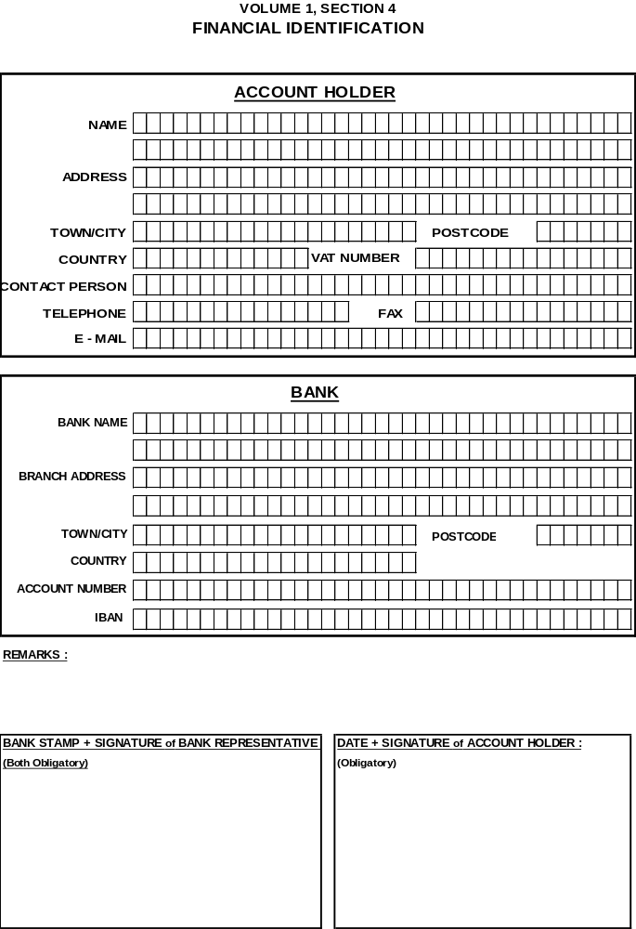

FORM 4.5b LEGAL ENTITY FILES

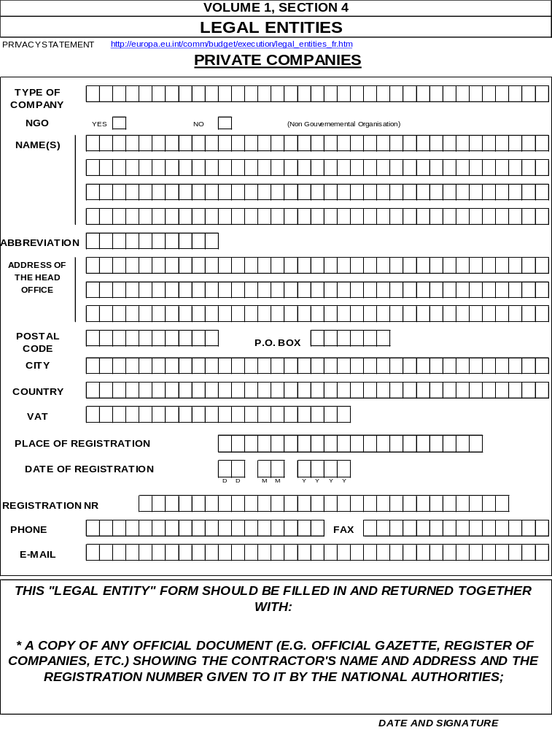

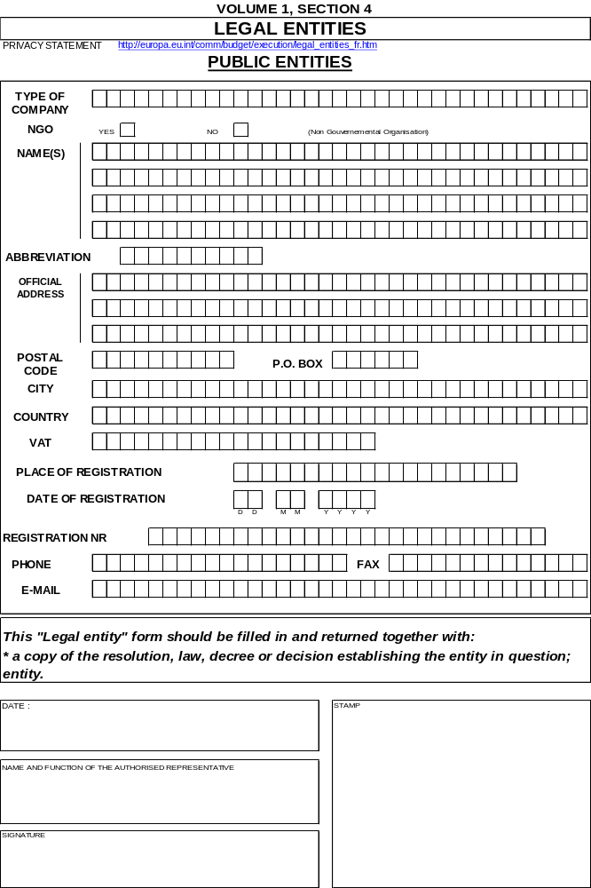

FORM 4.6 TECHNICAL QUALIFICATIONS

FORM 4.6.1 PERSONNEL

FORM 4.6.1.1 PRESENTATION OF THE TENDERER’S ORGANIZATION
i - Overview
a - Directors and management ........................
b - Administrative staff ........................
c - Technical staff
- Engineers ........................
- Surveyors
- Foremen ........................
- Mechanics
- Technicians ........................
- Machine operators
- Drivers ........................
- Other skilled staff
- Labourers and unskilled staff ........................
________________________________________________
Total ===========

ii - Site operatives to be employed on the contract (if relevant)
a - Site management ........................
b - Administrative staff ........................
c - Technical staff
- Engineers ........................
- Surveyors
- Foremen ........................
- Mechanics
- Technicians ........................
- Machine operators
- Drivers ........................
- Other skilled staff
- Labourers and unskilled staff ........................
_______________________________________________
Total ===========
Signature ....................................................
(a person or persons authorised to sign on behalf of the tenderer)

Date ............................................

FORM 4.6.1.2 PERSONNEL TO BE EMPLOYED IN THE CONTRACT

Position/Name | Nationality | Age | Education | Years of experience (with the company/in construction) | Major works for which responsible (project/value)
Program manager and Project Co-ordinator |  |  |  | /
Assistant supervisor |  |  |  | /
Quality control ......................................... |  |  |  | /
Others responsible for ......................................... |  |  |  | /
Others responsible for .........................................  ......................................... |  |  |  | /

Signature ......................................................
(a person or persons authorised to sign on behalf of the tenderer)
Date.........................................

FORM 4.6.1.3 PROFESSIONAL EXPERIENCE OF KEY PERSONNEL
CURRICULUM VITAE
(Maximum 3 pages + 3 pages of annexes)
1. Surname:
2. Name:
3. Date and place of birth:
4. Nationality:
5. Civil status:
6. Address (phone/fax/e-mail):
7. Education:
Institution:
Date:
From (month/year)
To (month/year)
Degree:
8. Language skills
(On a scale of 1 to 5, with 5 being the highest):
Language | Level | Passive | Spoken | Written
 | Mother tongue
9. Membership of professional bodies:
10. Other skills (e.g. computer literacy, etc.):
11. Present position:
12. Years of professional experience:
13. Key qualifications:
14. Specific experience in non-industrialised countries:
Country | Date: from (month/year) to (month/year) | Name and brief description of the project

15. Professional experience:
Date: from (month/year) to (month/year)
Place
Company/organisation
Position
Job description

16. Others:
16a. Publications and seminars:

16b. References:

Signature ............................................
(a person or persons authorised to sign on behalf of the tenderer)

Date...........................

FORM 4.6.2 PLANT
Plant proposed and available for the implementation of the contract

 | DESCRIPTION (type/make/model) | Power/ capacity | No of units | Age (years) | Owned (O) or hired (H)/ and percentage of ownership | Origin (country) | Present approximate value in euro or NC
A) | CONSTRUCTION PLANT

 | DESCRIPTION (type/make/model) | Power/ capacity | No of units | Age (years) | Owned (O) or hired (H)/ and percentage of ownership | Origin (country) | Present approximate value in euro or national currency
B) | VEHICLES AND TRUCKS
C) | OTHER PLANT
Signature ...........................................................
(a person or persons authorised to sign on behalf of the tenderer)
Date................................................

FORM 4.6.3 WORKPLAN AND PROGRAMME
4.6.3.1 State the proposed location of your main office on the site, stations (steel/concrete/asphalt structures), warehouses, laboratories, accommodation, etc. (sketches to be attached as required).
4.6.3.2 Give a brief outline of your programme for the completion of the works in accordance with the required method of construction and stated time of completion.
4.6.3.3 Attach a critical milestone bar chart (schedule of execution) representing the construction programme and detailing the relevant activities, dates, allocation of labour and plant resources, etc.
4.6.3.4 If the tenderer plans to subcontract part of the works, he/she must provide the following details:

Work intended to be subcontracted | Name and details of subcontractors | Value of subcontract as percentage of the total cost of the project | Experience in similar work (details to be specified)
Signature .......................................................
(a person or persons authorised to sign on behalf of the tenderer)

Date ....................................

FORM 4.6.4 EXPERIENCE AS CONTRACTOR
4.6.4.1 List of contracts of similar nature and extent performed during the past <insert number> years

Name of project/kind of works | Total value of works the Contractor was responsible for | Period of contract | Starting date | Percentage of works completed | Contracting authority and place | Prime contractor (P) or subcontractor (S) | Final acceptance issued?  - Yes  - Not yet (current contracts)  – No
A) In home country

Name of project/kind of works | Total value of works the Contractor was responsible for | Period of contract | Starting date | Percentage of works completed | Contracting authority and place | Prime contractor (P) or subcontractor (S) | Final acceptance issued?  - Yes  - Not yet (current contracts)  – No
B) Abroad
4.6.4.2 Please attach here available references and certificates from the relevant Contracting Authorities.
Signature .......................................................................................
(a person or persons authorised to sign on behalf of the tenderer)

Date ..................

FORM 4.6.5 INFORMATION ON JOINT VENTURES
4.6.5.1 Name ......................................................................................
4.6.5.2 Managing board's address ..................................................................................
.............................................................................................................................
Telex ..........................................................
Telephone .........................Fax..................................E-mail.....
4.6.5.3 Agency in the state of the Contracting Authority, if any (in the case of a joint venture/consortium with a foreign lead member )
Office address .....................................................................................................
.............................................................................................................................
Telex ..........................................................
Telephone ..............................Fax.........................................
4.6.5.4 Names of members
i) ......................................................................................................................
ii) ......................................................................................................................
iii) ......................................................................................................................
Etc. ......................................................................................................................
4.6.5.5 Name of lead member
.............................................................................................................................
.............................................................................................................................
4.6.5.6 Agreement governing the formation of the joint venture/consortium
i) Date of signature: ........................................................................................
ii) Place: ...........................................................................................................
iii) Enclosure - joint venture/consortium agreement
4.6.5.7 Proposed proportion of responsibilities between members (in %) with indication of the type of the works to be performed by each
.............................................................................................................................
.............................................................................................................................
.............................................................................................................................
.............................................................................................................................
.............................................................................................................................

Signature: ..................................................................................
(a person or persons authorised to sign on behalf of the tenderer)

Date: .....................

FORM 4.6.6 LITIGATION HISTORY
Please provide information on any history of litigation or arbitration resulting from contracts executed during the last 2 years or currently under execution.
A separate sheet should be used for each partner of a joint venture/consortium.

Year | Award FOR or AGAINST tenderer | Name of client, cause of litigation, and matter in dispute | Disputed amount (current value in euro or NC)

Signature ......................................................................................
(a person or persons authorised to sign on behalf of the tenderer)

Date ..................}

FORM 4.6.7 QUALITY ASSURANCE SYSTEM(S)
Please provide hereunder details of the quality assurance system(s) it is proposed to use to ensure successful completion of the works.

Signature .................................................
(a person or persons authorised to sign on behalf of the tenderer)

Date ..................

FORM 4.6.8 ACCOMMODATION FOR THE SUPERVISOR
Please attach sketches and data detailing the characteristics of the accommodation and facilities intended to be provided by the tenderer under the relevant items in the bill of quantities/breakdown of the overall price.

Signature .................................................
(a person or persons authorised to sign on behalf of the tenderer)

Date ..................

FORM 4.6.9 FURTHER INFORMATION
Tenderers may add here any further information that they deem useful for the evaluation of their tenders.

Signature ............................................
(a person or persons authorised to sign on behalf of the tenderer)

Date ..................

SECTION 6: EVALUATION GRID
EVALUATION GRID
The following table presents the criteria and their corresponding weights to be applied by the Evaluation Committee for evaluating the tenders.

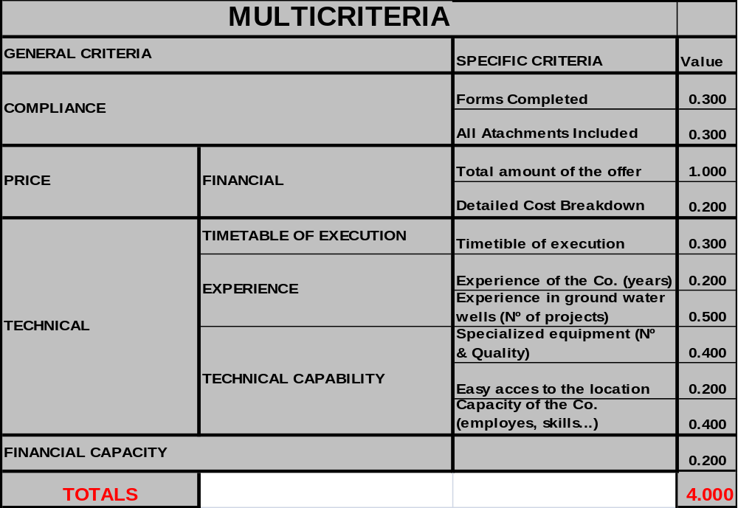

VOLUME 2

SECTION 1: CONTRACT FORM

PROJECT: Urgent action to secure the access of the population in the occupied Palestinian territories to water

CONTRACT: ECHO/-ME/BUD/2009/01038 project

This contract is concluded between:
<Full name of and address of the of Contracting Authority>
(hereinafter called "The Contracting Authority"),

of the one part,
and

<Full official Name of Contractor>
[Legal status/title]
[Official registration number]
[Full official address]
[VAT number],
(hereinafter called “the Contractor”)

of the other part,

have agreed as follows:
Whereas the Contracting Authority is desirous that certain works should be executed by the Contractor, viz.:
Construction of
……………………………………………………………………………………………………………………………….
and has accepted a tender by the Contractor for the execution and completion of such works and the remedying of any defects therein.

It is hereby agreed as follows:
Article 1. In this contract words and expressions shall have the meanings assigned to them in the contractual conditions set out below.
Article 2. The following documents shall be deemed to form and be read and construed as part of this contract, in the following order of precedence:
(a) the contract,
(b) the Special Conditions,
(c) the General Conditions,
(d) the design documentation (maps),
(e) the bill of quantities and the technical specifications,(after arithmetical corrections)/breakdown,
(f) the tender with appendix.
Addenda shall have the order of precedence of the document they are modifying.
Article 3. In consideration of the payments to be made by the Contracting Authority to the Contractor as hereinafter mentioned, the Contractor undertakes to execute and complete the works and remedy defects therein in full compliance with the provisions of the contract.
Article 4. The Contracting Authority hereby agrees to pay the Contractor in consideration of the execution and completion of the works and remedying of defects therein the amount of:
- Contract price (excluding VAT/other taxes) Euro or NC
(The EC component Euro)
< where necessary, enter other sources of financing >
- VAT and other taxes Euro or NC
- Contract price (in words: Euro or NC)
or such other sum as may become payable under the provisions of the contract at the times and in the manner prescribed by the contract. VAT and other taxes shall not be paid on the funds originating from EC funds.
Article 5. In witness whereof the parties hereto have signed the contract. This contract shall take effect on the date on which it is signed by the last party, namely the Contractor.
Done in English in three originals, two originals being for the Contracting Authority and one original being for the Contractor.

CONTRACTING AUTHORITY: | CONTRACTOR:
Signed and sealed by  ..................................................................................................................................................................................................................................................................  Date:............................................................................. | Signed and sealed by  ............................................................................................................................................................................  Name of the signatory (in block capitals) ......................................................................................  In the capacity of ............................................................................................................................................................................  Being fully authorised by and acting on behalf of ...........................................................................................................................................................................  Date ......................................................................  ENDORSED FOR FINANCING ON BEHALF OF THE EUROPEAN COMMISSION  ..................................................................................................................................................................................................................................................................  Date:.............................................................................

SECTION 2: GENERAL CONDITIONS
CONTENTS
PRELIMINARY PROVISIONS 64
ARTICLE 1 : Definitions 64
ARTICLE 2 : Law and language of the contract 64
ARTICLE 3 : Order of precedence of contract documents 64
ARTICLE 4 : Communications 64
ARTICLE 5 : Program manager and Project Co-ordinator and Program manager and Project Co-ordinator's representative 65
ARTICLE 6 : Assignment 66
ARTICLE 7 : Subcontracting 66
OBLIGATIONS OF THE CONTRACTING AUTHORITY 67
ARTICLE 8 : Supply of documents 67
ARTICLE 9 : Access to the site 67
ARTICLE 10 : Assistance with local regulations 67
OBLIGATIONS OF THE CONTRACTOR 68
ARTICLE 11 : General Obligations 68
ARTICLE 12 : Superintendence of the works 69
ARTICLE 13 : Performance guarantees 70
ARTICLE 14 : Insurance 70
ARTICLE 15 : Implementation programme 71
ARTICLE 16 : Detailed breakdown of prices 72
ARTICLE 17 : Contractor's drawings 72
ARTICLE 18 : Sufficiency of tender prices 73
ARTICLE 19 : Exceptional risks 73
ARTICLE 20 : Safety on site 74
ARTICLE 21 : Safeguarding adjacent properties 74
ARTICLE 22 : Interference with traffic 74
ARTICLE 23 : Cables and conduits 75
ARTICLE 24 : Setting-out 75
ARTICLE 25 : Demolished materials 75
ARTICLE 26 : Discoveries 76
ARTICLE 27 : Temporary works 76
ARTICLE 28 : Soil Studies 76
ARTICLE 29 : Overlapping contracts 77
ARTICLE 30 : Patents and licences 77
COMMENCEMENT OF IMPLEMENTATION AND DELAYS 78
ARTICLE 31 : Commencement order 78
ARTICLE 32 : Period of implementation of tasks 78
ARTICLE 33 : Extension of the period of implementation of tasks 78
ARTICLE 34 : Delays in implementation 79
ARTICLE 35 : Modifications 79
ARTICLE 36 : Suspension 81
MATERIALS AND WORKMANSHIP 83
ARTICLE 37 :Work register 83
ARTICLE 38 : Origin 83
ARTICLE 39 : Quality of works and materials 83
ARTICLE 40 : Inspection and testing 84
ARTICLE 41: Rejection 85
ARTICLE 42 : Ownership of plant and materials 85
PAYMENTS 87
ARTICLE 43 : General principles 87
ARTICLE 44 : Prefinancing 87
ARTICLE 45 : Retention monies 88
ARTICLE 46 : Price revision 88
ARTICLE 47 : Measurement 88
ARTICLE 48 : Interim payments 89
ARTICLE 49 : Final statement of account 90
ARTICLE 50 : Delayed payments 91
ARTICLE 51 : Payments to third parties 92
ARTICLE 52 : Claims for additional payment 92
ACCEPTANCE AND MAINTENANCE 93
ARTICLE 53 : Fixing a verification date 93
ARTICLE 54 : Verification operations 93
ARTICLE 55 : Partial acceptance 93
ARTICLE 56: Provisional acceptance 94
ARTICLE 57 : Maintenance obligations 94
ARTICLE 58 : Final acceptance 95
BREACH OF CONTRACT AND TERMINATION 96
ARTICLE 59 : Breach of contract 96
ARTICLE 60 : Termination by the Contracting Authority 97
ARTICLE 61 : Termination by the Contractor 98
ARTICLE 62 : Force Majeure 99
ARTICLE 63 : Death 100
DISPUTE SETTLEMENT 101
ARTICLE 64 : Amicable dispute settlement 101
ARTICLE 65 : Dispute settlement by litigation 101
ETHICS CLAUSES 102
ARTICLE 66 : Ethics clauses 102
ARTICLE 67 : Administrative and financial penalties 103
ARTICLE 68 : Checks and audits by Community bodies 103

PRELIMINARY PROVISIONS

ARTICLE 1 : Definitions
1.1 The headings and titles in these General Conditions shall not be taken as part thereof or be taken into consideration in the interpretation of the contract.
1.2 Where the context so permits, words in the singular shall be deemed to include the plural and vice versa and words in the masculine shall be deemed to include the feminine and vice versa.
1.3 Words designating persons or parties shall include firms and companies and any organisation having legal capacity.

ARTICLE 2 : Law and language of the contract
2.1 The Special Conditions shall specify the law governing all matters not covered by the contract.
2.2 The contract and all written communications between the parties will be drafted in the language of the procedure.

ARTICLE 3 : Order of precedence of contract documents
3.1 Save where otherwise provided in the special conditions, the contract is made up of the following documents, in order of precedence:
- the contract
- the General Conditions (Part I)
- the Special Conditions (Part II)
- the design documentation (maps attached in CD format),
- the priced bill of quantities and technical specifications (after arithmetical corrections)/price breakdown
- the tender with the appendix
- any other document forming part of the contract.
Addenda have the order of precedence of the document they are modifying.
3.2. The various documents making up the contract shall be deemed to be mutually explanatory; in cases of ambiguity or divergence, they should be read in the order in which they appear above.

ARTICLE 4 : Communications
4.1 Communications between the Contracting Authority and/or the Program manager and Project Co-ordinator on the one hand, and the Contractor on the other, shall be exclusively in writing. Unless otherwise specified in the Special Conditions, communications between the Contracting Authority and/or the Program manager and Project Co-ordinator on the one hand, and the Contractor on the other hand, shall be sent by post, cable, telex, e-mail, fax transmission, or delivered by hand, to the addresses designated by the Parties for that purpose.
4.2 If the person sending a communication requires acknowledgment of receipt, he/she shall indicate this in his/her communication. Whenever there is a deadline for the receipt of a written communication, the sender should ask for an acknowledgement of receipt of his/her communication. In any event, the sender shall take all necessary measures to ensure receipt of his/her communication.
4.3 Wherever the contract provides for the giving or issue of any notice, consent, approval, certificate or decision, unless otherwise specified such notice, consent, approval, certificate or decision shall be in writing and the words "notify", "certify", "approve" or "decide" shall be construed accordingly. Any such consent, approval certificate or decision shall not unreasonably be withheld or delayed.

ARTICLE 5 : Program manager and Project Co-ordinator and Program manager and Project Co-ordinator's representative
5.1 The Program manager and Project Co-ordinator shall carry out the duties specified in the contract. Except where expressly stated in the contract, the Program manager and Project Co-ordinator shall not have authority to relieve the Contractor of any of his/her obligations.
5.2 The Program manager and Project Co-ordinator may, from time to time, while retaining ultimate responsibility, delegate to the Program manager and Project Co-ordinator's representative any of the duties and authority vested in the Program manager and Project Co-ordinator and he/she may at any time revoke such delegation or replace the representative. Any such delegation, revocation or replacement shall be in writing and shall not take effect until a copy thereof has been delivered to the Contractor.
5.3 Any communication given by the Program manager and Project Co-ordinator's representative to the Contractor in accordance with the terms of such delegation shall have the same effect as if it had been given by the Program manager and Project Co-ordinator, save that:
- a failure on the part of the Program manager and Project Co-ordinator's representative to reject any work, materials or plant shall not prejudice the authority of the Program manager and Project Co-ordinator to reject such work, materials or plant and to give the instructions necessary for the rectification thereof;
- the Program manager and Project Co-ordinator shall be at liberty to reverse or vary the contents of such communication.
5.4 Instructions and/or orders issued by the Program manager and Project Co-ordinator shall take the form of administrative orders. Such orders shall be dated, numbered and entered by the Program manager and Project Co-ordinator in a register, and copies thereof delivered by hand, where appropriate, to the Contractor's representative.
5.5 The Contractor shall ensure that the Program manager and Project Co-ordinator have free access to the places in which the works covered by the contract are carried out and shall provide the Program manager and Project Co-ordinator with any information they might require. The Program manager and Project Co-ordinator may arrange for the supervision and inspection of any item being prepared and manufactured for supply under the contract. To this end, they may apply such tests as he/she considers necessary from among those provided for in these General Conditions, supplemented and amended where appropriate by the Special Conditions, in order to establish whether the materials and objects are of the requisite quality and quantity. They may require the replacement or repair, as the case may be, of items, which do not conform with the contract, even after their installation. They may also propose a reduction in price, which, if accepted by the Contractor, shall cover the latter for any imperfections, which have been found. The Contractor may not rely on the fact that such supervision and inspection have been effected in order to evade his/her responsibility in the event of the works being rejected by the Program manager and Project Co-ordinator.
5.6 The Contractor shall place at the disposal of the Program manager and Project Co-ordinator, temporarily and free of charge, the patterns and instruments specified in the Special Conditions which are considered necessary for verifying and inspecting the works to be carried out and the items to be provided.
5.7 In the performance of his/her duties, the Program manager and Project Co-ordinator shall not disclose information on the methods of manufacture and operation of the undertakings which they have obtained by reason of his/her supervision and inspection, except to those authorities that need to know it.

ARTICLE 6 : Assignment
6.1 An assignment shall be valid only if it is a written agreement by which the Contractor transfers his/her contract or part thereof to a third party.
6.2 The Contractor may not, without the prior written consent of the Contracting Authority, assign the contract or any part thereof, or any benefit or interest thereunder, except in the following cases:
- a charge, in favour of the Contractor's bankers, of any monies due or to become due under the contract;
or
- the assignment to the Contractor's insurers of the Contractor's right to obtain relief against any other person liable in cases where the insurers have discharged the Contractor's loss or liability.
6.3 For the purpose of Article 6.2, the approval of an assignment by the Contracting Authority shall not relieve the Contractor of his/her obligations for the part of the contract already performed or the part not assigned.
6.4 If the Contractor has assigned his/her contract without authorisation, the Contracting Authority may, without giving formal notice thereof, apply as of right the sanctions for breach of contract provided for in Articles 60 and 61.
  - Assignees must satisfy the eligibility criteria applicable for the award of the contract.

ARTICLE 7: Subcontracting
7.1 A subcontract shall be valid only if it is a written agreement by which the Contractor entrusts implementation of a part of his/her contract to a third party.
7.2 The Contractor shall not subcontract without the prior written authorisation of the Contracting Authority. The elements of the contract to be subcontracted and the identity of the subcontractors shall be notified to the Contracting Authority. With due regard to the provisions of Article 4.3, the Contracting Authority shall notify the Contractor of its decision within 30 days of receiving the notification, stating its reasons if authorisation is withheld.
7.3 Subcontractors must satisfy the eligibility criteria applicable for the award of the contract.
7.4 The Contracting Authority shall not be bound to the subcontractors.
7.5 The Contractor shall be responsible for the acts, defaults and negligence of his/her subcontractors and their agents or employees, as if they were the acts, defaults or negligence of the Contractor, his/her agents or employees. The approval by the Contracting Authority of the subcontracting of any part of the contract or of the subcontractor to perform any part of the works shall not relieve the Contractor of any of his/her obligations under the contract.
7.6 If a subcontractor has undertaken any continuing obligation extending for a period exceeding that of the maintenance period under the contract towards the Contractor in respect of the work executed or the goods, materials, plant or services supplied by the subcontractor, the Contractor shall, at any time after the expiration of the maintenance period, transfer immediately to the Contracting Authority, at the Contracting Authority's request and cost, the benefit of such obligation for the unexpired duration thereof.
7.7 If the Contractor enters into a subcontract without approval, the Contracting Authority may, without giving formal notice thereof, apply as of right the sanctions for breach of contract provided for in Article 60.
OBLIGATIONS OF THE CONTRACTING AUTHORITY

ARTICLE 8 : Supply of documents
8.1 Save where otherwise provided in the special conditions, within 30 days of the signing of the contract, the Program manager and Project Co-ordinator shall, on behalf of the Contracting Authority, provide the Contractor, free of charge, with a copy of the drawings prepared for the performance of the contract and a copy of the specifications and other contract documents. The Contractor may purchase additional copies of these drawings, specifications and other documents, in so far as they are available. Upon the issue of the maintenance certificate, or upon final acceptance, the Contractor shall return to the Program manager and Project Co-ordinator all drawings, specifications and other contract documents.
8.2 Unless it is necessary for the purposes of the contract, the drawings, specifications and other documents provided by the Contracting Authority shall not be used or communicated to a third party by the Contractor without the prior consent of the Program manager and Project Co-ordinator.
8.3 The Program manager and Project Co-ordinator shall have authority to issue to the Contractor, on behalf of the Contracting Authority, administrative orders incorporating such supplementary documents and instructions as are necessary for the proper execution of the works and the remedying of any defects therein.

8.4 The special conditions must indicate the procedure used, if necessary, by the Contracting Authority and the Program manager and Project Co-ordinator to approve drawings and other documents provided by the Contractor.

ARTICLE 9: Access to the site
9.1 The Contracting Authority shall, in due time and in conformity with the progress of the works, place the site and access thereto at the disposal of the Contractor in accordance with the programme of implementation referred to in these General Conditions. The Contractor shall afford other persons concerned every reasonable opportunity to carry out their work, as set out in the Special Conditions or as required by administrative orders.
9.2 Land procured for the Contractor by the Contracting Authority shall not be used by the Contractor for purposes other than the implementation of the contract.
9.3 The Contractor shall keep any premises placed at his/her disposal in good condition while he/she is in occupation. He shall, if so required by the Contracting Authority or the Program manager and Project Co-ordinator, restore them to their original state on completion of the contract, taking into account normal wear and tear.
9.4 The Contractor shall not be entitled to any payment for improvements resulting from work carried out on his/her own initiative.

ARTICLE 10: Assistance with local regulations
10.1 The Contractor may request the assistance of the Contracting Authority in obtaining copies of laws, regulations and information on local customs, orders or bye-laws of the country where the works are located which may affect the Contractor in the execution of his/her obligations under the contract. The Contracting Authority may provide the assistance requested to the Contractor at the Contractor's cost.
10.2 The Contractor shall respect internationally agreed core labour standards, e.g. the ILO core labour standards, conventions on freedom of association and collective bargaining, elimination of forced and compulsory labour, elimination of discrimination in respect of employment and occupation, and the abolition of child labour.
OBLIGATIONS OF THE CONTRACTOR

ARTICLE 11: General Obligations
11.1 The Contractor shall, with due care and diligence, and in accordance with the provisions of the contract, design the works to the extent stated in the contract, and execute, complete and remedy any defects in the works. The Contractor shall provide all superintendence, personnel, materials, plant, equipment and all other items, whether of a temporary or permanent nature, required for the design, execution and completion of works, and for remedying any defects, in so far as is specified in, or can be reasonably inferred from, the contract.
11.2 The Contractor shall carry out, and assume responsibility for, the design of the works with the help of experienced designers satisfying the criteria laid down by the Contracting Authority. He shall draw up the requisite technical documents according to the provisions laid down in the special conditions and technical specifications. These documents must be submitted to the Program manager and Project Co-ordinator for approval, in accordance with the Special Conditions, and may be corrected at the Contractor's expense to satisfy the Contracting Authority's contractual requirements and eliminate errors, omissions, ambiguities, inconsistencies and other drafting defects. The Contractor shall train the Contracting Authority's personnel and deliver and update the set of detailed documents and operating and maintenance manuals, in accordance with the Special Conditions.
11.3 The staff and workmen employed by the Contractor must be sufficient in number, and each must have the qualifications necessary to ensure due progress and satisfactory execution of the works. The Contractor shall immediately replace all persons indicated by the Program manager and Project Co-ordinator, in a letter stating reasons, as hampering the proper execution of the works. The Contractor shall make his/her own arrangements for the engagement of all staff and labour. He shall comply with all the relevant labour laws applying to his/her employees, shall duly pay them and afford them all their legal rights.
11.4 The equipment, which the Contractor has at the site, shall be deemed to be for the purpose of carrying out the works. The Contractor shall not be entitled to remove it without the written consent of the Program manager and Project Co-ordinator unless he/she shows that the said equipment is no longer required for the performance of the works.
11.5 The Contractor shall take full responsibility for the adequacy, stability and safety of all operations and methods of construction under the contract.
11.6 The Contractor shall comply fully with any administrative orders given to him. Where the Contractor considers that the requirements of an administrative order exceed the authority of the Program manager and Project Co-ordinator or the scope of the contract, he/she shall, on pain of being time-barred, notify the Program manager and Project Co-ordinator of this fact within 10 days of receiving the administrative order and inform the Contracting Authority. Execution of the administrative order shall be suspended during this period.
The Contractor shall draw up and submit for the Program manager and Project Co-ordinator's approval a programme of implementation of the contract, in accordance with the detailed rules laid down in the Special Conditions.
Where appropriate and within a period not exceeding three weeks, the Contractor must, in response to a reasoned request from the Program manager and Project Co-ordinator, be able to provide a detailed breakdown of his/her prices.
The Special Conditions shall specify any detailed drawings to be drawn up by the Contractor and submitted for the Program manager and Project Co-ordinator's approval. The same shall apply to documents and items, which are to be submitted to the Program manager and Project Co-ordinator for endorsement or acceptance. These detailed drawings, documents and items may not be reproduced or used for another purpose by the Contracting Authority, nor communicated to third parties, except with the Contractor's agreement and on payment of fair compensation.

11.7 The Contractor shall either give an address for service or give an address close to the works, or appoint an agent residing at that address. He shall notify the Contracting Authority of the address for service or other address. Should he/she fail to fulfil this obligation within two months of being notified of the approval of the contract, all notifications concerning the contract shall be valid when they are sent to the address given in Art 2 of the Special Conditions.
After final acceptance of the works, the Contractor shall be relieved of this obligation. Should he/she fail to inform the Contracting Authority of a change of address before final acceptance of the works, all notifications concerning the contract shall be valid when they are sent to the address given in Art 2 of the Special Conditions.
11.8 The Contractor shall respect and abide by all laws and regulations in force in the OpT authority and shall ensure that his/her personnel, their dependants, and his/her local employees also respect and abide by all such laws and regulations. The Contractor shall indemnify the Contracting Authority against any claims and proceedings arising from any infringement by the Contractor, his/her employees and their dependants of such laws and regulations.
11.9 If the Contractor or any of his/her subcontractors, agents or servants offers to give or agrees to offer or to give or gives to any person, any bribe, gift, gratuity or commission as an inducement or reward for doing or forbearing to do any act in relation to the contract or any other contract with the Contracting Authority; or for showing favour or disfavour to any person in relation to the contract or any other contract with the Contracting Authority, then the Contracting Authority may, without prejudice to any accrued rights of the Contractor under the contract, terminate the contract in accordance with the relevant provisions of these General Conditions.
11.10 The Contractor shall treat all documents and information received in connection with the contract as private and confidential. He shall not, save in so far as may be necessary for the purposes of the contract's execution, publish or disclose any particulars of the contract without the prior consent in writing of the Contracting Authority or the Program manager and Project Co-ordinator after consultation with the Contracting Authority. If any disagreement arises as to the necessity for any publication or disclosure for the purpose of the contract, the decision of the Contracting Authority shall be final.
11.11 If the Contractor is a joint venture or consortium of two or more persons, all such persons shall be jointly and severally bound to fulfil the terms of the contract according to the law of the state of the Contracting Authority and shall, at the request of the Contracting Authority, designate one of such persons to act as leader with authority to bind the joint venture or consortium. The composition or constitution of the joint venture or consortium shall not be altered without the prior consent in writing of the Contracting Authority.
11.12 Save where the European Commission requests or agrees otherwise, the Contractor shall take the necessary measures to ensure the visibility of the European Union financing or cofinancing. These measures must comply with the rules laid down and published by the Commission on the visibility of external operations.

ARTICLE 12: Superintendence of the works
12.1 The Contractor shall superintend the works himself or appoint a representative to do so. Such appointments shall be submitted to the Program manager and Project Co-ordinator for approval. The approval may be withdrawn at any time. Should the Program manager and Project Co-ordinator refuse to approve, or withdraw approval of the appointment, he/she shall set out the grounds on which his/her decision is based, and the Contractor shall submit an alternative appointment without delay. The address of the Contractor's representative shall be deemed to be the address for service given by the Contractor.
12.2 If the Program manager and Project Co-ordinator withdraw their approval of the Contractor's representative, the Contractor shall, as soon as is practicable, after receiving notice of such withdrawal, remove the representative from the works and replace him/her with another representative approved by the Program manager and Project Co-ordinator.
12.3 The Contractor's representative shall have full authority to make any decision necessary for the execution of the works, to receive and carry out administrative orders and to countersign the work register referred to in these General Conditions or the Annexes.
12.4 In any event, the Contractor shall be responsible for ensuring that the works are carried out satisfactorily, including ensuring that the specifications and administrative orders are adhered to by his/her own employees and by his/her subcontractors and their employees.

ARTICLE 13: Performance guarantees
13.1 The Contractor shall to, within 30 days of receipt of the notification of the award of contract, furnish the Contracting Authority with a guarantee for the full and proper execution of the contract. The amount of the guarantee shall be specified in the Special Conditions. It shall not exceed 10% of the amount of the contract price, including any amounts stipulated in addenda to the contract.
13.2 The performance guarantee shall be held against payment to the Contracting Authority for any loss resulting from the Contractor's failure to perform his/her contractual obligations fully and properly.
13.3 The performance guarantee shall be in the format given in Volume 2 of the tender dossier and may be provided in the form of a bank guarantee, a banker's draft, a certified cheque, a bond provided by an insurance and/or guarantee company or an irrevocable letter of credit made out to the Contracting Authority. If the performance guarantee is to be provided in the form of a bank guarantee, a banker's draft, a certified cheque or a bond, it shall be issued by a bank or guarantee and/or insurance company in accordance with the eligibility criteria applicable for the award of the contract.
13.4 The performance guarantee shall be denominated in the currency in which the contract is payable. No payments shall be made in favour of the Contractor prior to the provision of the guarantee. The guarantee shall continue to remain valid until the contract has been fully and properly performed.
13.5 If, during the execution of the contract, the natural or legal person providing the guarantee is not able to abide by his/her commitments, the Contracting Authority shall give formal notice to the Contractor to provide a new guarantee on the same terms as the previous one. Should the Contractor fail to provide a new guarantee, the Contracting Authority may terminate the contract. Before applying these measures, it shall send the Contractor a registered letter with acknowledgement of delivery serving notice for the establishment of the performance guarantee. Such notice shall set a new time limit, which may not be less than 15 days and which shall commence on the date of delivery of the letter.
13.6 The Contracting Authority shall demand payment from the guarantee of all sums for which the guarantor is liable under the guarantee due to the Contractor's default under the contract, in accordance with the terms of the guarantee and up to the value thereof. The guarantor shall, without delay, pay those sums upon demand from the Contracting Authority and may not raise any objection for any reason whatsoever. Before making any claim under the performance guarantee, the Contracting Authority shall notify the Contractor stating the nature of the default in respect of which the claim is to be made.
13.7 Unless the Special Conditions provide otherwise, the performance guarantee shall be released within 45 days of the signing of the final statement of account. However, in view of the special features of the contract, the Special Conditions may provide for half the guarantee to be released or refunded on the date of provisional acceptance.

ARTICLE 14: Insurance
14.1 The Contractor shall take out insurance in both his/her own and the Contracting Authority's name against any loss or damage for which he/she is liable under the contract. Such insurance shall, unless the Special Conditions provide otherwise, cover:
a) the works, together with materials and plant for incorporation therein, to the full replacement cost against all loss or damage from whatever cause arising other than from force majeure or risks attributable under the contract to the Contracting Authority;
b) an additional sum of 15% of such replacement cost or any other amount specified in the Special Conditions, to cover all the additional direct or indirect costs of making good losses or damage, including professional fees and the cost of demolishing and removing any part of the works and of removing debris of whatever nature;
(c) the Contractor's equipment and other things brought onto the site by the Contractor, for a sum sufficient to provide their replacement at the site.
14.2 The Contractor may substitute the insurance provided for in Article 14.1 by a comprehensive insurance policy that covers, inter alia, the elements of Article 14.1(a), (b) and (c). In that case, the Contractor shall notify the insurer of the Contracting Authority's interest.
14.3 The Contractor shall take out insurance against industrial accidents and civil liabilities arising from the execution of the works to any person employed by the Contractor on the works or to the Contracting Authority and its employees. Such liability shall be unlimited in the case of personal injuries.
14.4 The Contractor shall take out insurance covering liability with regard to risks and civil liability resulting from an act or omission attributed to him, to his/her legal successors or agents. Such insurance shall be for at least the amount stated in the Special Conditions. The Contractor shall ensure that all his/her subcontractors have taken out similar insurance.
14.5 All the insurance referred to in this Article shall be taken out within 30 days of the notification of the award of the contract, and shall be subject to approval by the Contracting Authority. Such insurance shall take effect front the commencement of the works and remain in force until final acceptance of the works. On being asked to do so by the Contracting Authority or the Program manager and Project Co-ordinator, the Contractor shall promptly present the Contracting Authority with the insurance policy and proof that premiums have been duly paid.
14.6 Notwithstanding the Contractor's insurance obligations under Article 14, the Contractor shall bear sole liability for, and indemnify the Contracting Authority and the Program manager and Project Co-ordinator against, any claims by third parties for damage to property or personal injuries arising from the execution of the works by the Contractor, his/her subcontractors and employees.

ARTICLE 15: Implementation programme
15.1 If the Special Conditions so require, the Contractor shall submit a programme of implementation of the contract for the approval of the Program manager and Project Co-ordinator. The programme shall contain at least the following:
a) the order in which the Contractor proposes to carry out the works;
b) the deadlines for submission and approval of the drawings;
c) a general description of the methods which the Contractor proposes to adopt for carrying out the works; and
d) such further details and information as the Program manager and Project Co-ordinator may reasonably require.
15.2 The Special Conditions shall specify the time limit within which the programme of implementation must be submitted to the Program manager and Project Co-ordinator for approval. They may set time limits within which the Contractor must submit all or part of the detailed drawings, documents and items. They shall also state the deadline for the Program manager and Project Co-ordinator's approval or acceptance of the programme of implementation, detailed drawings, documents and items. The approval of the programme by the Program manager and Project Co-ordinator shall not relieve the Contractor of any of his/her obligations under the contract.
15.3 No material alteration to the programme shall be made without the approval of the Program manager and Project Co-ordinator. If, however, the progress of the works does not conform to the programme, the Program manager and Project Co-ordinator may instruct the Contractor to revise the programme and submit the revised programme to him for approval.

ARTICLE 16 : Detailed breakdown of prices
16.1 Where necessary for the purposes of the contract, the Contractor shall provide a detailed breakdown of his/her rates and prices within no more than 20 days of the Program manager and Project Co-ordinator 's reasoned request.
16.2 After the notification of award, the Contractor shall provide the Program manager and Project Co-ordinator, for his/her information only, with a detailed quarterly cashflow estimate of all payments that may be due to the Program manager and Project Co-ordinator under the contract. The Contractor shall subsequently supply revised quarterly cashflow estimates, if so required by the Program manager and Project Co-ordinator. The communication shall not impose any liability whatsoever on the Contracting Authority or the Program manager and Project Co-ordinator.

ARTICLE 17 : Contractor's drawings
17.1 The Contractor shall submit to the Program manager and Project Co-ordinator for approval:
a) the drawings, documents, samples and/or models, according to the time limits and procedures laid down in the Special Conditions;
b) such drawings as the Program manager and Project Co-ordinator may reasonably require for the implementation of the contract.
17.2 If the Program manager and Project Co-ordinator fails to notify his/her decision of approval referred to in Article 17.1 within the deadlines referred to in the contract or the approved programme of implementation, such drawings, documents, samples or models shall be deemed to be approved on expiry of the deadlines. If no deadline is specified, they shall be deemed to be approved 30 days after receipt.
17.3 Approved drawings, documents, samples and models shall be signed or otherwise identified by the Program manager and Project Co-ordinator and may only be departed from on the Program manager and Project Co-ordinator's instructions. Any of the Contractor's drawings, documents, samples or models which the Program manager and Project Co-ordinator fail to approve shall immediately be modified to meet the requirements of the Program manager and Project Co-ordinator and resubmitted by the Contractor for approval.
17.4 The Contractor shall supply additional copies of approved drawings in the form and numbers stated in the contract or in subsequent administrative orders.
17.5 The approval of the drawings, documents, samples or models by the Program manager and Project Co-ordinator shall not relieve the Contractor from any of his/her obligations under the contract.
17.6 The Program manager and Project Co-ordinator shall have the right to inspect all drawings, documents, samples or models relating to the contract at the Contractor's premises at all reasonable times.
17.7 Before provisional acceptance of the works, the Contractor shall supply operating and maintenance manuals together with drawings, which shall be detailed enough to enable the Contracting Authority to operate, maintain, adjust and repair all parts of the works. Unless otherwise stated in the Special Conditions, the manuals and drawings shall be in the language of the contract. The works shall not be considered complete for the purpose of provisional acceptance until such manuals and drawings have been supplied to the Contracting Authority.

ARTICLE 18 : Sufficiency of tender prices
18.1 Subject to the Special Conditions, the Contractor shall be deemed to have inspected and examined the site and its surroundings and to have satisfied himself as to the nature of the ground and the subsoil before submitting his/her tender. He shall also be deemed to have taken into account the form and nature of the site, the extent and nature of the work and materials necessary for the completion of the works, the means of communication with and access to the site, the accommodation he/she may require and in general to have obtained for himself all necessary information as to the risks, contingencies and any other circumstances influencing or affecting his/her tender.
18.2 The Contractor shall be deemed to have satisfied himself before submitting his/her tender as to the correctness and sufficiency of the tender and of the rates and prices stated in the bill of quantities or price schedule, which shall, save where otherwise provided in the Special Conditions, cover all his/her obligations under the contract.
18.3 Since the Contractor is deemed to have determined his/her prices on the basis of his/her own calculations, operations and estimates, he/she shall, at no additional charge, carry out any work that is the subject of any item whatsoever in his/her tender for which he/she indicates neither a unit price nor a lump sum.

ARTICLE 19 : Exceptional risks
19.1 If, during the execution of the works, the Contractor encounters artificial obstructions or physical conditions which could not reasonably have been foreseen by an experienced Contractor, and if the Contractor is of the opinion that additional costs will be incurred and/or an extension of the period of implementation of the contract will be necessary as a result of this, he/she shall notify the Program manager and Project Co-ordinator in accordance with the articles of the General Conditions concerning the extension of the period of implementation and claims for additional payments. The Contractor's notification shall specify the artificial obstructions and/or physical conditions, giving details of the expected effects thereof, the measures he/she is taking or intends to take and the extent of the expected delay in, or interference with, the execution of the works.
19.2 On receipt of notification, the Program manager and Project Co-ordinator may inter alia:
a) require the Contractor to provide an estimate of the cost of the measures he/she is taking or intends to take;
b) approve the measures referred to in Article 19.2(a) with or without modification;
c) give written instructions as to how the artificial obstructions or physical conditions are to be dealt with;
d) order that the contract be modified, suspended or terminated.

19.3 In so far as he/she considers that some or all of the said artificial obstructions or physical conditions could not reasonably have been foreseen by an experienced Contractor, the Program manager and Project Co-ordinator shall:
a) take into account any delay suffered by the Contractor as a result of such obstructions or conditions in determining any extension of the period of implementation to which the Contractor is entitled under the General Conditions; and/or
b) calculate, in the event of artificial obstructions or physical conditions other than weather conditions, the additional payments due to the Contractor under the General Conditions.
19.4 If the Program manager and Project Co-ordinator decide that some or all of the artificial obstructions or physical conditions could reasonably have been foreseen by an experienced Contractor, he/she shall so inform the Contractor as soon as practicable.
19.5 Weather conditions shall not entitle the Contractor to claim additional payments under Article 52. Where the Program manager and Project Co-ordinator judge that weather conditions that are normally foreseeable or specified in the Special Conditions make the smooth execution of the works difficult, he/she may decide to suspend such works for a given period. During the periods of suspension, the Contractor shall, at his/her own expense, take every precaution necessary to safeguard the works and materials.

ARTICLE 20 : Safety on site
20.1 The Contractor shall have the right to forbid access to the site to any person not involved in the execution of the contract, with the exception of persons authorised by the Program manager and Project Co-ordinator or representatives of the Contracting Authority.
20.2 The Contractor shall ensure the safety of sites throughout the period of execution and shall be responsible for taking the necessary steps, in the interests of his/her employees, agents of the Contracting Authority and third parties, to prevent any loss or accident which may result from carrying out the works.
20.3 The Contractor shall, on his/her own responsibility and at his/her own expense, do his/her utmost to ensure that existing structures and installations are protected, preserved and maintained. He shall be responsible for providing and maintaining at his/her own expense all lighting, protection, fencing and security equipment that proves necessary for the proper implementation of the works or that the Program manager and Project Co-ordinator may reasonably require.
20.4 If, during the implementation of the contract, urgent measures are necessary to obviate any risk of accident or damage or to ensure safety after an accident or damage, the Program manager and Project Co-ordinator shall give formal notice to the Contractor to do what is necessary. If the Contractor is unwilling or unable to undertake the necessary measures, the Program manager and Project Co-ordinator may, to the extent that the Contractor is liable, arrange for such measures to be implemented at the expense of the Contractor.

ARTICLE 21 : Safeguarding adjacent properties
21.1 On his/her own responsibility and at his/her expense, the Contractor shall take all the precautions required by good construction practice and by the prevailing circumstances to safeguard adjacent properties and avoid causing any abnormal disturbance therein.
21.2 The Contractor shall indemnify the Contracting Authority against the financial consequences of all claims by neighbouring landowners or residents to the extent that the Contractor is liable and to the extent that the damage to adjacent properties is not the result of a hazard arising from the design or method of construction imposed on the Contractor by the Contracting Authority or the Program manager and Project Co-ordinator.

ARTICLE 22 : Interference with traffic
22.1 The Contractor shall ensure that the works and installations do not impede traffic on communication links such as roads, railways, waterways and aerodromes, save as permitted under the Special Conditions. He shall, in particular, take account of weight restrictions when selecting routes and vehicles.
22.2 Any special measures which the Contractor considers necessary or which are specified in the Special Conditions or which are required by the Contracting Authority in order to protect or strengthen sections of roads, tracks or bridges shall be at the expense of the Contractor, whether or not they are carried out by the Contractor. The Contractor shall inform the Program manager and Project Co-ordinator of any special measures he/she intends to take before carrying them out. The repair of any damage caused to roads, tracks or bridges by the transport of materials, plant or equipment shall be at the expense of the Contractor.

ARTICLE 23 : Cables and conduits
23.1 Where, in the course of carrying out the works, the Contractor encounters markers indicating the course of underground cables, conduits and installations, he/she shall leave such markers in place or, if the execution of the works required their temporary removal, put them back. Such ancillary operations shall require the prior authorisation of the Program manager and Project Co-ordinator.
23.2 The Contractor shall be responsible for preserving, removing or putting back, as the case may be, the cables, conduits and installations specified by the Contracting Authority in the contract and shall cover the cost of doing so.
23.3 Where the presence of cables, conduits and installations has not been specified in the contract but is revealed by markers and signs, the Contractor shall have a general duty of care and obligations comparable to those above regarding preservation, removal and replacement. In this case, the Contracting Authority shall compensate the Contractor for such expenditure, to the extent that such work is necessary for the execution of the contract.
23.4 However, the obligations to remove and replace cables, conduits and installations and the expenditure resulting therefrom shall not be the responsibility of the Contractor if the Contracting Authority decides to assume them itself. The same shall apply where this obligation and the expenditure resulting therefrom are borne by a specialist administration or an agent.
23.5 Where any work on the site is likely to disrupt or damage a public utility service, the Contractor shall immediately inform the Program manager and Project Co-ordinator in writing, giving a reasonable period of notice so that suitable measures can be taken in time to allow work to continue normally.

ARTICLE 24 : Setting-out
24.1 The Contractor shall be responsible for:
a) the accurate setting-out of the works in relation to the original marks, lines and reference levels provided by the Program manager and Project Co-ordinator;
b) the accuracy of the positioning, levelling, dimensioning and alignment of all parts of the works; and
c) the provision of all necessary instruments, accessories and labour in connection with the foregoing responsibilities.
24.2 If, at any time during the execution of the works, any error appears in the positioning, levelling, dimensioning or alignment of any part of the works, the Contractor shall, if the Program manager and Project Co-ordinator so requires, rectify such errors at his/her own cost and to the satisfaction of the Program manager and Project Co-ordinator, unless the error is based on inaccurate data supplied by the Program manager and Project Co-ordinator, in which case the Contracting Authority shall be responsible for the cost of rectification.
24.3 The checking of any setting-out or of any alignment or levelling by the Program manager and Project Co-ordinator shall in no way relieve the Contractor of his/her responsibility for the accuracy of these operations. The Contractor shall carefully protect and preserve all markers, sightrails, pegs and other items used in setting out the works.

ARTICLE 25 : Demolished materials
25.1 Where the contract includes demolition work, materials and articles obtained therefrom shall, unless the Special Conditions and/or the law of the state of the Contracting Authority provide otherwise and subject to the provisions of the General Conditions on discoveries, be the property of the Contractor.
25.2 Should the Special Conditions assign the ownership of materials or all or part of the articles obtained from the demolition work to the Contracting Authority, the Contractor shall take all the necessary precautions to ensure that they are preserved. He shall be liable for any destruction of, or damage to, such materials or articles caused by him or his/her agents.
25.3 Irrespective of the use to which the Contracting Authority intends to put the materials or articles over which it retains ownership, all costs incurred in transporting and storing them and all warehouse charges at the place indicated by the Program manager and Project Co-ordinator shall be borne by the Contractor for any carriage not exceeding 100 metres.
25.4 Save where the Special Conditions provide otherwise, the Contractor shall, at his/her expense, progressively remove rubble and other demolition materials, rubbish and debris from the site.

ARTICLE 26 : Discoveries
26.1 Discoveries of any interest whatsoever made during excavation or demolition work shall immediately be brought to the attention of the Program manager and Project Co-ordinator. The Program manager and Project Co-ordinator shall decide how such discoveries are to be dealt with, taking due account of the law of the state of the Contracting Authority.
26.2 The Contracting Authority reserves the ownership of materials found during excavation and demolition works on land belonging to it, subject to its compensating the Contractor for any special efforts he/she may have made.
26.3 Artefacts, antiquities, natural or numismatic objects, other objects of academic interest, rare objects or objects made of precious metals found during excavation or demolition work shall be the property of the Contracting Authority.
26.4 In the event of disagreements, the Contracting Authority shall have sole authority to decide as to the qualifications set out in Articles 26.1 and 26.3.

ARTICLE 27 : Temporary works
27.1 The Contractor shall carry out at his/her expense all the temporary works to enable the works to be carried out. He shall submit to the Program manager and Project Co-ordinator drawings of temporary works, which he/she intends to use, such as cofferdams, scaffolding, trusses and shuttering. He shall take account of any observations made to him by the Program manager and Project Co-ordinator, while remaining responsible for these drawings.
27.2 Where the design of particular temporary works is specified in the Special Conditions to be the responsibility of the Contracting Authority, the Program manager and Project Co-ordinator shall provide the Contractor with all drawings necessary in reasonable time to enable the Contractor to undertake the temporary works in accordance with his/her programme. In such cases, the Contracting Authority shall bear sole responsibility for the safety and suitability of the design. The Contractor, however, shall be responsible for their proper execution.

ARTICLE 28 : Soil Studies
28.1 Subject to the Special Conditions and to the technical specifications, the Contractor shall make available to the Program manager and Project Co-ordinator, the personnel and equipment necessary to carry out any soil survey that the Program manager and Project Co-ordinator may reasonably consider necessary.
28.2 The Contractor shall be compensated for the actual cost of the manpower and equipment used or made available in such work, if not already provided for in the contract.

ARTICLE 29 : Overlapping contracts
29.1 In accordance with the requirements of the Program manager and Project Co-ordinator, the Contractor shall afford other contractors employed by the Contracting Authority and their workmen, and the workmen of the Contracting Authority and of any other public authorities who may be employed on or near the site for the purposes of works not covered by the contract or of any contract that the Contracting Authority may enter into in connection with, or ancillary to, the works every reasonable opportunity to carry out their work.
29.2 However, if the Contractor, on the written request of the Program manager and Project Co-ordinator, make available to any such contractor or public authority, or to the Contracting Authority, any roads or ways for the maintenance of which the Contractor is responsible, or permits the use by any such other persons of the Contractor's temporary works, scaffolding or other site equipment, or provides any other service of any kind not provided for in the contract, the Contracting Authority shall, in respect of such use or service, pay the Contractor such sums and/or grant such extension of time as the Program manager and Project Co-ordinator considers reasonable.
29.3 Article 29 does not relieve the Contractor of any of his/her obligations under the contract, nor does it entitle him to any compensation other than that provided for in Article 29.2.
29.4 In no circumstances may difficulties arising with regard to one contract entitle the Contractor to modify or delay implementation of other contracts. Similarly, the Contracting Authority may not take advantage of such difficulties to suspend payments due under another contract.

ARTICLE 30 : Patents and licences
  - Save where otherwise provided in the Special Conditions, the Contractor shall indemnify the Contracting Authority and the Program manager and Project Co-ordinator against any claim resulting from the use as specified in the contract of patents, licences, drawings, designs, models, or brand or trade marks, unless such infringement results from compliance with the design or specification provided by the Contracting Authority and/or the Program manager and Project Co-ordinator.
COMMENCEMENT OF IMPLEMENTATION AND DELAYS

ARTICLE 31 : Commencement order
31.1 The Contracting Authority shall fix the date on which implementation of the contract is to commence and advise the Contractor thereof either in the notice of award of the contract or by administrative order issued by the Program manager and Project Co-ordinator.
31.2 Save where the Parties agree otherwise, implementation of the contract shall begin no later than 15 days after notification of award of contract. After that date the Contractor shall be entitled not to implement the contract and to obtain its termination or compensation for the damage he/she has suffered. The Contractor shall forfeit this right unless he/she exercises it within 7 days of the expiry of the 15 day period.

ARTICLE 32 : Period of implementation of tasks
32.1 The period of implementation of tasks shall commence on the date fixed in accordance with Article 31. It shall stated in the contract, without prejudice to extensions of the period, which may be granted under Article 33.
32.2 If provision is made for separate periods of implementation for separate lots, such periods shall not be aggregated in cases where one Contractor is allocated more than one lot.

ARTICLE 33 : Extension of the period of implementation of tasks
33.1 The Contractor may request an extension to the period of implementation of tasks if his/her implementation of the contract is delayed, or expected to be delayed, for any of the following reasons:
a) exceptional weather conditions in the state of the Contracting Authority;
b) artificial obstructions or physical conditions which could not reasonably have been foreseen by an experienced contractor;
c) administrative orders affecting the date of completion other than those arising from the Contractor's default;
d) failure of the Contracting Authority to fulfil its obligations under the contract;
e) any suspension of the works which is not due to the Contractor's default;
f) force majeure;
g) any other causes referred to in these General Conditions which are not due to the Contractor's default.
33.2 Within 7 days of realising that a delay might occur, the Contractor shall notify the Program manager and Project Co-ordinator of his/her intention to make a request for extension of the period of implementation to which he/she considers himself entitled and, save where otherwise agreed between the Contractor and the Program manager and Project Co-ordinator, within 15 days provide the Program manager and Project Co-ordinator with comprehensive details with an estimation of a re-planning of work that includes the new period for competition of the remaining tasks, so that the request can be examined.
33.3 Within 15 days the Program manager and Project Co-ordinator shall, by written notice to the Contractor after due consultation with the Contracting Authority and, where appropriate, the Contractor, grant such extension of the period of implementation as may be justified, either prospectively or retrospectively, or inform the Contractor that he/she is not entitled to an extension.

ARTICLE 34 : Delays in implementation
34.1 If the Contractor fails to complete the works by the deadline(s) specified in the contract, the Contracting Authority shall, without formal notice and without prejudice to any other remedies under the contract, be entitled to liquidated damages for every day or part thereof which elapses between the end of the period of implementation or extended period of implementation and the actual date of completion, at the rate and up to the maximum amount specified in the Special Conditions. If the works have undergone partial acceptance in accordance with Article 59, the liquidated damages specified in the Special Conditions may be reduced by the proportion of the value of the whole of the works represented by the accepted part.
34.2 If the Contracting Authority is entitled to the maximum claim under Article 34.1, it may, after giving notice to the Contractor:
a) seize the performance guarantee;
b) terminate the contract, in which case the Contractor will have no right to compensation; and
- enter into a contract with a third party at the Contractor's cost for the provision of the balance of the works The Contractor shall not be paid for this part of the contract. The Contractor shall also be liable for the additional costs and damages caused by his/her failure.
34.3 If the Contractor fails under his own responsibility to deliver the equipments in the work site within the time limit(s) specified in the Special Conditions, the Contracting Authority shall, without formal notice and without prejudice to its other remedies under the contract, be entitled, for every day which shall elapse between the expiry of the implementation period and the actual date of completion, to liquidated damages equal to 5/1000 of the value of the undelivered supplies to a maximum of 15% of the total value of the contract.
34.4 If the non-delivery of any of the goods prevents the normal use of the supplies as a whole, the liquidated damages provided for in paragraph 34.3 shall be calculated on the basis of the total contract value.
34.5 If the Contracting Authority has become entitled to claim at least 15% of the contract value under Article 34.3 it may, after giving written notice to the Contractor:
- seize the performance guarantee;
- terminate the contract, in which case the Contractor will have no right to compensation; and
- enter into a contract with a third party for the provision of the balance of the supplies. The Contractor shall not be paid for this part of the contract. The Contractor shall also be liable for the additional costs and damages caused by his failure.

ARTICLE 35: Modifications
35.1 The Program manager and Project Co-ordinator shall have power to order any modification to any part of the works necessary for the proper completion and/or functioning of the works. Such modifications may consist of additions, omissions, substitutions, changes in quality, quantity, form, character, kind, position, dimension, level or line and changes in the specified sequence, method or timing of execution of the works. No order for a modification may result in the invalidation of the contract. However, the financial effect, if any, of all such modifications shall be valued in accordance with the following Articles. Substantial modifications to the contract, including modifications to the total contract amount, must be made by means of an addendum.
35.2 Modifications may only be made by administrative order, subject to the following provisos:
a) if, for whatever reason, the Program manager and Project Co-ordinator believe it necessary to give an order orally, he/she shall confirm the order by an administrative order as soon as possible;
b) if the Contractor confirms in writing an oral order given for the purpose of Article 35.2(a) and the confirmation is not immediately refuted in writing by the Program manager and Project Co-ordinator, an administrative order shall be deemed to have been issued for the execution of the modification;
c) an administrative order for a modification shall not be required when increasing or decreasing the quantity of works because the estimates in the bill of quantities or price schedule were too high or too low.
35.3 Save where Article 35.2 provides otherwise, prior to issuing an administrative order for a modification, the Program manager and Project Co-ordinator shall notify the Contractor of the nature and form of that modification. As soon as possible, after receiving such notice, the Contractor shall submit to the Program manager and Project Co-ordinator a proposal containing:
a) a description of the tasks, if any, to be performed or the measures to be taken and a programme for execution; and
b) any necessary modifications to the programme of implementation or to any of the Contractor's obligations under the contract; and
c) any adjustment to the contract price in accordance with the rules set out in Article 35.
35.4 Following the receipt of the Contractor's submission referred to in Article 35.3, the Program manager and Project Co-ordinator shall, after due consultation with the Contracting Authority and, where appropriate, the Contractor, decide as soon as possible whether or not the modification should be carried out. If the Program manager and Project Co-ordinator decide that the modification is to be carried out, he/she shall issue an administrative order stating that the modification is to be made at the prices and under the conditions given in the Contractor's submission referred to in Article 35.3 or as modified by the Program manager and Project Co-ordinator in accordance with Article 35.5.
35.5 The prices for all modifications ordered by the Program manager and Project Co-ordinator in accordance with Articles 35.2 and 35.4 shall be ascertained by the Program manager and Project Co-ordinator in accordance with the following principles:
a) where work is of similar character and executed under similar conditions to work priced in the bill of quantities or price schedule, it shall be valued at such rates and prices contained therein;
b) where work is not of a similar character or is not executed under similar conditions, the rates and prices in the contract shall be used as the basis for valuation in so far as is reasonable, failing which a fair valuation shall be made by the Program manager and Project Co-ordinator;
c) if the nature or amount of any modification relative to the nature or amount of the whole of the contract or to any part thereof is such that, in the opinion of the Program manager and Project Co-ordinator, any rate or price contained in the contract for any item of work is by reason of such modification rendered unreasonable, then the Program manager and Project Co-ordinator shall fix such rate or price as he/she thinks reasonable and proper in the circumstances;
d) where a modification is necessitated by a default or breach of contract by the Contractor, any additional cost attributable to such modification shall be borne by the Contractor.
35.6 On receipt of the administrative order requesting the modification, the Contractor shall proceed to carry out the modification as if it had been stated in the contract. The works shall not be delayed pending the granting of any extension of time for completion or adjustment to the contract price. Where the order for a modification precedes the adjustment to the contract price, the Contractor shall keep records of the costs of undertaking the modification and of the time expended thereon. Such records shall be open to inspection by the Program manager and Project Co-ordinator at all reasonable times.
35.7 Unless otherwise provided by the Special Conditions, in the event of an increase or decrease in the total volume of work required by the Contracting Authority or resulting from circumstances which are caused neither by the Contractor's negligence nor by any action on his/her part, the Contractor may not claim compensation unless that increase or decrease, calculated on the basis of the original prices and without varying the object of the contract, exceeds a percentage of the original contract price specified in the Special Conditions. This percentage may not be more than 15% or less than 10%. In these circumstances, on making a reasoned request submitted to the Contracting Authority, the Contractor shall be entitled to have the contractual period of implementation changed.
35.8 Where the increase or decrease, calculated in the manner described, exceeds the percentage laid down in the Special Conditions, the Contractor may, when the general statement is drawn up, make a claim for compensation on the grounds of any damage he/she has suffered as a result of modifications to the original project. He shall also be entitled, on making a reasoned request submitted to the Contracting Authority, to a modification in the contractual period of execution. Where the modification, calculated in the manner described, exceeds 33%, the Contractor is entitled to refuse to carry out any work beyond that value. In that case, he/she shall inform the Contracting Authority of his/her decision by registered letter with acknowledgement of delivery within two months of the administrative order specifying that modification. The Program manager and Project Co-ordinator shall, after consulting the Contracting Authority and the Contractor, determine any addition/compensation and extension of period of implementation.
35.9 Subject to the limits indicated in the Special Conditions, if the contract contains a bill of quantities or breakdown of the overall price giving an itemised list of the scale and prices of the various works, and if modifications required by the Contracting Authority or resulting from circumstances which are caused neither by the Contractor's negligence nor by any action on his/her part alter the scale of some of the works in such a manner that the quantity shown for any item is increased or decreased by 20% or more, the Contractor shall, on making a reasoned request to the Contracting Authority, be entitled to compensation for any damage he/she has suffered as a result of modifications to the original project, once all the quantities in the relevant item have been executed for the purposes of the contract.
35.10 Contract modifications not covered by an administrative order must be formalised through an addendum to the contract signed by all parties. Changes of address or bank account may simply be notified in writing by the Contractor to the Contracting Authority. All contract modifications have to respect the general principles defined in the Practical Guide to contract procedures for EC external actions.

ARTICLE 36: Suspension
36.1 The Contractor shall, on the order of the Program manager and Project Co-ordinator, suspend the progress of the works or any part thereof for such time or times and in such manner as the Program manager and Project Co-ordinator may consider necessary.
36.2 During the period of suspension, the Contractor shall take such protective measures as may be necessary to safeguard the works, plant, equipment and site against any deterioration, loss or damage.
36.3 Additional expenses incurred in connection with such protective measures shall be added to the contract price, unless such suspension is:
a) dealt with differently in the contract;
or
b) necessary owing to some default of the Contractor;
or
c) necessary owing to normal weather conditions on site;
or
d) necessary for the safety or the proper execution of the works or any part thereof insofar as such necessity does not arise from any act or default by the Program manager and Project Co-ordinator or the Contracting Authority or from any of the exceptional risks referred to in Article 19.
36.4 The Contractor shall not be entitled to such additions to the contract price unless he/she notifies the Program manager and Project Co-ordinator, within 30 days of receiving the order to suspend the works, of his/her intention to make a claim for them.
36.5 The Program manager and Project Co-ordinator, after consultation with the Contracting Authority and the Contractor, shall determine such extra payment and/or extension of the period of implementation to be made to the Contractor in respect of such claim as shall, in the opinion of the Program manager and Project Co-ordinator, be fair and reasonable.
36.6 If the period of suspension exceeds 90 days (or any shorter period specified in the Special Conditions) and the suspension is not due to the Contractor's default, the Contractor may, by notifying the Program manager and Project Co-ordinator and the Contracting Authority, either request permission to restart or terminate the contract within 30 days.
36.7 Where the contract's award procedure or implementation is vitiated by substantial errors or irregularities or by fraud, the institutions shall suspend execution of the contract. Where such errors, irregularities or fraud are attributable to the Contractor, the Commission may also refuse to make payments or may recover amounts already paid, in proportion to the seriousness of the errors, irregularities or fraud.
The purpose of suspending the contract shall be to verify whether presumed substantial errors and irregularities or fraud have actually occurred. If they are not confirmed, execution of the contract shall resume as soon as possible. A substantial error or irregularity shall be any infringement of a contract or regulatory provision resulting from an act or an omission that causes or might cause a loss to the Community budget.

MATERIALS AND WORKMANSHIP

ARTICLE 37 :Work register
37.1 A work register shall, unless otherwise provided by the Special Conditions, be kept on the site by the Program manager and Project Co-ordinator, who shall enter in it at least the following information:
a) the weather conditions, interruptions of work owing to inclement weather, hours of work, number and type of workmen employed on the site, materials supplied, equipment in use, equipment not in working order, tests carried out in situ, samples dispatched, unforeseen circumstances, as well as orders given to the Contractor;
b) detailed statements of all the quantitative and qualitative elements of the work done and the supplies delivered and used, capable of being checked on the site and relevant in calculating payments to be made to the Contractor.
37.2 The statements shall form an integral part of the work register but may, where appropriate, be recorded in separate documents. The technical rules for drawing up the statements shall be set out in the Special Conditions.
37.3 The Contractor shall ensure that statements are drawn up, in good time and in accordance with the Special Conditions, in respect of work, services and supplies which cannot be measured or verified subsequently. Failing this, he/she shall accept the decisions of the Program manager and Project Co-ordinator unless, at his/her own expense, he/she provides evidence to the contrary.
37.4 Entries made in the work register as work progresses shall be signed by the Program manager and Project Co-ordinator and countersigned by the Contractor or his/her representative. If the Contractor objects, he/she shall communicate his/her views to the Program manager and Project Co-ordinator within 15 days of the date on which the entry or the statements objected to are recorded. Should he/she fail to countersign or to submit his/her views within the period allowed, the Contractor shall be deemed to agree with the notes shown in the register. The Contractor may examine the work register at any time and may, without removing the document, make or receive a copy of entries which he/she considers necessary for his/her own information.
37.5 The Contractor shall, on request, provide the Program manager and Project Co-ordinator with the information needed to keep the work register in good order.

ARTICLE 38 : Origin
38.1 Save where otherwise provided for in the Special Conditions, goods and materials must originate in a Member State of the European Union or in one of the beneficiary countries as stated in the invitation to tender. The origin of the goods and materials shall be determined according to the rules laid down in the Community Customs Code or the international agreements to which the country concerned is a signatory.
38.2 The Contractor must certify that the goods tendered comply with this requirement, specifying the respective country of origin. He may be required to provide more detailed information in this respect.
38.3 The Contractor shall present an official certificate of origin on provisional acceptance. Failure to comply with this obligation shall lead, after formal notice, to termination of the contract.

ARTICLE 39 : Quality of works and materials
39.1 The works, components and materials shall conform to the specifications, drawings, surveys, models, samples, patterns and other requirements in the contract, which must be held at the disposal of the Contracting Authority or the Program manager and Project Co-ordinator for the purposes of identification throughout the period of execution.
39.2 Any preliminary technical acceptance stipulated in the Special Conditions should be the subject of a request sent by the Contractor to the Program manager and Project Co-ordinator. The request shall indicate, as appropriate, the reference to the contract, the lot number and the place where such acceptance is to take place. The components and materials specified in the request must be certified by the Program manager and Project Co-ordinator as meeting the requirements for such acceptance prior to their incorporation in the works.
39.3 Even if materials or items to be incorporated in the works or in the manufacture of components have been technically accepted in this way, they may still be rejected if a further examination reveals defects or faults, in which case they must immediately be replaced by the Contractor. The Contractor may be given the opportunity to repair and make good materials and items which have been rejected, but such materials and items will be accepted for incorporation in the works only if they have been repaired and made good to the satisfaction of the Program manager and Project Co-ordinator.

ARTICLE 40 : Inspection and testing

40.1 The Contractor shall ensure that the components and materials are delivered to the site in time to allow the Program manager and Project Co-ordinator to proceed with acceptance of the components and materials. The Contractor is deemed to have fully appreciated the difficulties which he/she might encounter in this respect, and he/she shall not be permitted to advance any grounds for delay in fulfilling the obligations.
40.2 The Program manager and Project Co-ordinator shall be entitled, either by himself or through his/her agent, to inspect, examine, measure and test the components, materials and workmanship, and check the progress of preparation, fabrication or manufacture of anything being prepared, fabricated or manufactured for delivery under the contract, in order to establish whether the components, materials and workmanship are of the requisite quality and quantity. This shall take place at the place of manufacture, fabrication, preparation or on the site or at such other places as may be specified in the Special Conditions.
40.3 For the purposes of such tests and inspections, the Contractor shall:
a) provide the Program manager and Project Co-ordinator, temporarily and free of charge, with such assistance, samples, parts, machines, equipment, tools or materials and labour as are normally required for inspection and testing;
b) agree, with the Program manager and Project Co-ordinator, the time and place for tests;
c) give the Program manager and Project Co-ordinator access at all reasonable times to the place where the tests are to be carried out.
40.4 If the Program manager and Project Co-ordinator is not presented on the date agreed for tests, the Contractor may, unless otherwise instructed by the Program manager and Project Co-ordinator, proceed with the tests, which shall be deemed to have been made in the Program manager and Project Co-ordinator 's presence. The Contractor shall immediately send duly certified copies of the test results to the Program manager and Project Co-ordinator, who shall, if he/she has not attended the test, be bound by the test results.
40.5 When components and materials have passed the above-mentioned tests, the Program manager and Project Co-ordinator shall notify the Contractor or endorse the Contractor's certificate to that effect.
40.6 If the Program manager and Project Co-ordinator and the Contractor disagree on the test results, each shall state his/her views to the other within 15 days of such disagreement. The Program manager and Project Co-ordinator or the Contractor may require such tests to be repeated on the same terms and conditions or, if either Party so requests, by an expert selected by common consent. All test reports shall be submitted to the Program manager and Project Co-ordinator, who shall communicate the results of these tests without delay to the Contractor. The results of the retesting shall be conclusive. The cost of the retesting shall be borne by the Party whose views are proved wrong by the retesting.
40.7 In the performance of their duties, the Program manager and Project Co-ordinator and any person authorised by him shall not disclose to unauthorised persons information concerning the undertaking's construction and operating methods obtained through inspection and testing.

ARTICLE 41: Rejection
41.1 Components and materials which are not of the specified quality shall be rejected. A special mark may be applied to the rejected components or materials. This shall not be such as to alter them or affect their commercial value. Rejected components and materials shall be removed by the Contractor from the site within a period which the Program manager and Project Co-ordinator shall specify, failing which they shall be removed by the Program manager and Project Co-ordinator as of right at the expense and risk of the Contractor. Any works incorporating rejected components or materials shall be rejected.
41.2 The Program manager and Project Co-ordinator shall, during the progress of the works and before their acceptance, have the power to order or decide:
a) the removal from the site, by a deadline specified in the administrative order, of any components or materials which, in the opinion of the Program manager and Project Co-ordinator, are not in accordance with the contract;
b) the substitution of proper and suitable components or materials; or
c) the demolition and proper re-execution, or satisfactory repair, notwithstanding any previous test thereof or interim payment therefore, of any works which, in respect of components, materials, workmanship or design for which the Contractor is responsible, is not, in the opinion of the Program manager and Project Co-ordinator, in accordance with the contract.
41.3 The Program manager and Project Co-ordinator shall, as soon as reasonably practicable, notify the Contractor in writing of his/her decision, specifying particulars of the alleged defects.
41.4 The Contractor shall, with all speed and at his/her own expense, make good the defects so specified. If the Contractor does not comply with such order, the Contracting Authority shall be entitled to employ other persons to carry out the same works, and all expenses consequent thereon or incidental thereto may be deducted by the Contracting Authority from any monies due or which may become due to the Contractor.
41.5 The provisions of Article 41 shall not affect the right of the Contracting Authority to claim for any delays and shortcomings in execution.

ARTICLE 42 : Ownership of plant and materials
42.1 All equipment, temporary works, plant and materials provided by the Contractor shall, when brought on the site, be deemed to be exclusively intended for the execution of the works, and the Contractor may not remove the same or any part thereof, except for the purpose of moving it from one part of the site to another, without the consent of the Program manager and Project Co-ordinator. Such consent shall not, however, be required for vehicles engaged in transporting any staff, labour, equipment, temporary works, plant or materials to or from the site.
42.2 The Special Conditions may provide that all equipment, temporary works, plant and materials on site owned by the Contractor or by any company in which the Contractor has a controlling interest shall, for the duration of the execution of the works, be:
a) vested in the Contracting Authority; or
b) made subject to a lien in favour of the Contracting Authority; or
c) made subject to any other arrangement regarding priority interest or guarantee.
42.3 In the event of termination of the contract due to the Contractor's breach of contract, the Contracting Authority shall be entitled to use the equipment, temporary works, plant and materials on site in order to complete the works.
42.4 Any agreement for the hire by the Contractor of equipment, temporary works, plant or materials brought onto the site shall contain a provision binding the owner, at the written request of the Contracting Authority within 7 days of the date of termination under the General Conditions, and on the Contracting Authority's undertaking to pay all hire charges from that date, to hire such equipment, temporary works, plant or materials to the Contracting Authority on the same terms as they were hired by the Contractor, without prejudice to the Contracting Authority's right to permit their use by any other contractor employed by it to complete the works in accordance with the provisions of the General Conditions concerning termination of contract.
42.5 In the event of termination of the contract before completion of the works, the Contractor shall hand over to the Contracting Authority any plant, temporary works, equipment or materials the ownership of which has been vested in the Contracting Authority or made subject to a lien by virtue of Article 42.2. If the Contractor fails to do so, the Contracting Authority may take such action as it deems appropriate to obtain possession of such plant, temporary works, equipment, and materials and to recover the cost of so doing from the Contractor.

PAYMENTS

ARTICLE 43 : General principles
43.1 Payments shall be made in Euro. The Special Conditions shall lay down the administrative or technical conditions governing payments of pre-financing, interim and/or final payments made in accordance with the General Conditions.
43.2 Payments due by the Contracting Authority shall be made to the bank account mentioned on the financial identification form completed by the Contractor. The same form, annexed to the payment request, must be used to report changes of bank account.
43.3 Sums due shall be paid within no more than 15 calendar days from the date on which an admissible payment request is registered by the competent department specified in the Special Conditions. The date of payment shall be the date on which the institution's account is debited. The payment request shall not be admissible if one or more essential requirements are not met.
43.4 The 15-day period may be suspended by notifying the Contractor that the payment request cannot be fulfilled because the sum is not due, because appropriate substantiating documents have not been provided or because there is evidence that the expenditure might not be eligible. In the latter case, an inspection may be carried out on the spot for the purpose of further checks. The Contractor shall provide clarifications, modifications or further information within 15 days of being asked to do so. The payment period shall continue to run from the date on which a properly drawn-up payment request is registered.

43.5 The Contractor undertakes to repay any amounts paid in excess of the final amount due to the Contracting Authority within 45 days of receiving a request to do so. Should the Contractor fail to make repayment within the deadline set by the Contracting Authority, the Contracting Authority may (unless the Contractor is a government department or public body of a Member State of the Community) increase the amounts due by adding interest:
- at the rediscount rate applied by the central bank of the country of the Contracting Authority if payments are in the currency of that country;
- at the rate applied by the European Central Bank to its main refinancing transactions in Euro where payments are in Euro,
on the first day of the month in which the time-limit expired, plus three and a half percentage points. The default interest shall be incurred over the time which elapses between the date of the payment deadline set by the Contracting Authority (exclusive), and the date on which payment is actually made (inclusive). Any partial payments shall first cover the interest thus established.
Amounts to be repaid to the Contracting Authority may be offset against amounts of any kind due to the Contractor. This shall not affect the Parties' right to agree on payment in instalments. Bank charges incurred by the repayment of amounts due to the Contracting Authority shall be borne entirely by the Contractor. Where necessary the European Community may as a donor subrogate itself to the Contracting Authority.

ARTICLE 44 : Prefinancing
44.1 If the Special Conditions so provide, the Contractor shall, at his/her request, be granted prefinancing for operations connected with the execution of the works, in the cases listed hereinafter:
a) as a lump-sum advance enabling him to meet expenditure resulting from the commencement of the contract;
b) if he/she affords proof of the conclusion of a contract for the purchase or order of materials, plant, equipment, machines and tools necessary for the execution of the contract, and of any other substantial prior expenses such as the acquisition of patents or study costs.
44.2 The Special Conditions shall state the total amount of the prefinancing, which shall not exceed 10% of the original contract price for the lump-sum advance referred to in Article 44.1(a) and 20% of the contract price for all the other prefinancing referred to in Article 44.1(b).
44.3 No prefinancing shall be granted until:
a) the conclusion of the contract;
b) provision to the Contracting Authority by the Contractor of the performance guarantee in accordance with Article 13; and
c) provision to the Contracting Authority by the Contractor of a separate directly liable guarantee for the full amount of prefinancing provided by one of the institutions referred to in Article 13.3, which shall remain effective until the prefinancing has been completely repaid by the Contractor out of interim payments under the contract.
44.4 The Contractor shall use prefinancing exclusively for operations connected with the execution of the works. Should the Contractor misuse any portion of the prefinancing, it shall become due and repayable immediately and no further prefinancing will be paid to him.
44.5 Should the prefinancing guarantee cease to be valid and the Contractor fail to revalidate it, the Contracting Authority may either deduct the amount of the prefinancing from future payments due to the Contractor under the contract or apply the provisions of Article 13.5.
44.6 If the contract is terminated for any reason whatsoever, the guarantees securing the prefinancing may be invoked immediately in order to repay the balance of the prefinancing still owed by the Contractor, and the guarantor shall not delay payment or raise objection for any reason whatever.
44.7 The prefinancing guarantee provided for in Article 44 shall be released as and when advances are repaid.
44.8 Further conditions and procedures for granting and repaying prefinancing shall be as laid down in the Special Conditions.

ARTICLE 45 : Retention monies
45.1 The Special Conditions shall specify the sum to be retained from interim payments to guarantee performance of the Contractor's obligations during the maintenance period, and the detailed rules governing that guarantee; the sums retained may in no circumstances exceed 10% of the contract price.
45.2 Subject to the approval of the Contracting Authority the Contractor may, if he/she so wishes, replace these retention monies by a retention guarantee issued in accordance with Article 13.3.
45.3 The retention monies or the retention guarantee shall be released within 45 days of the date of final acceptance of the works.

ARTICLE 46 : Price revision
46.1 Unless otherwise stipulated in the Special Conditions, contracts shall be at fixed prices which shall not be revised.

ARTICLE 47 : Measurement
47.1 The following principles shall apply to the measurement of works contracts:
a) For lump-sum contracts, the amount due under the contract shall be determined on the basis of the breakdown of the overall contract price, or on the basis of a breakdown expressed as a percentage of the contract price corresponding to completed stages of the works. Where items are accompanied by quantities, these shall be firm quantities for which the Contractor has submitted a lump-sum price and shall be paid for irrespective of the quantities of works actually carried out.
b) For unit-price contracts:
i) the amount due under the contract shall be calculated by applying the unit rates to the quantities actually executed for the respective items, in accordance with the contract;
ii) the quantities set out in the bill of quantities shall be the estimated quantities of the works, which shall not be taken as the actual and correct quantities of the works to be executed by the Contractor in fulfilment of his/her obligations under the contract;
iii) the Program manager and Project Co-ordinator shall determine by measurement the actual quantities of the works executed by the Contractor, and these shall be paid for in accordance with the provisions of the General Conditions concerning interim payments. Save where otherwise provided in the Special Conditions, no additions may be made to the items in the bill of quantities, save as a result of a variation in accordance with Article 35 or another provision of the contract entitling the Contractor to additional payment;
iv) the Program manager and Project Co-ordinator must, when he/she requires any parts of the works to be measured, give the Contractor reasonable notice to attend or send a qualified agent to represent him. The Contractor or his/her agent shall assist the Program manager and Project Co-ordinator in making such measurements and shall furnish all particulars required by the Program manager and Project Co-ordinator. Should the Contractor fail to attend or to send an agent, the measurement made or approved by the Program manager and Project Co-ordinator shall be binding on the Contractor;
v) the works shall be measured net, notwithstanding any general or local custom, save where otherwise provided for in the contract.
47.2 The Special Conditions shall stipulate the method and conditions to be used to evaluate the works.

ARTICLE 48 : Interim payments
48.1 Save where otherwise provided in the Special Conditions, the Contractor shall submit an application for interim payment to the Program manager and Project Co-ordinator at the end of each period referred to in Article 48.7 in a form approved by the Program manager and Project Co-ordinator. The application shall include the following items, as applicable:
a) the estimated contract value of the permanent works executed up to the end of the period in question;
b) an amount reflecting any revision of prices pursuant to Article 46;
c) an amount to be withheld by way of retention monies under Article 45;
d) an amount to be deducted for the repayment of prefinancing under Article 44;
e) any credit and/or debit for the period in question in respect of plant and materials on site intended for, but not yet incorporated in, the permanent works in the amount and under the conditions set out in Article 48.2;
f) any other sum to which the Contractor may be entitled under the contract.
48.2 The Contractor shall be entitled to such sums as the Program manager and Project Co-ordinator may consider proper in respect of plant and materials intended for, but not yet incorporated in, the permanent works, provided that:
a) the plant and materials conform with the specifications for the permanent works and are set out in batches in a way that they may be recognised by the Program manager and Project Co-ordinator;
b) such plant and materials have been delivered to the site and are properly stored and protected against loss or damage or deterioration to the satisfaction of the Program manager and Project Co-ordinator;
c) the Contractor's record of requirements, orders, receipts and use of plant and materials under the contract are kept in a form approved by the Program manager and Project Co-ordinator and such records are available for inspection by the Program manager and Project Co-ordinator;
d) the Contractor submits, with his/her statement, the estimated value of the plant and materials on site and such documents as may be required by the Program manager and Project Co-ordinator for the purpose of valuation of the plant and materials and providing evidence of ownership and payment therefore; and
e) where the Special Conditions so provide, ownership of the plant and materials referred to in Article 42 shall be deemed to be vested in the Contracting Authority.
48.3 Approval by the Program manager and Project Co-ordinator of any interim payment certified by him in respect of plant and materials pursuant to Article 48 shall be without prejudice to the Program manager and Project Co-ordinator's right under the contract to reject any plant or materials which are not in accordance with the provisions of the contract.
48.4 The Contractor shall be responsible for any loss or damage to, and for the cost of storing and handling, such plant and materials on site. He shall take out any additional insurance necessary to cover the risk of such loss or damage from any cause.
48.5 Within 45 days of receiving an application for interim payment, it shall be approved or amended in such a way that it reflects, in the Program manager and Project Co-ordinator's opinion, the amount due to the Contractor under the contract. In cases where there is a difference of opinion as to the value of an item, the Program manager and Project Co-ordinator's view shall prevail. After calculating the amount due to the Contractor the Program manager and Project Co-ordinator shall send the Contracting Authority and the Contractor an interim payment certificate for the amount due to the Contractor and shall inform the Contractor of the works for which payment is being made.
48.6 The Program manager and Project Co-ordinator may, by an interim payment certificate, make any corrections or modifications to any previous certificate issued by him and shall have power to modify the valuation in, or withhold the issue of, any interim payment certificate if the works or any part thereof are not being carried out to his/her satisfaction.

ARTICLE 49 : Final statement of account
49.1 Not later than 30 days after the issue of the final acceptance certificate, the Contractor shall submit to the Program manager and Project Co-ordinator a draft final statement of account with supporting documents showing in detail the value of the work done in accordance with the contract, together with all further sums which the Contractor considers to be due to him under the contract in order to enable the Program manager and Project Co-ordinator to prepare the final statement of account. The Special Conditions may, however, stipulate, in accordance with Article 49.6, that the draft final statement of account and further proceedings related thereto, be dealt with before the issue of the provisional acceptance certificate.
49.2 Within 30 days of receiving the draft final statement of account and of all information reasonably required for its verification, the Program manager and Project Co-ordinator shall prepare the final statement of account, which determines:
a) the amount which, in his/her opinion, is finally due under the contract;
b) after establishing the amounts previously paid by the Contracting Authority and all sums to which the Contracting Authority is entitled under the contract, the balance, if any, due, from the Contracting Authority to the Contractor, or from the Contractor to the Contracting Authority, as the case may be.
49.3 The Program manager and Project Co-ordinator shall issue the Contracting Authority or its duly authorised representative, and the Contractor, with the final statement of account showing the final amount to which the Contractor is entitled under the contract. The Contracting Authority or its duly authorised representative and the Contractor shall sign the final statement of account as an acknowledgement of the full and final value of the work performed under the contract and shall promptly submit a signed copy to the Program manager and Project Co-ordinator. However, the final statement of account shall not include amounts in dispute, which are the subjects of negotiations, conciliation, arbitration or litigation.
49.4 The final statement of account signed by the Contractor shall constitute a written discharge of the Contracting Authority confirming that the total in the final statement of account represents full and final settlement of all monies due to the Contractor under the contract, other than those amounts which are the subject of negotiations, a conciliation or arbitration procedure or litigation. However, such discharge shall become effective only after any payment due to the Contractor under the final statement of account has been made and after the performance guarantee referred to in Article 13 has been returned to the Contractor.
49.5 The Contracting Authority shall not be liable to, the Contractor for any matter or thing whatsoever arising out of, or in connection with, the contract or execution of the works, unless the Contractor has included a claim in that respect in his/her draft final statement of account.

ARTICLE 50 : Delayed payments
50.1 The Contracting Authority shall pay the Contractor sums due within 15 days of the date on which an admissible payment is registered, in accordance with Article 43 of these General Conditions. This period shall begin to run from the approval of these documents by the competent department referred to in Article 43 of the Special Conditions. These documents shall be approved either expressly or tacitly, in the absence of any written reaction in the 15 days following their receipt accompanied by the requisite documents.
50.2 Once the deadline laid down in Article 50.1 has expired, the Contractor may, within two months of late payment, claim late-payment interest:
- at the rediscount rate applied by the issuing institution of the country of the Contracting Authority where payments are in national currency;
- at the rate applied by the European Central Bank to its main refinancing transactions in Euro, as published in the Official Journal of the European Union, where payments are in Euro,
on the first day of the month in which the deadline expired, plus three and a half percentage points. The late-payment interest shall apply to the time which elapses between the date of the payment deadline (exclusive) and the date on which the Contracting Authority's account is debited (inclusive).
50.3 Any default in payment of more than 90 days from the expiry of the period laid down in Article 50.1 shall entitle the Contractor either not to perform the contract or to terminate it, with 30 days' prior notice to the Contracting Authority and the Program manager and Project Co-ordinator.

ARTICLE 51 : Payments to third parties
51.1 Orders for payments to third parties may be carried out only after an assignment made in accordance with Article 6. The Contracting Authority shall be notified of the assignment.
51.2 Notification of beneficiaries of the assignment shall be the sole responsibility of the Contractor.
51.3 In the event of a legally binding attachment of the property of the Contractor affecting payments due to him under the contract, and without prejudice to the time limit laid down in the Special Conditions, the Contracting Authority shall have 30 days, starting from the day on which it receives notification of the definitive lifting of the obstacle to payment, to resume payments to the Contractor.

ARTICLE 52 : Claims for additional payment
52.1 If there are circumstances which he/she considers entitle him to additional payment under the contract, the Contractor shall:
a) if he/she intends to make any claim for additional payment, notify the Program manager and Project Co-ordinator of his/her intention or make such claim, stating his/her reasons, within 15 days of the date on which the said circumstances became known to him; and
b) as soon as is reasonably practicable after the date of such notification, but no later than 60 days afterwards, unless he/she agrees otherwise with the Program manager and Project Co-ordinator, submit to the Program manager and Project Co-ordinator full and detailed particulars of his/her claim. In any event, such particulars shall be submitted no later than the date of submission of the draft final statement of account. The Contractor shall thereafter promptly submit such further elements as the Program manager and Project Co-ordinator may reasonably require to assess the validity of the claim.
52.2 When the Program manager and Project Co-ordinator has received the full and detailed elements of the Contractor's claim that he/she requires, he/she shall, after duly consulting the Contracting Authority and, where appropriate, the Contractor, determine whether the Contractor is entitled to additional payment and notify the Parties accordingly.
52.3 The Program manager and Project Co-ordinator may reject any claim for additional payment, which does not comply with the requirements of Article 52.
ACCEPTANCE AND MAINTENANCE

ARTICLE 53 : Fixing a verification date
53.1 Verification of the works by the Program manager and Project Co-ordinator with a view to provisional or final acceptance shall take place in the presence of the Contractor. The absence of the Contractor shall not be a bar to verification, provided that the Contractor has been summoned in due form at least 30 days prior to the date of verification.
53.2 Should exceptional circumstances make it impossible to ascertain the state of the works or otherwise proceed with their acceptance during the period fixed for provisional or final acceptance, a statement certifying such impossibility shall be drawn up by the Program manager and Project Co-ordinator, if possible after consulting the Contractor. The verification shall take place and a statement of acceptance or rejection shall be drawn up by the Program manager and Project Co-ordinator within 30 days following the date on which such impossibility ceases to exist. The Contractor shall not invoke these circumstances in order to avoid his/her obligation to present the works in a state suitable for acceptance.

ARTICLE 54 : Verification operations
54.1 The works shall not be accepted until the prescribed verifications and tests have been carried out at the expense of the Contractor. The Contractor shall notify the Program manager and Project Co-ordinator of the date on which such verification and tests may commerce.
54.2 Works which do not satisfy the terms and conditions of the contract or which, in the absence of such terms and conditions, are not carried out in accordance with trade practices in the state where the works are located shall, if necessary, be demolished and rebuilt by the Contractor or repaired to the satisfaction of the Program manager and Project Co-ordinator. Otherwise, this shall be done as of right after due notice, at the expense of the Contractor, by order of the Program manager and Project Co-ordinator. The Program manager and Project Co-ordinator may also require the Contractor to demolish and reconstruct, or to repair to the Program manager and Project Co-ordinator 's satisfaction, works in which unacceptable materials have been used or works carried out in the periods of suspension provided for in Article 36.

ARTICLE 55 : Partial acceptance
55.1 The Contracting Authority may make use of the various structures, parts of structures or sections of the works forming part of the contract as and when they are completed. Any taking over of the structures, parts of structures or sections of the works by the Contracting Authority shall be preceded by their partial provisional acceptance. However, in cases of urgency, works may be taken over prior to acceptance, provided an inventory of outstanding works is drawn up by the Program manager and Project Co-ordinator and agreed to by the Contractor and the Program manager and Project Co-ordinator beforehand. Once the Contracting Authority has taken possession of a structure, a part thereof or section of the works, the Contractor shall no longer be required to make good any damage resulting otherwise than from faulty construction or workmanship.
55.2 The Program manager and Project Co-ordinator may, at the request of the Contractor and if the nature of the works so permits, proceed with partial provisional acceptance, provided that the structures, parts of structures or sections of the works are completed and suited to the use as described in the contract.
55.3 In the cases of partial provisional acceptance referred to in Article 55.1 and 55.2, the maintenance period provided for in Article 57 shall, unless the Special Conditions provide otherwise, run from the date of such partial provisional acceptance.

ARTICLE 56: Provisional acceptance
56.1 The works shall be taken over by the Contracting Authority when they have satisfactorily passed the tests on completion and a certificate of provisional acceptance has been issued or is deemed to have been issued.
56.2 The Contractor may apply, by notifying the Program manager and Project Co-ordinator, for a certificate of provisional acceptance not earlier than 15 days before the works are, in the Contractor's opinion, complete and ready for provisional acceptance. The Program manager and Project Co-ordinator shall within 30 days of receipt of the Contractor's application either:
a) issue the certificate of provisional acceptance to the Contractor with a copy to the Contracting Authority stating, where appropriate, his/her reservations, and, inter alia, the date on which, in his/her opinion, the works were completed in accordance with the contract and ready for provisional acceptance; or
b) reject the application, giving his/her reasons and specifying the action which, in his/her opinion, is required of the Contractor for the certificate to be issued.
56.3 If the Program manager and Project Co-ordinator fails either to issue the certificate of provisional acceptance or to reject the Contractor's application within the period of 30 days, he/she shall be deemed to have issued the certificate on the last day of that period. The certificate of provisional acceptance shall not be deemed to be an admission that the works have been completed in every respect. If the works are divided by the contract into sections, the Contractor shall be entitled to apply for separate certificates for each of the sections.
56.4 Upon provisional acceptance of the works, the Contractor shall dismantle and remove temporary structures and materials no longer required for use in connection with the implementation of the contract. He shall also remove any litter or obstruction and redress any change in the condition of the site as required by the contract.
56.5 Immediately after provisional acceptance, the Contracting Authority may make use of all the works completed.

ARTICLE 57 : Maintenance obligations
57.1 The Contractor shall be responsible for making good any defect in, or damage to, any part of the works which may appear or occur during the maintenance period and which arises either from:
a) the use of defective plant or materials or faulty workmanship or design of the Contractor; and/or
b) any act or omission of the Contractor during the maintenance period;
c) in the course of an inspection made by, or on behalf of, the Contracting Authority.
57.2 The Contractor shall at his/her own cost make good the defect or damage as soon as practicable. The maintenance period for all items replaced or renewed shall recommence from the date on which the replacement or renewal was made to the satisfaction of the Program manager and Project Co-ordinator. If the contract provides for partial acceptance, the maintenance period shall be extended only for the part of the works affected by the replacement or renewal.
57.3 If any such defect appears or such damage occurs, during the maintenance period, the Contracting Authority or the Program manager and Project Co-ordinator shall notify the Contractor. If the Contractor fails to remedy a defect or damage within the time limit stipulated in the notification, the Contracting Authority may:
a) carry out the works itself or employ someone else to carry them out at the Contractor's risk and cost, in which case the costs incurred by the Contracting Authority will be deducted from monies due to, or from guarantees held against, the Contractor, or from both; or
b) terminate the contract.
57.4 If the defect or damage is such that the Contracting Authority has been deprived substantially of the whole or a part of the benefit of the works, the Contracting Authority shall, without prejudice to any other remedy, be entitled to recover all sums paid in respect of the parts of the works concerned together with the cost of dismantling such parts and clearing the site.
57.5 In emergencies, where the Contractor cannot be reached immediately or, having been reached, is unable to take the measures required, the Contracting Authority or the Program manager and Project Co-ordinator may have the work carried out at the expense of the Contractor. The Contracting Authority or the Program manager and Project Co-ordinator shall as soon as practicable inform the Contractor of the action taken.
57.6 Where the Special Conditions stipulate that maintenance work necessitated by normal wear and tear is to be carried out by the Contractor, such work shall be paid for from a provisional sum. Deterioration resulting from the circumstances provided for in Article 19 or from abnormal use shall be excluded from this obligation unless it reveals a fault or defect justifying the request for repair or replacement under Article 57.
57.7 The maintenance obligations shall be stipulated in the Special Conditions and technical specifications. If the duration of the maintenance period is not specified, it shall be 365 days. The maintenance period shall commence on the date of provisional acceptance and may recommence, in accordance with Article 57.2.
57.8 After provisional acceptance and without prejudice to the maintenance obligations referred to in Article 57, the Contractor shall no longer be responsible for risks which may affect the works and which result from causes not attributable to him. However, the Contractor shall be responsible from the date of provisional acceptance for the soundness of the construction, as laid down in the Special Conditions.

ARTICLE 58 : Final acceptance
58.1 Upon expiry of the maintenance period or, where there is more than one such period, upon expiry of the last period, and when all defects or damage have been rectified, the Program manager and Project Co-ordinator shall issue the Contractor a final acceptance certificate, with a copy to the Contracting Authority, stating the date on which the Contractor completed his/her obligations under the contract to the Program manager and Project Co-ordinator's satisfaction. The final acceptance certificate shall be issued by the Program manager and Project Co-ordinator within 30 days of the expiry of the above period or as soon as any works ordered under Article 57 have been completed to the satisfaction of the Program manager and Project Co-ordinator.
58.2 The contract shall not be considered to have been performed in full until the final acceptance certificate has been signed or is deemed to have been signed by the Program manager and Project Co-ordinator.
58.3 Notwithstanding the issue of the final acceptance certificate, the Contractor and the Contracting Authority shall remain liable for the fulfilment of any obligation incurred under the contract prior to the issue of the final acceptance certificate which remains unperformed at the time that final acceptance certificate is issued. The nature and extent of any such obligation shall be determined by reference to the provisions of the contract.
BREACH OF CONTRACT AND TERMINATION

ARTICLE 59 : Breach of contract
59.1 A Party shall be in a breach of contract if it fails to discharge any of its obligations under the contract. Breaches of contract shall be entered in the work record. Where a breach of contract occurs, the injured Party shall be entitled to damages and/or termination of the contract.
59.2 Where a breach of contract is attributable to the Contractor, the Contracting Authority shall also be entitled to the following remedies as of right:
a) implementation of all or part of the works using directly-employed labour;
b) termination of all or part of the contract with or without compensation payable by the Contractor;
c) conclusion of a contract with a third party replacing the Contractor, after prior termination of the original contract;
d) temporary or permanent exclusion from the award of contracts.
59.3 The following procedures must be used for the application of measures taken as of right:
Any decision relating to the application of measures taken as of right shall be adopted by the Contracting Authority and notified to the Contractor by registered letter with acknowledgement of delivery.
In applying any of these measures, the Program manager and Project Co-ordinator shall take all appropriate steps to protect or ensure proper implementation of the works.
In the event of the works being executed by directly employed labour or by a contract with a third party replacing the Contractor, the Program manager and Project Co-ordinator shall inspect the works, draw up an inventory of plant and materials and make out a statement of emoluments due to, and amounts owed by, the Contractor under the contract, after summoning the Contractor by registered letter with acknowledgement of delivery.
In the event of the works being executed by directly employed labour, the Program manager and Project Co-ordinator shall be entitled to use the Contractor's equipment to complete the implementation of the contract. Where the works are undertaken using directly employed labour, the Contractor shall be authorised to observe the operations, without, however, being able to interfere in the execution of instructions given by the Program manager and Project Co-ordinator. The use of directly employed labour may be discontinued if the Contractor furnishes proof of the necessary means to resume the works and bring them to a satisfactory conclusion.
Additional expenditure resulting from the use of directly employed labour or of a contract with a third party replacing the Contractor shall be borne by the latter.
If the use of directly employed labour or a contract with a third party replacing the Contractor results in a reduction in expenditure, the Contractor may not claim any part of the profit thus derived; it shall be the property of the Contracting Authority.
59.4 In addition to the above-mentioned measures, damages may be awarded. They may be either:
a) general damages; or
b) liquidated damages.
The amount and procedures for these damages shall be laid down in the Special Conditions.
59.5 Recovery of damages, disbursements or expenses resulting from the application of measures provided for in this Article shall be effected by deduction from the sums due to the Contractor, from the deposit, or by payment under the guarantee.

ARTICLE 60 : Termination by the Contracting Authority
60.1 The Contracting Authority may, after giving the Contractor seven days' notice, terminate the contract in any of the following cases:
a) the Contractor substantially fails to perform his/her obligations under this contract;
b) the Contractor fails to comply within a reasonable time with a notice given by the Program manager and Project Co-ordinator requiring him to make good any neglect or failure to perform his/her obligations under the contract which seriously affects the proper and timely implementation of the works;
c) the Contractor refuses or neglects to carry out administrative orders given by the Program manager and Project Co-ordinator;
d) the Contractor assigns the contract or subcontracts without the authorisation of the Contracting Authority;
e) the Contractor is bankrupt or being wound up, is having its affairs administered by the courts, has entered into an arrangement with creditors, has suspended business activities, is the subject of proceedings concerning those matters, or is in any analogous situation arising from a similar procedure provided for in national legislation or regulations;
f) the Contractor has been convicted of an offence concerning professional conduct by a judgment which has the force of res judicata;
g) the Contractor has been guilty of grave professional misconduct proven by any means which the Contracting Authority can justify;
h) the Contractor has been the subject of a judgment which has the force of res judicata for fraud, corruption, involvement in a criminal organisation or any other illegal activity detrimental to the Communities' financial interests;
i) the Contractor, following another procurement procedure or grant award procedure financed by the Community budget, has been declared to be in serious breach of contract for failure to perform its contractual obligations.
j) any organisational modification occurs involving a change in the legal personality, nature or control of the Contractor, unless such modification is recorded in an addendum to the contract;
k) any other legal disability hindering execution of the contract occurs;
l) the Contractor fails to provide the required guarantee or insurance, or if the person providing the earlier guarantee or insurance required under the present contract is not able to abide by his/her commitments.
60.2 Termination shall be without prejudice to any other rights or powers of the Contracting Authority and the Contractor under the contract. The Contracting Authority may then complete the works itself or conclude another contract with a third party on behalf of the Contractor. The Contractor's liability for delay in completion shall immediately cease when the Contracting Authority expels him from the site, without prejudice to any such liability that may already have occurred.
60.3 The Program manager and Project Co-ordinator shall, upon the issue of the notice of termination of the contract, instruct the Contractor to take immediate steps to bring the works to a close in a prompt and orderly manner and to reduce expenditure to a minimum.
60.4 The Program manager and Project Co-ordinator shall, as soon as is possible after termination, certify the value of the works and all sums due to the Contractor at the date of termination.
60.5 In the event of termination:
a) A report on work performed by the Contractor shall be drawn up by the Program manager and Project Co-ordinator as soon as possible after inspection of the works, and inventory taken of temporary structures, materials, plant and equipment. The Contractor shall be summoned to the inspection and the taking of the inventory. The Program manager and Project Co-ordinator shall also draw up statements of emoluments still owed by the Contractor to workers employed by him in relation to the contract and of sums owed by the Contractor to the Contracting Authority.
b) The Contracting Authority shall have the option of acquiring in whole or in part temporary structures which have been approved by the Program manager and Project Co-ordinator, plant and materials specifically supplied or manufactured in connection with the execution of works under the contract.
c) The purchase price of the temporary structures, equipment, plant and materials referred to above shall not exceed the unpaid portion of the expenditure incurred by the Contractor, such expenditure being limited to that required for the implementation of the contract under normal conditions;
d) The Contracting Authority may purchase, at market prices, the materials and items supplied or ordered by the Contractor and not already paid for by the Contracting Authority on such conditions as the Program manager and Project Co-ordinator considers appropriate.
60.6 The Contracting Authority shall not be obliged to make any further payments to the Contractor until the works are completed. Once they have been completed, the Contracting Authority shall be entitled to recover from the Contractor the extra costs, if any, of completing the works or shall pay any balance due to the Contractor prior to the termination of the contract.
60.7 If the Contracting Authority terminates the contract, it shall be entitled to recover from the Contractor any loss it has suffered up to the maximum amount stated in the contract. If no maximum amount is stated, the Contracting Authority shall not be entitled to recover more than the part of the contract price corresponding to the value of that part of the works which cannot, by reason of the Contractor's failure, be put to their intended use.
60.8 Where termination is not due to an act or omission on his/her part, the Contractor shall be entitled to claim, in addition to sums owing to him for work already performed, an indemnity for loss suffered.
60.9 This contract shall be automatically terminated if it has given risen to no payment in the three years following its signing.

ARTICLE 61 : Termination by the Contractor
61.1 The Contractor may, after giving 14 days notice to the Contracting Authority, terminate the contract if the Contracting Authority:
a) fails to pay the Contractor the amounts due under any certificate issued by the Program manager and Project Co-ordinator after the expiry of the deadline laid down in Article 50.2; or
b) consistently fails to meet its obligations after repeated reminders; or
c) suspends the progress of the works or any part thereof for more than 180 days, for reasons not specified in the contract or not attributable to the Contractor.
61.2 Termination shall be without prejudice to any other rights or powers under the contract of the Contracting Authority and the Contractor. Upon such termination, the Contractor shall, subject to the law of the state of the Contracting Authority, be entitled to immediately remove his/her equipment from the site.
61.3 In the event of such termination, the Contracting Authority shall pay the Contractor for any loss or damage the Contractor may have suffered.

ARTICLE 62 : Force Majeure
62.1 Neither Party shall be considered to be in default or in breach of its obligations under the contract if the execution of such obligations is prevented by any event of force majeure arising after the date of notification of award or the date when the contract becomes effective, whichever is the earlier.
62.2 For the purposes of this Article, the term "force majeure" means acts of God, strikes, lock-outs or other industrial disturbances, acts of the public enemy, wars whether declared or not, blockades, insurrection, riots, epidemics, landslides, earthquakes, storms, lightning, floods, washouts, civil disturbances, explosions and any other similar unforeseeable events which are beyond the Parties' control and cannot be overcome by due diligence.
62.3 Notwithstanding the provisions of the General Conditions relating to delays in implementation and termination by the Contracting Authority, the Contractor shall not be liable to forfeiture of his/her performance guarantee, liquidated damages or termination for default if, and to the extent that, his/her delay in implementation or other failure to perform his/her obligations under the contract is the result of an event of force majeure. Nor, notwithstanding the provisions of the General Conditions on delayed payments and termination by the Contractor, shall the Contracting Authority be liable for the payment of interest on delayed payments, for non-execution or for termination by the Contractor for default if, and to the extent that, the Contracting Authority's delay or other failure to perform its obligations is the result of force majeure.
62.4 If either Party considers that any circumstances of force majeure have occurred which may affect execution of its obligations, it shall promptly notify the other Party and the Program manager and Project Co-ordinator, giving details of the nature, the probable duration and the likely effect of the circumstances. Unless otherwise directed by the Program manager and Project Co-ordinator in writing, the Contractor shall continue to perform his/her obligations under the contract as far as is reasonably practicable, and shall employ every reasonable alternative means to perform any obligations that the event of force majeure does not prevent him from performing. The Contractor shall not employ such alternative means unless directed to do so by the Program manager and Project Co-ordinator.
62.5 If the Contractor incurs additional costs in complying with the Program manager and Project Co-ordinator's directions or using alternative means under Article 62.4, the amount thereof shall be certified by the Program manager and Project Co-ordinator.
62.6 If circumstances of force majeure have occurred and continue for a period of 180 days then, notwithstanding any extension of time for completion of the works that the Contractor may by reason thereof have been granted, either Party shall be entitled to serve the other with 30 days' notice to terminate the contract. If, on the expiry of the period of 30 days, the situation of force majeure still applies, the contract shall be terminated and, by virtue of the law governing the contract, the Parties shall be released from further execution of the contract.

ARTICLE 63 : Death
63.1 Where the Contractor is a natural person, the contract shall be automatically terminated if that person dies. However, the Contracting Authority shall examine any proposal made by the heirs or beneficiaries if they have notified their wish to continue the contract. The decision of the Contracting Authority shall be notified to those concerned within 30 days of receipt of such proposal.
63.2 Where the Contractor consists of a number of natural persons and one or more of them die, a report shall be agreed between the Parties on the progress of the works, and the Contracting Authority shall decide whether to terminate or continue the contract in accordance with the undertaking given by the survivors and by the heirs or beneficiaries, as the case may be.
63.3 In the cases provided for in Articles 64.1 and 64.2, persons offering to continue to perform the contract shall notify the Contracting Authority thereof within 15 days of the date of decease. Such persons shall be jointly and severally liable, save where otherwise stated in the Special Conditions, for the proper execution of the contract to the same extent as the defunct Contractor. Continuation of the contract shall be subject to the rules relating to establishment.
DISPUTE SETTLEMENT

ARTICLE 64 : Amicable dispute settlement
64.1 The Parties shall make every effort to settle amicably any dispute, which may arise between them. Once a dispute has arisen, the Parties shall notify each other in writing of their positions on the dispute and any solution, which they consider possible. If either Party deems it useful, the Parties shall meet and try and settle the dispute. A Party shall respond to a request for amicable settlement within 15 days of such a request. The maximum period laid down for reaching such a settlement shall be 30 days from the commencement of the procedure. Should the attempt to reach an amicable settlement fail or a Party fail to respond in time to requests for a settlement, either Party shall be free to proceed to the next stage of the dispute-settlement procedure by notifying the other.
64.2 If the amicable dispute-settlement procedure fails, the Parties may, in the case of decentralised contracts, agree to try conciliation through the European Commission. If no settlement is reached within 30 days of the start of the conciliation procedure, each Party shall be entitled to move on to the next state of the dispute-settlement procedure.

ARTICLE 65: Dispute settlement by litigation
If no settlement is reached within 90 days of the start of the amicable dispute-settlement procedure, each Party may seek:
a) either a ruling from a national court
b) or an arbitration ruling
in accordance with the Special Conditions of this contract.
ETHICS CLAUSES

ARTICLE 66 : Ethics clauses
66.1 Any attempt by a candidate or tenderer to obtain confidential information, enter into unlawful agreements with competitors or influence the committee or the Contracting Authority during the process of examining, clarifying, evaluating and comparing tenders shall lead to the rejection of his/her candidacy or tender.
66.2 Without the Contracting Authority's prior written authorisation, a Contractor and his/her staff or any other Company with which the Contractor is associated or linked may not, even on an ancillary or subcontracting basis, supply other services, carry out works or supply equipment for the project.
66.3 This prohibition also applies to any other programmes or projects that could, owing to the nature of the contract, give rise to a conflict of interest on the part of the Contractor.
66.4 When putting forward a candidacy or tender, the candidate or tenderer shall declare that he/she is affected by no potential conflict of interest and has no particular link with other tenderers or parties involved in the project. Should such a situation arise during execution of the contract, the Contractor must immediately inform the Contracting Authority.
66.5 The Contractor must at all times act impartially and as a faithful adviser in accordance with the code of conduct of his/her profession. He shall refrain from making public statements about the project or services without the Contracting Authority's prior approval. He may not commit the Contracting Authority in any way without its prior written consent.
66.6 For the duration of the contract the Contractor and his/her staff shall respect human rights and undertake not to offend the political, cultural and religious mores of the beneficiary state.
66.7 The Contractor may accept no payment connected with the contract other than that provided for therein. The Contractor and his/her staff must not exercise any activity or receive any advantage inconsistent with their obligations to the Contracting Authority.
66.8 The Contractor and his/her staff shall be obliged to maintain professional secrecy for the entire duration of the contract and after its completion. All reports and documents drawn up or received by the Contractor shall be confidential.
66.9 The contract shall govern the Parties' use of all reports and documents drawn up, received or presented by them during the execution of the contract.
66.10 The Contractor shall refrain from any relationship likely to compromise his/her independence or that of his/her staff. If the Contractor ceases to be independent, the Contracting Authority may, regardless of injury, terminate the contract without further notice and without the Contractor having any claim to compensation.
66.11 The Commission reserves the right to suspend or cancel project financing if corrupt practices of any kind are discovered at any stage of the award process and if the Contracting Authority fails to take all appropriate measures to remedy the situation. For the purposes of this provision, "corrupt practices" are the offer of a bribe, gift, gratuity or commission to any person as an inducement or reward for performing or refraining from any act relating to the award of a contract or implementation of a contract already concluded with the Contracting Authority.
66.12 Such unusual commercial expenses are commissions not mentioned in the main contract or not stemming from a properly concluded contract referring to the main contract, commissions not paid in return for any actual and legitimate service, commissions remitted to a tax haven, commissions paid to a recipient who is not clearly identified or commissions paid to a company which has every appearance of being a front company.

66.13 The Contractor undertakes to supply the Commission on request with all supporting documents relating to the conditions of the contract's execution. The Commission may carry out whatever documentary or on-the-spot checks it deems necessary to find evidence in cases of suspected unusual commercial expenses.

ARTICLE 67 : Administrative and financial penalties
67.1 Without prejudice to the application of penalties laid down in the contract, a Contractor who has been guilty of making false declarations or has been found to have seriously failed to meet his/her contractual obligations in an earlier procurement procedure shall be excluded from all contracts and grants financed by the Community budget for a maximum of two years from the time when the infringement is established, as confirmed after an adversarial procedure with the Contractor. The Contractor may present his/her arguments against this penalty within 30 days of notification of the penalty by registered letter with acknowledgement of receipt or any equivalent means. In the absence of any reaction on the part of the Contractor, or of withdrawal of the penalty by the Commission within 30 days of receipt of the Contractor's arguments against it, the decision imposing the penalty shall become enforceable. That period may be increased to three years in the event of a repeat offence within five years of the first infringement.
67.2 If the Contractor is found to have seriously failed to meet its contractual obligations, it shall incur financial penalties representing 10% of the total value of the contract in question. That rate may be increased to 20% in the event of a repeat offence within five years of the first infringement.

ARTICLE 68 : Checks and audits by Community bodies
68.1 The Contractor will allow the European Commission, the European Anti-Fraud Office and the European Court of Auditors to verify, by examining the documents or by means of on-the-spot checks, the implementation of the project and conduct a full audit, if necessary, on the basis of supporting documents for the accounts, accounting documents and any other document relevant to the financing of the project. These inspections may take place up to 7 years after the final payment.
68.2 Furthermore, the Contractor will allow the European Anti-Fraud Office to carry out checks and verification on the spot in accordance with the procedures set out in the European Community legislation for the protection of the financial interests of the European Communities against fraud and other irregularities.
68.3 To this end, the Contractor undertakes to give appropriate access to staff or agents of the European Commission, of the European Anti-Fraud Office and of the European Court of Auditors to the sites and locations at which the Contract is carried out, including its information systems, as well as all documents and databases concerning the technical and financial management of the project and to take all steps to facilitate their work. Access given to agents of the European Commission, European Anti-Fraud Office and the European Court of Auditors shall be on the basis of confidentiality with respect to third parties, without prejudice to the obligations of public law to which they are subject. Documents must be easily accessible and filed so as to facilitate their examination and the Consultant must inform the Contracting Authority of their precise location.
68.4 The Contractor guarantees that the rights of the European Commission, of the European Anti-Fraud Office and of the European Court of Auditors to carry out audits, checks and verification will be equally applicable, under the same conditions and according to the same rules as those set out in this Article, to any sub-contractor or any other party benefiting from EC funds.

SECTION 3: SPECIAL CONDITIONS

Contents

Article 2 : Law and language of the contract 105
Article 4 : Communications 105
Article 8 : Supply of documents 105
Article 10 : Assistance with local regulations 105
Article 11 : The Contractor's obligations 105
Article 13 : Performance guarantee 106
Article 14 : Insurance 106
Article 15 : Implementation programme (timetable) 106
Article 18 : Tender prices 106
Article 31 : Commencement order 106
Article 32 : Period of implementation of tasks 106
Article 34 : Delays in the implementation 106
Article 37 : Work register 107
Article 38 : Origin 107
Article 39 : Quality of works and materials 107
Article 42 : Ownership of plant and materials 107
Article 43 : General principles 107
Article 44 : Prefinancing 107
Article 45 : Retention of monies 107
Article 46 : Price revision 108
Article 56 : Provisional acceptance 108
Article 57 : Maintenance obligations 108
Article 59 : Breach of contract 108
Article 65 : Dispute settlement by litigation 108

These conditions amplify and supplement, if necessary, the General Conditions governing the contract. Unless the Special Conditions provide otherwise, those General Conditions remain fully applicable. The numbering of the Articles of the Special Conditions is not consecutive but follows the numbering of the Articles of the General Conditions.

Article 2 : Law and language of the contract
2.1 The Palestinian Authority’s law shall apply in all matters not covered by the provisions of the contract.
2.2 The language of the contract and of all written communications between the Contractor and the Contracting Authority and/or the Project Manager shall be English.

Article 4 : Communications
Any written communication relating to the contract between the Contracting Authority and the Contractor must state the Contract title and identification number, and must be sent by post, cable, telex, e-mail, fax transmission, or delivered by hand to the addresses designated by the Parties.
Communications relating to the contract addressed to the Contracting Authority shall be sent to:

Program Manager: Mrs. Kirsten Ruiberriz de Torres
ACPP Project Manager
Sharafa St. No. 6, Ramallah.
Fax: +972 (2) 240 98 12

Project Co-ordinator: Mr. Amjad Assi
PHG Headquarters
Annahda Building, above Bravo 2 Supermarket, Al Masyoun.
P.O.BOX: 565 Ramallah
Fax: +972 (2)2966319

Article 8: Supply of documents
The information and documents supplied within the tender documents will be deemed as the necessary performance documents (Technical Specifications and Bill of Quantity). In case the Contractor requests further information, the Program Manager and Project Co-ordinator shall submit it before the 26th of November 2008.

Article 10: Assistance with local regulations
The Contractor may request the assistance of the Contracting Authority in obtaining copies of laws, access permits, regulations and information on local customs, orders or bye-laws of the country where the works are located which may affect the Contractor in the performance of his obligations under the contract. The Contracting Authority may provide the assistance requested to the Contractor at the Contractor's cost. However, obtaining copies of laws, access permits, regulations and information on local customs, orders or bye-laws of the country where the works are located are deemed to be the sole responsibility of the Contractor, and these documents may be requested by the Program Manager and Project Co-ordinator to the Contractor.

Article 11: The Contractor's obligations
11.1 The Contractor shall take the necessary measures to ensure the visibility of the European Union financing or co financing. These measures must comply with the rules laid down and published by the Commission on the visibility of external operations in force of the time of operation.

Article 13: Performance guarantee
13.1 The Contractor shall furnish the Contracting Authority with a guarantee in the amount of 10% of the total value of the contract for the full and proper performance of the contract before the 11th October 2009.
13.7 The performance guarantee shall be valid from the day of submission until 15th February 2010 and it shall be released upon receipt of the maintenance guarantee.

Article 14: Insurance
14.4 The Contractor shall subscribe a Full Liability Construction insurance policy equivalent, at least, to 100% of the contract price. The insurance shall be valid until 15th March 2010.

Article 15 : Implementation programme (timetable)
The work programme supplied within the tender by the Contractor will be deemed as the implementation programme and must be submitted to the Program Manager and Project Co-ordinator before the 11th October 2009.
The approval of the performance programme by the Program Manager and Project Co-ordinator shall be submitted before the 11th October 2009. In case the Program Manager and Project Co-ordinator request changes in the implementation programme, the Contractor shall submit it before 14th October 2009.
The Contractor shall have the capacity to work in parallel in the same location (civil and electro-mechanical works related to the rehabilitation of natural springs and extension of water networks at the same time in the same location) and in different locations (the work has to be undertaken at the same time in different villages of the same District). This shall be properly mentioned in the implementation programme.

Article 18: Tender prices
The prices supplied within the tender by the Contractor will be deemed as the detailed breakdown of his rates and prices. In case the Program Manager and Project Co-ordinator request additional information on the Contractor’s rates and prices, the Contractor shall submit it before 11th October 2009.

Article 31: Commencement order
31.1 Performance of the contract is to commence no later than 13th October 2009.

Article 32: Period of implementation of tasks
32.1 The performance period will be of 4 (four) months, from the date of commencement order. The deadline for the implementation of this contract is the 7th February 2010.The deadline for submitting the provisional acceptance is in article 32 of the Special Conditions.

Article 34: Delays in the implementation
34.1 In the event of delay in the completion of the works beyond the time specified, or such extended time in accordance with Article 34 of the General Conditions, the Contractor shall pay the Contracting Authority as liquidated damages the sum of 100 EUR for each day of delay. Such liquidated damages may be deducted from any sums due to the Contractor under contract and without any notice, as the expiration of the time of completion is considered as sufficient notice in this respect.
34.3 The Contractor shall bear all risks relating to the goods until provisional acceptance at destination. The supplies shall be packaged so as to prevent their damage or deterioration in transit to their destination.
34.4 The delivery in the work site of all the equipments needed to perform the works shall be done no later than 15th of November 2009. The delivery of the materials should be done correctly and safely to the appropriate places and according to the field engineer directions.

Article 37: Work register
37.2 The technical rules for drawing up the statements shall be established in accordance with the internal regulations followed by the Program Manager and the Project Co-ordinator.

Article 38 : Origin
38.1 There are no restrictions on the origin of the equipments buy under this contract.

Article 39: Quality of works and materials
Preliminary technical acceptance stipulated in the Special Conditions should be the subject of a request sent by the Contractor to the Program manager and Project Co-ordinator. The request shall indicate, as appropriate, the reference to the contract, the lot number and the place where such acceptance is to take place. The components and materials specified in the request must be certified by the Program manager and Project Co-ordinator as meeting the requirements for such acceptance prior to their incorporation in the works.
A preliminary technical acceptance is necessary and should be the subject as stated in Article 38 of the General Conditions.

Article 42 : Ownership of plant and materials
42.2 All equipment, temporary works, plant and materials provided by the Contractor shall, when brought on the site, belong to the Contracting Authority for the entire duration of the execution of the works.

Article 43 : General principles
43.1 Payments shall be made in Euros.
Payments shall be done upon submission of invoices stamped by the Ministry of Finance as V.A.T. exempted.
Payments shall be authorised by the Field Engineers of the PHG Nablus Branch, and the Project Co-ordinator of the PHG Ramallah Branch. Payments will be made by the Program Manager at the ACPP Middle East Headquarters, Ramallah. Payments will be made effective through certified checks.

Article 44 : Prefinancing
44.1 No prefinancing is considered under this contract.

Article 45 : Retention of monies
  - The Contracting Authority shall retain an amount of 10% of every interim payment. All sums retained shall be released upon submission by the Contractor of the maintenance guarantee. The maintenance guarantee shall have the duration of the maintenance period established in the sub-article 57.6 of the Special Conditions.
The retention of money will be kept by the contracting authority as maintenance guarantee until the 7th of February 2010 (and not before the final payment is received by the donor).

Article 46 : Price revision
46.1. No revision of prices is considered under this contract.

Article 56 : Provisional acceptance
A single certificate of provisional acceptance shall be issued by the Contracting Authority no later than 15th February 2010.

Article 57 : Maintenance obligations
  - The Contractor shall be responsible for making good any defect in, or damage to, any part of the works as established in the sub-article 57.1 of the General Conditions. The maintenance period will be of one year from the first day after the provisional acceptance of works.

Article 59 : Breach of contract
  - The Contractor shall repair all the damages stated in the sub-article 59.4 of the General Conditions. The costs of the reparations shall be evaluated by the Program Manager and the Project Co-ordinator according to their technical experience.

Article 65 : Dispute settlement by litigation
Any dispute between the Parties that may arise during the execution of this contract and that it has not been possible to settle otherwise between the Parties shall be submitted to the National Court in accordance with the national law of the Contracting Authority.

SECTION 4: SPECIMEN PERFORMANCE GUARANTEE
(To be completed on paper bearing the letterhead of the financial institution)

For the attention of
(Address of the Contracting Authority)
(Financial Unit mentioned in the Contract)
referred to below as the “Contracting Authority”

Subject: Guarantee No…
Performance Guarantee for the full and proper execution of contract (contract number and title) (please quote number and title in all correspondence)

We, the undersigned, [name, and address of financial institution], hereby irrevocably declare that we guarantee, as primary obligor, and not merely as a surety on behalf of [Contractor's name and address], hereinafter referred to as “the Contractor”, payment to the Contracting Authority of [amount of the performance guarantee], representing the performance guarantee mentioned in Article 13 of the Special Conditions of the contract (contract number and title) concluded between the Contractor and the Contracting Authority, hereinafter referred to as “the Contract”.
Payment shall be made without objection or legal proceedings of any kind, upon receipt of your first written claim (sent by registered letter with confirmation of receipt) stating that the Contractor has failed to perform his/her contractual obligations fully and properly or that the Contract has been terminated for any reason whatsoever. We shall not delay the payment, nor shall we oppose it for any reason whatsoever. We shall inform you in writing as soon as payment has been made.
We accept notably that no amendment to the terms of the Contract can release us from our obligation under this guarantee. We waive the right to be informed of any change, addition or amendment to the Contract.
We note that the guarantee will be released within 45 days of the issue of the final acceptance certificate and in any case at the latest on (at the expiry of 18 months after the implementation period of the Contract)
The law applicable to this guarantee shall be that of <country of the Contracting Authority/ country in which the financial institution issuing the guarantee is established>. Any dispute arising out of or in connection with this guarantee shall be referred to the courts of <name of the country of the Contracting Authority>.
The guarantee shall enter into force and take effect upon its signature.

Done at ………….., ../../..

Name and first name: …………………………… On behalf of: …………………

Signature: ……………..

[stamp of the body providing the guarantee]

SPECIMEN RETENTION GUARANTEE
(To be completed on paper bearing the letterhead of the financial institution)

For the attention of
(Address of the Contracting Authority)
(Financial Unit mentioned in the Contract)
referred to below as the “Contracting Authority”

Subject: Guarantee No…
Retention Guarantee for contract (contract number and title) (please quote number and title in all correspondence)

We, the undersigned, [name, and address of financial institution], hereby irrevocably declare that we guarantee, as primary obligor, and not merely as a surety on behalf of [Contractor's name and address], hereinafter referred to as “the Contractor”, payment to the Contracting Authority of [amount of the retention guarantee], representing the retention guarantee mentioned in Article 45 of the Special Conditions of the contract (contract number and title) concluded between the Contractor and the Contracting Authority, hereinafter referred to as “the contract”

Payment shall be made without objection or legal proceedings of any kind, upon receipt of your first written claim (sent by registered letter with confirmation of receipt) stating that the Contractor has failed to perform his/her contractual obligations fully and properly or that the Contract has been terminated for any reason whatsoever. We shall not delay the payment, nor shall we oppose it for any reason whatsoever. We shall inform you in writing as soon as payment has been made.

We accept notably that no amendment to the terms of the Contract can release us from our obligation under this guarantee. We waive the right to be informed of any change, addition or amendment to the Contract.

We note that the guarantee will be released within 45 days of the issue of the final acceptance certificate and in any case at the latest on (at the expiry of 18 months after the implementation period of the Contract)

The law applicable to this guarantee shall be that of <country of the Contracting Authority/ country in which the financial institution issuing the guarantee is established>. Any dispute arising out of or in connection with this guarantee shall be referred to the courts of (name of the country of the Contracting Authority).

The guarantee shall enter into force and take effect upon its signature.

Done at ………….., ../../..

Name and first name: …………………………… On behalf of: …………………

Signature: ……………..

[stamp of the body providing the guarantee]

VOLUME 3

DRAWINGS PROVIDED BY THE CONTRACTING AUTHORITHY
Drawings of the description of the works to be performed are attached to the tender documentation.

CONTRACTOR’S DESIGN DOCUMENTS, INCLUDING DRAWINGS
List of drawings attached

No | Drawing Name | Drawing No | Locality
1.1 | Power Circuit | 1 | Al-Nazleh Al-Sharqiya Well Site
2.1 | Power Circuit | 2 | Al-Nazleh Al-Sharqiya Well Site
3.1 | Control Circuit | 3 | Al-Nazleh Al-Sharqiya Well Site
4.1 | Control Circuit | 4 | Al-Nazleh Al-Sharqiya Well Site
5.1 | Control Circuit | 5 | Al-Nazleh Al-Sharqiya Well Site
6.1 | Alarm Circuit Well Pump | 6 | Al-Nazleh Al-Sharqiya Well Site
7.1 | Control Circuit | 7 | Al-Nazleh Al-Sharqiya Well Site
8.1 | Control Circuit | 8 | Al-Nazleh Al-Sharqiya Well Site
9.1 | Control Circuit | 9 | Al-Nazleh Al-Sharqiya Well Site
10.1 | Alarm Circuit Booster Pump | 10 | Al-Nazleh Al-Sharqiya Well Site
11.1 | Site Plan | 11 | Al-Nazleh Al-Sharqiya Well Site
12.1 | DBG | 12 | Al-Nazleh Al-Sharqiya Well Site
13.1 | Erath System | 13 | Al-Nazleh Al-Sharqiya Well Site
14.1 | Lighting Fixtures | 14 | Al-Nazleh Al-Sharqiya Well Site
15.1 | Electric Outlets & Sockets | 15 | Al-Nazleh Al-Sharqiya Well Site

List of design documents available

No | Drawing Name | Drawing No | Locality
1.2 | Well Site-Azzoun | - | Azzoun Well Site
2.2 | Power Circuit | 1 | Azzoun Well Site
3.2 | Power Circuit | 2 | Azzoun Well Site
4.2 | Control Circuit | 3 | Azzoun Well Site
5.2 | Control Circuit | 4 | Azzoun Well Site
6.2 | Control Circuit | 5 | Azzoun Well Site
7.2 | Alarm Circuit Well Pump | 6 | Azzoun Well Site
8.2 | Control Circuit | 7 | Azzoun Well Site
9.2 | Control Circuit | 8 | Azzoun Well Site
10.2 | Control Circuit | 9 | Azzoun Well Site
11.2 | Control Circuit | 10 | Azzoun Well Site
12.2 | Control Circuit | 11 | Azzoun Well Site
13.2 | Control Circuit | 12 | Azzoun Well Site
14.2 | Alarm Circuit | 13 | Azzoun Well Site
15.2 | Sight Plan | 14 | Azzoun Well Site
16.2 | Lighting | 15 | Azzoun Well Site
17.2 | Power Sockets | 16 | Azzoun Well Site

Drawings are available for inspection from [date] at the following address:

Consultant:
Person in charge:
Tel.: +
Fax: +
E-mail:

Signature:
(a person or persons authorised to sign on behalf of the tenderer)

Date:

VOLUME 4
TECHNICAL SPECIFICATIONS, BILL OF QUANTITY AND PRICING I.
I. Quantity of items
The quantities set forth against the items in the bill of quantities are an estimate of the quantity of each kind of the work likely to be carried out under the contract and are given to provide a common basis for bids. There is no guarantee to the Contractor that he/she will be required to carry out the quantities of work indicated under any one particular item in the bill of quantities or that the quantities will not differ in magnitude from those stated.
When pricing items, reference should be made to the conditions of contract, the specifications and relevant drawings for directions and descriptions of work and materials involved.
The quantities given in the bill of quantities are provisional and reflect the estimates made at the time of approval to provide a basis for this dossier and tenders. Tenderers must consider every aspect of the dossier carefully.
Note: The contractor who will win the contract must provide a work plan that explains the work which must be parallel in all villages.

II. Units of measurement
The units of measurement used in the annexed technical documentation are those of the International System of Units (SI). No other units may be used for measurements, pricing, detail drawings etc. (Any units not mentioned in the technical documentation must also be expressed in terms of the SI.)
Abbreviations used in the bill of quantities are to be interpreted as follows:

L.M | Linear Meter
L.S  Num. | Lump Sum  Number
M | Meter
BOQ | Bill of Quantities

III. Completing the bill of quantities
In the bill of quantities, rates and prices will be entered in the appropriate columns in EURO.
The contractor shall supply operation- maintenance manuals, catalogs, characteristic curves, testing certificates, shipping, lading documents and specifications of pumps, motor, valves and fittings, shafts, gear box and gear disks, retainers, pumping pipes, mechanical and electrical control devices, switches, breakers, contactors, relays, soft starters, cables, wiring and all accessories and ancillaries to complete the work. All to be new and not renewed in accordance with the specified specifications.
a) Errors will be corrected as follows:
  - where there is a discrepancy between amounts in figures and in words, the amount in words will prevail; and
  - where there is a discrepancy between the unit rate and the total amount derived from the multiplication of the unit price and the quantity, the unit rate as quoted will prevail.
b) The declared prices in the following tables do not include VAT (zero VAT).
- In his offer the contractor should submit maintenance manuals, catalogs, characteristic curves, testing certificates, shipping, lading documents and specifications.
- The declared prices of the items of bill of quantity involve supplying the required materials and achieving all works related with these items.
- The above prices involve supplying, distributing and assembling all above items..
- The above prices involve checking and operating the pumping equipment both during the implementation of the works and before the handing over; it also includes checking, operating and substituting the spare parts of the pumping system within first 100 operating hours.
- The works will be implemented in 2 locations in Qalqilya District and 2 locations in Tulkarem District.
- The awarded Contractor shall deliver the materials to these locations and implement the works according to the tender documents and the bill of quantity.
- All dimensions and diameters mentioned in the bill of quantities which concerns the existing pumping equipments (lifting pipes, turbine, column shafts, discharge head, etc) have to be checked and verified by the contractor and inform the supervisor engineer before order or try to replace any of them with new ones

IV. General
The contractor shall supply operation- maintenance manuals, catalogs, characteristic curves, testing certificates, shipping, lading documents and specifications of pumps, motor, valves and fittings, shafts, gear box and gear disks, retainers, pumping pipes, mechanical and electrical control devices, switches, breakers, contactors, relays, soft starters, cables, wiring and all accessories and ancillaries to complete the work. All to be new and not renewed in accordance with the specified specifications

A-The Electric Motor Set shall be complete with the accessories and ancillaries needed in accordance with the following specifications:
- An efficient approved engine speed 1500 rpm and fitted to maintain engine speed at all condition of load.
- The cooling system shall be a closed type with, class F insulation, temperature rise class B
- The Electric Engine set shall be mounted on a suitable common steel frame and no vibration
- Other standard parts and instruments needed for good operation. As power factor at full load not less than 89% and efficiency at full load not les than 94%
- Winding design as standard 3-phase motor 415 V, 50 Hz and permissible tolerance in voltage, and Hertz supply not less than 5%.
- Rated and output power apply for standard ambient conditions of 40°C
- Motor frame, end shields, terminal box are made of cast iron, fan made of sheet stainless steel.
- High capacity bearing, single output shaft of stainless steel
- Degree of protection as standard IP 55
- The offer must be supplied with catalogue (M&O) for the motor set, curves power, efficiency, engine specification and test certificate, etc…
- The contractor is responsible to issue a 1 year warranty starting from the date of the taking over certificate or 3000 working hours and depend on which will end first to terminate the warranty.

B- Fittings: All fittings in this project must meet the standard specification mentioned in the B.O.Q/ Annex 2. The contractor should install them wherever the supervisor engineer decides within each project area and not to claim any variation for that. The installation process includes all works such as excavation in all kinds of rocks and soils, welding, shaping, cleaning the site of work and painting.
C- Irrigation pipes: the contractor should comply wherever the supervisor engineer decides to install the pipes within the project area. The contractor should reconnect the new installed pipes with old network and add new connections of similar sizes for all farms which exist on the old pipe line.
D- Turbines: The contractor may also attach or make his offer for EU, or locally made turbines. In each case he should include the manufacturer brand name, testing curves, and full specifications of manufacturing materials and dimensions.
E- Electric Control Panel: The contractor shall supply all soft starters, breakers, relays, timers, capacitors, switches all as Moeller quality. Control panel should be equipped with operation, protection and alarming control circuits.

V- Scope of Work
A. Furnish all labor, materials, equipment and incidentals required, install, complete and ready for operation and field test, electrical motors, power towers, transformers, control panels, turbines and diesel motors including all details in respect to the setting in the well as shown on the Drawings and as specified herein.
B. All necessary and desirable accessory equipment and auxiliaries whether specifically mentioned in this specification or not shall be furnished and installed as required for an installation incorporating the highest standards for this type of service. Also included shall be supervisory services during installation and field testing of each unit and instructing the regular operating personnel in the proper care, operation and maintenance of the equipment.

VI. Related Work
- Instrumentation and control work, except as specified herein are included Instrumentation and controls provided in this section shall adhere to Instrumentation and Control specifications
- Valves, mechanical piping and appurtenances are included
Electrical work, except as specified herein, is included

VII. Submittals
Submit shop drawings and product data. Submittals shall include the following:
- Certified catalogs, dimensional drawings an specifications of each item or equipment and auxiliary apparatus to be furnished including: pumps, motors (both electric and mechanical), electric cables, gear box, discharge head, valves, electric breakers, relays, soft starters, pipes, shafts, anchors, bolts or any other item to be included in the tender. plans and details.
- Schematic electrical wiring diagram and other data as required for complete control panel and network installation.
- Literature and drawings describing the equipment in sufficient detail. including materials of construction, to indicate full conformance with the detail specifications.

VIII. Design Data For Pumps And Motors.
- Manufacturer's certified rating curves, to satisfy the specified design conditions including operating speed , showing pump characteristics of discharge, anticipated field head, brake horsepower, bowl efficiency and guaranteed net positive suction head required
- Manufacturer's certified nameplate including all information about motor speed, capacity, and efficiency. Tabulated data for the drive motors including rated horsepower, full load rpm, power factor and efficiency curves at ½ , 3/4 and full load, service factor and (Kw) input. including when the pump is at its design point. Submit a certified statement from the motor manufacturer that the motors are capable of continuous operation on the power supply without affecting their design life for bearings or windings and submit copies of all test data.

IX. Operation and Maintenance Data
The maintenance instructions shall include troubleshooting data and full preventative maintenance schedules and complete spare parts lists with ordering information. Complete operating and maintenance instructions shall be furnished for all equipment included under this Section .

Fittings Materials Specifications
S1: Check valves
- Body: Cast Iron
- Disc: Cast Iron
- Cover: Cast Iron
- Seat Holder Cast: Iron
- Body Seat Ring: Bronze ASTM B62
- Disc Seat Ring: Rubber (BUNA-N) ASTM D 2000 AA 7008
- Hinge Pin: Stainless Steel
- Plug: Malleable Iron
- Cover: Bolt & Nut: Steel
- Seat Holder Bolt: Stainless Steel
- Cover Gasket: Rubber (BUNA-N)
- Coating: fusion bonded epoxy inside and outside
S2: Gate valves none rising stem:
- Body: Cast Iron
- Bonnet: Cast Iron
- Packing Box: Cast Iron
- Disc Cast: Iron
- Hand Wheel: Cast Iron
- Body Seat Ring: Bronze
- Disc Seat Ring: Bronze
- Gland Cast: Iron
- Stem Nut: Bronze
- Stem Bronze
- Bonnet Gasket: steel
- Packing Box Gasket: steel
- Bonnet Bolt & Nut: Steel
- Gland Stud & Nut: Steel
- Packing Box Stud & Nut: Steel
- Top Nut: Steel
- Washer: Steel
- Packing: Graphite Fiber Commercial
- Operating Nut: Cast Iron A 126 Class B
- Coating: Electro statically applied epoxy inside and outside,
S3: Combination Air Valve
1. Body: PN21 Sphero Nodular ASTM-536 60-40-18
2. Rolling Seal: Rubber E.P.D.M
3. Clamping Stem: Reinforced Nylon
4. Float: Foamed Polypropylene
5. Base: Brass ASTM B-124
6. O-Ring: Buna-N
7. Cover : PN21 Cast iron ASTM A-48 CL-35B
8. Nozzle Seat: Bronze ASTM B-62 B-271 C83600
9. Nozzle Seal: Rubber E.P.D.M
10. O-Ring: Buna-N
11. Bolt and Nut: Galvanized Steel, Chromate Plated
12. Float: Stainless Steel 304L
13. Body: PN21 Cast iron ASTM A-48 CL-35B
14. Sleeve: Reinforced Nylon
15. Threaded Outlet: Brass
16: Coating: fusion bonded epoxy inside and outside
S4: Butterfly Valves: (GEAR)
- Stem: Stainless steel
- Body: Cast iron
- Bushing: Brass
- O ring: EPDM
- Bushing (spacer): Polymeric
- Disc: Stainless steel
- Liner: EPDM
- Washer: Bronze
- Retaining ring: Spring steel
- Plug: Plastic
- Coating: Fusion bonded epoxy inside and outside
S5: Water meter specification and materials.
- Working pressure 16 or 25 bars as required.
- Max. temperature 60 C
- Body: cast iron
- Coating: epoxy
- Connection: Flanged ends
S6: Strainers Specifications:
- Body: cast iron ASTM 126 class B
- Cover: cast iron ASTM 126 class B
- Screen: stainless steel
- Gasket: Buna -N
- Plug: steel
- Bolts: steel
- Coating: fusion bonded epoxy inside and outside
S7: Control Valves specifications (float valves and pressure reducing valves)
1- Connection: flanged
2- Water temperature up to 60 C
3- Working pressure 16 bars
4- Valve body and cover ductile iron (ASTM A-536)
5- Valve internals: stainless steel and bronze
6- Control trim: brass
7- Elastomers: Buna-N
8- Coating: fusion bonded epoxy
S8: Carbon steel line shafts: According to ASTM A576
S9: Irrigation Steel Pipes Welded Black Steel Pipes, ASTM A53 Or as API5L:
A53 Type F, which is longitudinally furnace butt welded or continuous welded (Grade A only),
A53 Type E, which is longitudinally electric resistance welded (Grades A and B)

Submersible Turbine Pump and Settings
PART 1. GENERAL
1.1 Scope Of Work
- Furnish all labor, materials, equipment and incidentals required, install, complete and ready for operation and field test, submersible turbine pump and motor including all details in respect to the setting in the well as shown on the Drawings and as specified herein.
- All necessary and desirable accessory equipment and auxiliaries whether specifically mentioned in this specification or not shall be furnished and installed as required for an installation incorporating the highest standards for this type of service. Also included shall be supervisory services during installation and field testing of each unit and instructing the regular operating personnel in the proper care, operation and maintenance of the equipment.
1.2 Related Work
- Instrumentation and control work, except as specified herein are included Instrumentation and controls provided in this section shall adhere to Instrumentation and Control specifications
- Valves, mechanical piping and appurtenances are included
- Electrical work, except as specified herein, is included

1.3 Submittals
Submit shop drawings and product data. Submittals shall include the following:
- Certified dimensional drawings of each item of equipment and auxiliary apparatus to be furnished including: pump supports and anchor bolt plans and details.
- Schematic electrical wiring diagram and other data as required for complete pump installation.
- Literature and drawings describing the equipment in sufficient detail. including materials of construction, to indicate full conformance with the detail specifications.
- Total weight of pumping unit as well as weights of individual components
Design Data
- Manufacturer's certified rating curves, to satisfy the specified design conditions including operating speed , showing pump characteristics of discharge, anticipated field head, brake horsepower, bowl efficiency and guaranteed net positive suction head required (NPSHR). Curves shall show the full recommended range of performance and include shut-off head. This information shall be prepared specifically for the pump proposed. Catalog sheets showing a family of curves will not be acceptable.
- Calculations for velocity of flow past the motor based on motor proposed and designated well casing shall be submitted. Should such calculations show a velocity below that required by the motor manufacturer for adequate motor cooling a design of an enclosing flow inducer (suction sleeve/shroud) shall be submitted for approval. Incase the results of calculations showed a need for shroud the contractor should install it. Therefore, the contractor should this step before he submits his offer because the price he declares for the submersible pump in this tender include such item work and material if needs.
Test Reports
- Copies of all test data as described above
- Tabulated data for the drive motors including rated horsepower, full load rpm, power factor and efficiency curves at ½ , 3/4 and full load, service factor and (Kw) input. including when the pump is at its design point. Submit a certified statement from the motor manufacturer that the motors are capable of continuous operation on the power supply without affecting their design life for bearings or windings
- A schedule of the date of shop testing and delivery of the equipment to the job site
- Description of pump factory test procedures and equipment
Operation and Maintenance Data
The maintenance instructions shall include troubleshooting data and full preventative maintenance schedules and complete spare parts lists with ordering information
Complete operating and maintenance instructions shall be furnished for all equipment included under this Section.

1.4 Reference Standards
A. Design, manufacturing and assembly of elements of the equipment specified herein shall be in accordance with PWA and EU standards.
1.5 Quality Assurance
- To assure unity of responsibility, the motors shall be furnished and coordinated by the pump manufacturer. The Contractor and manufacturer shall assume responsibility for the satisfactory installation and operation of the entire pumping system including pump, motor, surface discharge head and controls, as specified herein.
- The equipment specified herein is intended to be standard pumping equipment of proven ability as manufactured by concerns having extensive experience in the production of such equipment. Units specified herein shall be furnished by a single manufacturer. The equipment furnished shall be designed, constructed and installed to operate satisfactorily when installed as shown on the contractor submittals.
- Pumps shall be manufactured in accordance with the standards specified herein.
- The pump manufacturer shall be fully responsible for the design, arrangement and operation of all connected rotating components, to ensure operation meets all specified conditions.
- The Contractor shall be fully responsible for all elements of the pump installation and pump setting so that the installation meets the requirements as shown on the contractor submittals and as specified herein including depth of setting, discharge column pipe, column check valve, installation of water level instrumentation and surface discharge head assembly.

1.6 System Description
The submersible pump, to be installed under this section, is a replacement pump to be set in an existing water supply well.
1.7 Delivery, Storage And Handling

- All parts shall be properly protected so that no damage or deterioration will occur during a prolonged delay from the time of shipment until installation is completed and the unit and equipment are ready for operation.
- All equipment and parts must be properly protected against any damage during shipment. Store the equipment in accordance with manufacturer's recommendations
- Factory assembled parts and components shall not be dismantled for shipment unless permission is received in writing from the Engineer.
- The finished surfaces of all exposed flanges shall be protected by wooden or equivalent blank thongs, strongly built and securely bolted thereto.
- Finished iron or steel surfaces not painted shall be properly protected to prevent rust and corrosion.
- No shipment shall be made until all required submittals have been approved by the Engineer and shipment approved by the Engineer in writing.
1.8 Maintenance
- Provide a list of recommended spare parts for 1 year operation of the pump, together with the current price of each item.
1.9 Warranty
- The equipment shall be warranted for a period of one year from date of substantial completion as defined under the General Conditions, to be free from defects in workmanship, design or material. If the equipment should fail during the warranty period due to a defective part(s), it shall be replaced and the unit(s) restored to service at no additional cost to the Owner.

PART 2. PRODUCTS
2.1 General
- The pumping units shall all be supplied by one manufacturer and shall be complete including pumps, motors, submersible power cable and motor RTDs.
- The pumps, motors, and devices shall be designed and built for 24-hour continuous service at any and all points within the required range of operation, without overheating, without cavitations, and without excessive vibration or strain. All parts shall be so designed and proportioned as to have liberal strength, stability and stiffness and to be especially constructed to meet the Specifications.
- Pump support and surface discharge is to be as described in Paragraph 2.08 below
- Each major piece of equipment shall be furnished with a stainless steel nameplate (with embossed data) securely mounted to the body of the equipment. As a minimum, the nameplate for the pumps shall include the manufacturer's name and model number, serial number, rated flow capacity, head, speed and all other pertinent data. As a minimum, nameplates for motors shall include the manufacturer's name and model number, serial number, KW/horsepower, speed, input voltage, full load amperes, Hz and power and service factors and insulation code.
2. 2 Conditions Of Operation
The pump shall be EU origin.
The pump shall be designed for the conditions of service tabulated as follows and shall operate within the system head curves as appended. All pumps shall have a rising head capacity curve for stable pump operation from the minimum head operating point to the shut-off head.
Groundwater well No. 15-18/003 in Falamyeh existing information

- digging date 1959
- depth of well 165 m
- static water level 105 meter below surface
- pumping capacity 65 m³/h @ 150 m. head
- existing vertical pump horizontal motor of 90 Kw, 3 phase, 1500 rpm
- existing new electric control panels for the well.
- casing pipes 10"
- Pumping pipes are 5” diameter and 150 m length
- gear box 110 hp at 5/6 speed factor
- the well supplies domestic water for Attil Town and for agriculture as well
Groundwater well No. 15-17/004 in Azzoun existing information

- groundwater well no. 15-17/004
- digging date 12/4/1965
- depth of well 273 m
- static water level 175.29 m
- water level during pumping 180.66 m
- pumping capacity 65-72 m³/h
- existing submersible pump of 75 Kw, 3 phase, 2900 rpm
- 3 boosters 1 in operation (45 Kw, Q 64 m³/h, H 172 m), one booster needs maintenance and another one is out of order.
- Existing electric control panels one for the submersible motor and three for the boosters.
- Casing pipes from 0-146 m 10" and from 146-273 without casing pipes.
- Main towns benefiting from the well are Azzoun, Jayyous and Seer.
Groundwater well No. 15-19/031 in Attil existing information

- digging date 1965
- depth of well 80 m
- static water level 48-52 meter below surface
- pumping capacity 90 m³/h @ 150 m. head
- existing vertical pump horizontal motor of 90 Kw, 3 phase, 1500 rpm
- existing new electric control panels for the well.
- casing pipes 12"
- the well supplies domestic water for Attil Town and for agriculture as well

Groundwater well No. 16-20/005 in Al-Nazleh existing information

- digging date 1965
- depth of well 179 m
- static water level 130 meter below surface
- pumping pipes diameters 4” and length 150 meters
- pumping capacity 50 m³/h @ 160 m. head
- existing submersible, 3 phase, 1500 rpm
- existing electric control panels for well.
- casing pipes from 10"
- the well supplies domestic water for Al-Nazleh Town and for agriculture as well
Al-Nazleh Proposed Submersible Pump and Main Data
Liquid: Potable Water
- Design capacity (m³/h): 120
- Design anticipated total head (TDH) (m): 150
- Maximum pump column and discharge head assembly head losses (m): 3
- Minimum bowl efficiency at design point (percent): 70
- Shut-off head limits (m):minimum 210 m
- Minimum bowl efficiency (80%) rough out the flow range.
- Maximum run out capacity (m3/h): 200
- Minimum bowl efficiency at run out capacity (80 %)
- NPSHA at maximum run out capacity (m): 8
- NPSHA at maximum anticipated TDH (m): 5
- Motor and pump operating speed (rpm): 2,900
- Non-overloaded motor KW: 135
- Max. Pump and motor diameter (in): 8
- Column pipe and discharge head diameter (in): 5
- Shroud on the motor to direct the water inlet to the pump as to pass from underneath the motor to the pump.
Azzoun Proposed Submersible Pump and Main Data

- Liquid: potable water
- Design Capacity: (m³/h): 90
- Design anticipated total head (TDH) (m): 210
- Maximum pump column and discharge head assembly head losses (m): 3
- Minimum bowl efficiency at design point (%): 70
- Shut – off head limits (m): max. 300m , min. 160m
- Maximum run out capacity (m³/h) : 110
- Minimum bowl efficiency at run out capacity (%): 80
- NPSHA at maximum run out capacity (m): 8
- NPSHA at minimum anticipated TDH (m): 5
- Motor and pump operating speed (rpm): 2,900
- Non-overloaded motor not less than (Kw): 135
- Main frequency (Hz): 50
- Rated voltage (V): 3 * 380 – 400 – 415
- Starting method: Soft Starter
- Pump diameter (inch): 5
- Pump out let : Rp 5
- Liquid maximum temperature (C deg.): 25
- Shaft seal: rubber lip
- Motor diameter (inch): 7.5-8
- Shroud on the motor to direct the water inlet to the pump as to pass from underneath the motor to the pump.

  - Where anticipated Total Head (TH) is inferred to in conjunction with the specified discharge requirements, it shall be understood to consist of the discharge pressure at the nozzle in meters plus the velocity head at that point. plus the difference in elevation between the discharge gauge and the well water level. The efficiency of the pump shall be understood to be based upon the bowl efficiency.
  - For Al-Nazleh well, the static pumping water level elevation is 130 m below surface and the minimum pumping water level elevation is not known exactly, so it has to be measured by the contractor.

Column Check Valve
The pump column shall be equipped with a poppet check valve non-spring return. located one column pipe joint above pump discharge
The check valve diameter shall be 8-in or less and constructed with disc and bushings of the same material. The pressure rating of the valve shall be 1.5 times shutoff head (such as to accommodate the maximum pressure of the pump's total dynamic head through its entire performance curve from shut off run out).

2.3 Pump Construction

- Materials of construction shall be in conformity with nomenclature and be of a material grade as standard with the manufacturer except as may be modified to conform with the following requirements
- Pump bowl shall be cast iron.
- Impellers shall be bronze free Zink of the closed type, machined to a smooth, hard finish and shall be dynamically balanced and designed. Particularly for the service described herein. If the impellers are trimmed to provide the characteristic curve for the pump as specified this work shall be done with utmost accuracy. Pump shaft shall be ASTM A276, Type 410 or Type 416 stainless steel. The shaft shall be of sufficient diameter to transmit the pump horsepower with a liberal safety factor and rigidly support the impellers between the bowl or case bearings.
- The bottom of the pump shall be fitted with a one-piece motor adapter of stain less steel type 410 or type 416 designed to serve as the suction inlet, the lower bearing housing and the motor adapter piece. The coupling housing portion shall be designed to prevent the entrance of abrasive material into the top end of the motor. The pump suction shall include a stainless steel strainer. The inlet area shall be equal to at least 5 times the impeller inlet area. The coupling connecting the motor to the pump bowl assembly shall be of sufficient size and strength to with stand maximum torque generated by the motor plus added safety factor. The coupling shall be of Type 416 stainless steel and keyed or spliced to the pump shaft
- Intermediate bearings shall be furnished at each bowl assembly
- The bottom bearing shall be the sleeve type fully enclosed in bearing shell provided with large grease reservoir. Bearing shall be packed with non-soluble grease or equal. A sand collar of rubber shall be provided to protect the suction adapter bearings from abrasives in the liquid pumped.
- Column pipe shall be steel pipe conforming to ASTM A53. Grade B. Column pipe shall be 5-in diameter and shall be connected with threaded cast steel couplings.
- The contractor shall provide a matching ring to be welded to the well casing to which the surface discharge plate is to be bolted.
- Column pipe shall be coated with a material certified for use in potable water supply conditions
- A minimum of five radically spaced guide vanes shall be welded onto the discharge column pipe immediately above the pump bowl assembly to assure that the submersible pump and motor assembly is properly centered within the well casing
- The pump shall be capable of temporary operation at and near shut off head during five minutes maximum. opening and closing of the pump discharge control valve as the pump starts and stops

2.4 Submersible Motor Pump Drive System

- A hermetically sealed water-filled submersible motor as manufactured by EU origin and shall be furnished, designed to operate on 400 Volt. 3 Phase, 50 Hz electrical power supply.
- The submersible motor shall be rated at the KW/horsepower. The nameplate rating on the motor shall not be exceeded at any point on the pump performance curve. The motor shall have a 1.15 service factor or according to the decision of the supervisor PHG engineer.
- All materials design, construction and nomenclature for the motor shall be in accordance with the PWA standards for the class of installation and enclosure employed.
- The hermetically sealed stator and windings shall be further sealed in an all-welded stainless steel case, to dissipate heat quickly to the surrounding well water. An ample sized expansion chamber shall be provided within the motor to equalize internal and external pressures at any depth of submergence
- The motor shall be furnished with a removable water-block (IP65) lead assembly to prevent ingress of water and a sand slinger shall be installed where the shaft enters the stator
- A dynamically balanced rotor shall be mounted on an amply sized stainless steel shaft supported by water lubricated sleeve type carbon bearings. The thrust bearing shall be a water lubricated self-aligning and self equalizing Kingsbury Type assembly with multiple micro-finished stainless steel bearing shoes providing contact with a graphite or carbon rotating ring and shall have the capability to run in either direction without sustaining any damage.
- The motor shall be filled at the factory with a treated glycol water internal lubricating solution for a maximum reliability and long life
- The motor nameplate shall list the motor manufacturer's name, rated volts and full load amperes. rated frequency, number of phases, rated full load speed, rated temperature rise or the insulation system class and rated ambient temperature, time rating (continuous), rated horsepower, code letter or locked-rotor amperes, etc. Data shall be stamped into nameplate making indented impressions. Ink or paint shall not be allowed.
- A flow inducer (suction sleeve/shroud) shall be furnished in accordance with an approved submittal made as required where such submittal shows that a flow inducer is necessary for adequate motor cooling.
- The motor shall be furnished with a 4-conductor power cable including ground cable with a common jacket having a minimum rating of 600 Volts. The power cable shall be sized so that the voltage drop at full motor load is less than 2% or the motor manufacturer's recommended size but not to exceed 2%. Cable shall be designed for submerged service and must be nonhydroscopic Cable jacketing shall be neoprene or equal and insulation shall be Ethylene Propylene Rubber (EPR) or equal. Stainless Steel Cable clamps to securely fasten the cable at intervals of not more than 3 m shall be provided. One cable shall be furnished and installed in one continuous length from the motor extender leads to the wellhead junction box with one splice only allowed at the connection to the motor. The cable shall be permanently marked include, maximum rated voltage, type cable (i.e. submersible well cable, etc.) manufacturer’s name, A WG/ circular mill area / or mm² size, number of conductors/ground. This information shall be repeated at intervals not exceeding 1.0 meter. The motor and power cable unit shall be furnished complete with a cable splicing kit consisting of the various type tapes and crimp type connectors or the pump/motor manufacturers formed resin kit supplied by the manufacturer of the motor. The kit shall be installed by a technician or electrician certified for the task by the pump/motor manufacturer.
- The motor shall be furnished with PT 100 RTDs. The RTD cable shall be furnished and installed in one continuous length from the motor RTD leads to the RTD Controller in the MCC with one splice only allowed at the connection to the motor RTD leads. The cable shall be permanently marked on the surface per include, maximum rated voltage, type cable (i.e. submersible well cable, etc.) manufacturer's name, AWG/ circular mill area / or mm2 size, number of conductors/ground. This information shall be repeated at intervals not exceeding 1.0 meter. The cable shall be 3 conductor, tinned copper, 12 AWG (4 mm2), 600 Volt submersible cable. The motor and RTD cable unit shall be furnished complete with a cable splicing kit consisting of the various type tapes and crimp type connectors or the pump/motor manufacturers formed resin kit supplied by the manufacturer of the motor. The kit shall be installed by a technician or electrician certified for the task by the pump/motor manufacturer.
- The pump manufacturer shall maintain an authorized permanent service organization for servicing both pump and motor.

2.5 Pumping Unit Accessories

- Water Level Monitoring Access Pipe
- Furnish two steel sleeves welded to the surface discharge plate to accept the two access pipes for water level measuring equipment and RTD's. The sleeves shall extend through the access plate and be flush with the bottom surface of the plate. The sleeves shall extend 150 mm above the upper surface of the plate and be sized to provide a 9 mm space around the pipe within the sleeve.
- Furnish a pair of 38 mm (1-1/2 in), 5 mm (0.200 in) wall thickness water level monitoring access pipes. Each pipe shall extend into the well to a depth equal to within 2 m of the installed depth of the top of the pump bowl assembly.
- The 38mm (1 1/2 in) PVC pipe shall be slotted Schedule 80 flush coupled and threaded
- The access pipes shall each have a PVC cap mounted at the top of the PVC pipe. The cap shall be slipped onto the top of the access pipe to permit removal when the instrument is pulled for inspection or service. Do not attach the cap to the pipe with solvent. Cut a slot in the cap to the instrument size and seal around the cable and the slot with silicone rubber sealant to prevent debris from entering the access pipes.
- Low Level Shut-Off
Wire a data logger with a suspended sensor and solid-state relay for low level shut-off and alarm. to be installed under this section, shall be as furnished and as specified

2.6 Shop Tests
A. The Engineer shall have the right to witness the factory tests and inspect any equipment to be furnished under this Section prior to their shipment from place of manufacture.
B. Each pump shall be factory tested with a Standard Performance Test as described in PWA test standards. Vertical Pumps -test data submitted for approval by the Engineer prior to shipment. Certified copies of the calculated pump performance curves shall be submitted including anticipated head, capacity, bowl efficiency, total brake horsepower, NPSH and required submergence. Such testing shall be performed in a manner that will ensure that each assembled pump and motor shall be tested at the specified design operating conditions to make certain that the unit conforms to the specified requirements. In addition, the unit should be operated at a sufficient number of other capacities to establish head-capacity, efficiency and brake horsepower curves for each unit. Certified copies of test results shall be submitted to the Engineer for approval.
C. The bowl assembly shall be hydrostatically tested in full compliance with PWA standards
D. Motor shall be factory tested and copies of test results shall be submitted to the Engineer for approval. Tests should include the following:

1. Routine tests shall be performed on representative motors, and shall include the information described on: "Report of Test Form for Routine Tests on Induction Motors". Efficiency shall be determined in accordance with test results. Power factor shall be measured on site
2. Stators shall be pressured checked for leaks to ensure a guaranteed leak proof housing
3. Standard shop no load running current test
4. High potential test
5. Winding resistance test

2.7 Surface Preparation And Shop Prime Painting

- The pump and associated equipment shall be shop-primed and finished-coated in accordance with the manufacturer's standard practice prior to shipment
- All interior and exterior wetted surfaces of pump columns and discharge elbows and the exterior of the bowl assemblies shall be cleaned of all rust and mill scale
- All protective coating on the outside wetted surfaces shall meet with drinking water specifications.
- Discharge head shall be supplied with a protective coating on the outside. All coatings on wetted surfaces shall meet with drinking water systems.

2.8 Pump Support And Surface Discharge

- Discharge pipe system shall comply with the requirements specified herein
1. Bury depth: 0.7 m cover over discharge pipe
2. Well casing size 10-in for 16-20/005 and 15-17/004 wells
- Provide manufacturer's written documentation that all components in contact with water are non toxic and are suitable for use with potable water.
- The replacement pump shall be installed in the well utilizing the existing supporting means including column pipe, surface discharge assembly and all other accessory equipment unless the replacement or addition of certain equipment is otherwise shown on the Drawings or as specified herein.
- The sole plate shall be replaced or the existing plate adapted (cut or drilled) to accommodate the power cable and access tubes.

2.9 Field Testing

- After the pump has been completely installed, a test of the equipment shall be conducted by the Contractor under the direction of the Engineer to prove compliance with the requirements set forth for the pump design. An efficiency test of the pump shall also be conducted and the Contractor shall furnish all instruments, meters, gauges and incidentals which may be required for the test.
- Pump capacity and pump discharge head shall be recorded at a minimum of 5 capacity points along the curve. One of the capacity points shall be within plus or minus 2 percent of the design capacity as shown on the approved shop drawing submittal of a pump curve. The pump at all times shall be operated at plus or minus 5 percent of the design speed
- Upon recording pump discharge and pressure at 5 capacity points, the pump shall be shut down and the water level recovered within I-in of static levels. At this time, the pump shall be operated within plus or minus 2 percent of the design capacity for a period of I hour. Measurements of pump capacity, discharge head. horsepower input and motor speed shall be made.
- Pump performance shall be computed from field pump test data. After accounting for field test accuracy, the well pump shall be expected to operate within 5 percent of the approved head capacity curve and not more than 2 percent from the approved efficiency) curve. Correct an) condition to obtain performance equal to these field operating conditions
- If compliance with the above requirements are not met and corrections not effected within 30 days of a mutually agreed date, then the pump unit shall be replaced with one that will meet the head-capacity and efficiency requirements. Such replacement shall be in full accordance with all requirements as specified herein. Rejection of the pumping unit may not preclude its use after rejection if removal of the pumping unit, prior to furnishing a replacement un it. will adversely affect the Owner.

2.10 General Notes:

- The declared prices in the following tables do not include VAT (zero VAT).
- In his offer the contractor should submit maintenance manuals, catalogs, characteristic curves, testing certificates, shipping, lading documents and specifications.
- The declared prices of the items of bill of quantity involve supplying the required materials and achieving all works related with these items.
- The above prices involve supplying, distributing and assembling all above items..
- The prices involve checking and operating the pumping equipment both during the implementation of the works and before the handing over; it also includes checking, operating and substituting the spare parts of the pumping system within first 100 operating hours.
- The works will be implemented in 4 locations in Qalqilya and Tulkarm Districts.
- The awarded Contractor shall deliver the materials to these locations and implement the works according to the tender documents and the bill of quantity.
- All dimensions and diameters mentioned in the bill of quantities which concerns the existing pumping equipments (lifting pipes, turbine, column shafts, discharge head, etc) have to be checked and verified by the contractor and inform the supervisor engineer before order or try to replace any of them with new ones.

XIX. Bill of Quantities:

Table No. 1: Groundwater Well No. 15-18/003 (Falamyeh)
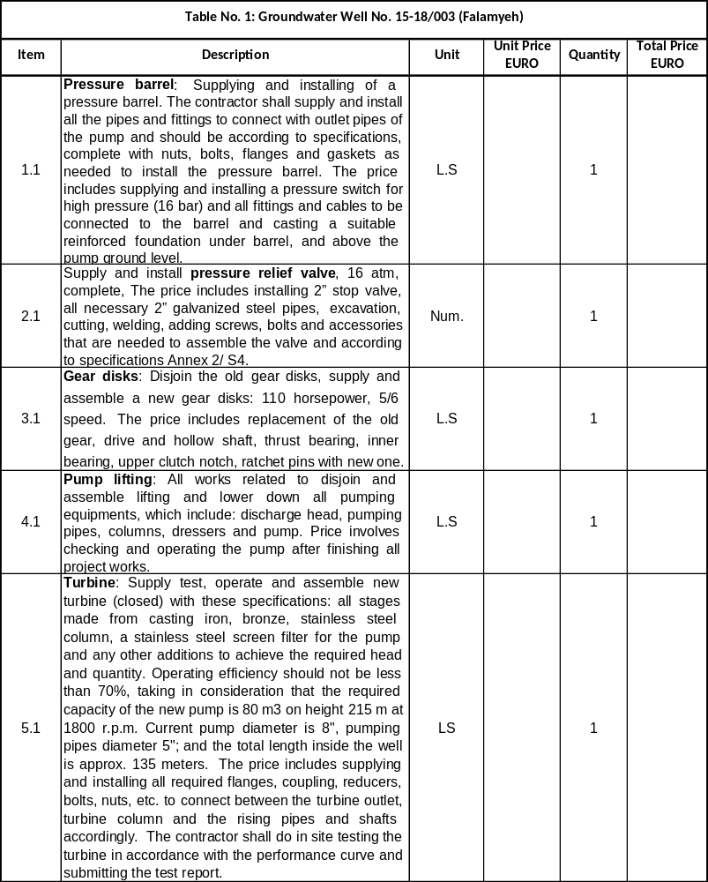

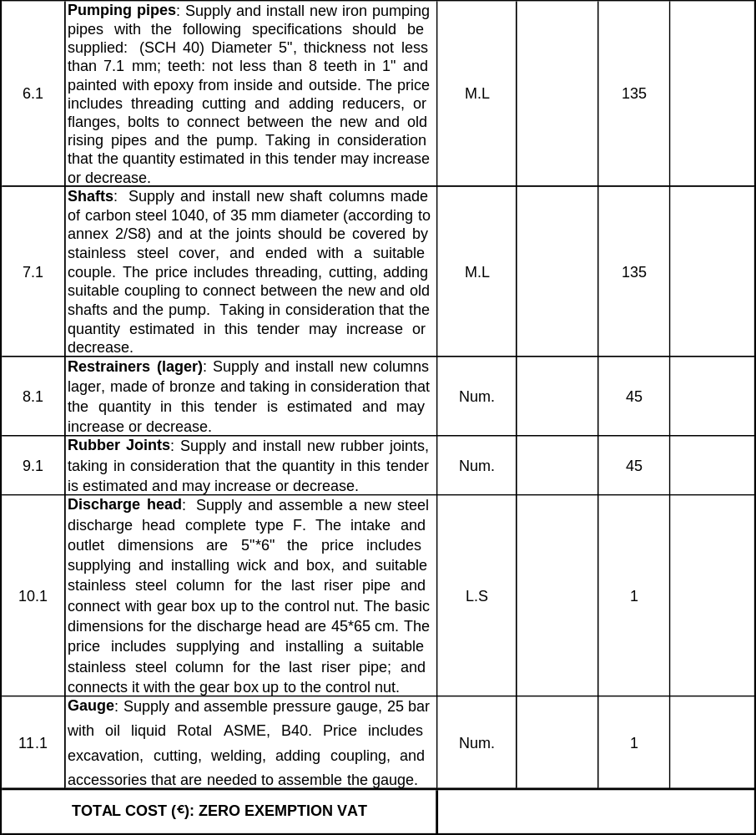

Table No. 2: Groundwater Well No. 15-19/031 (Attil)

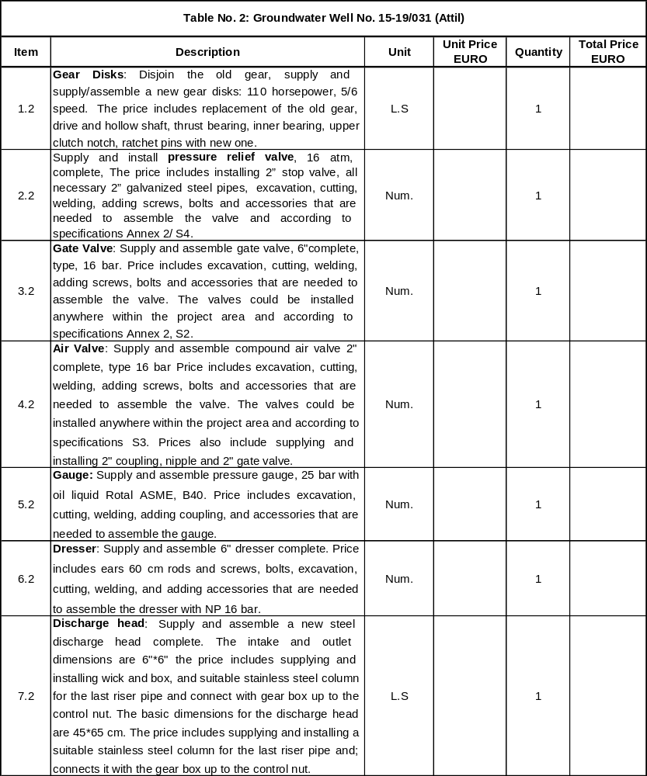

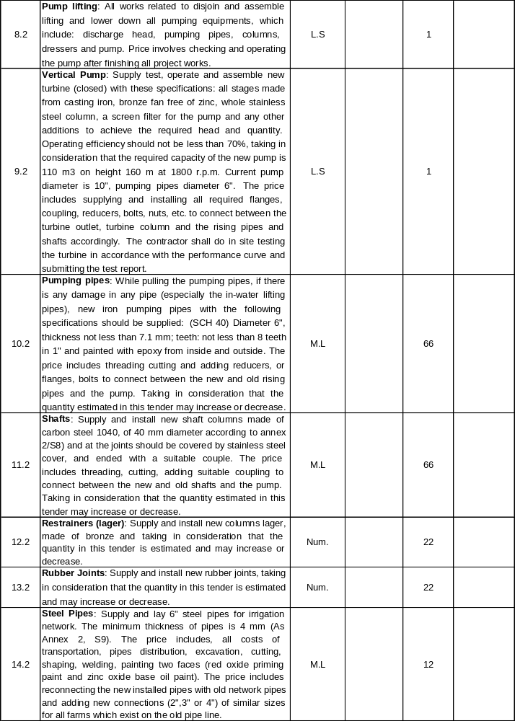

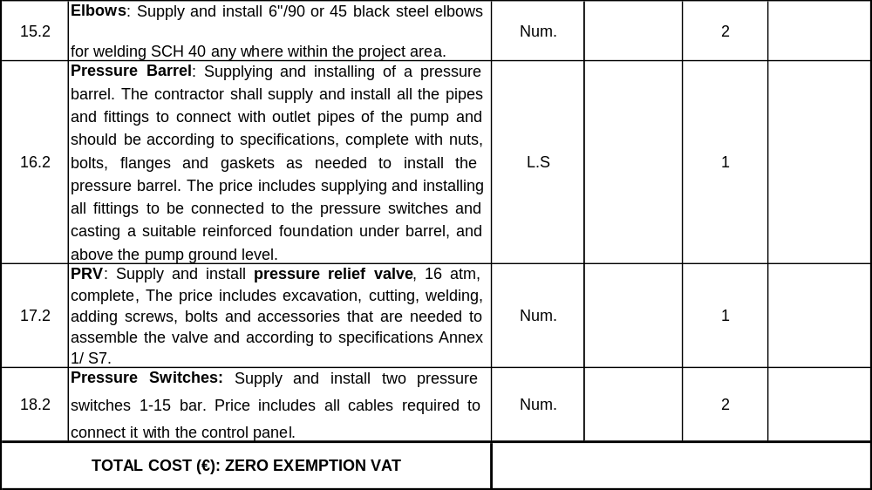

Table No. 3: Groundwater Well No. 16-20/005 in Al-Nazleh Al-Sharqiya

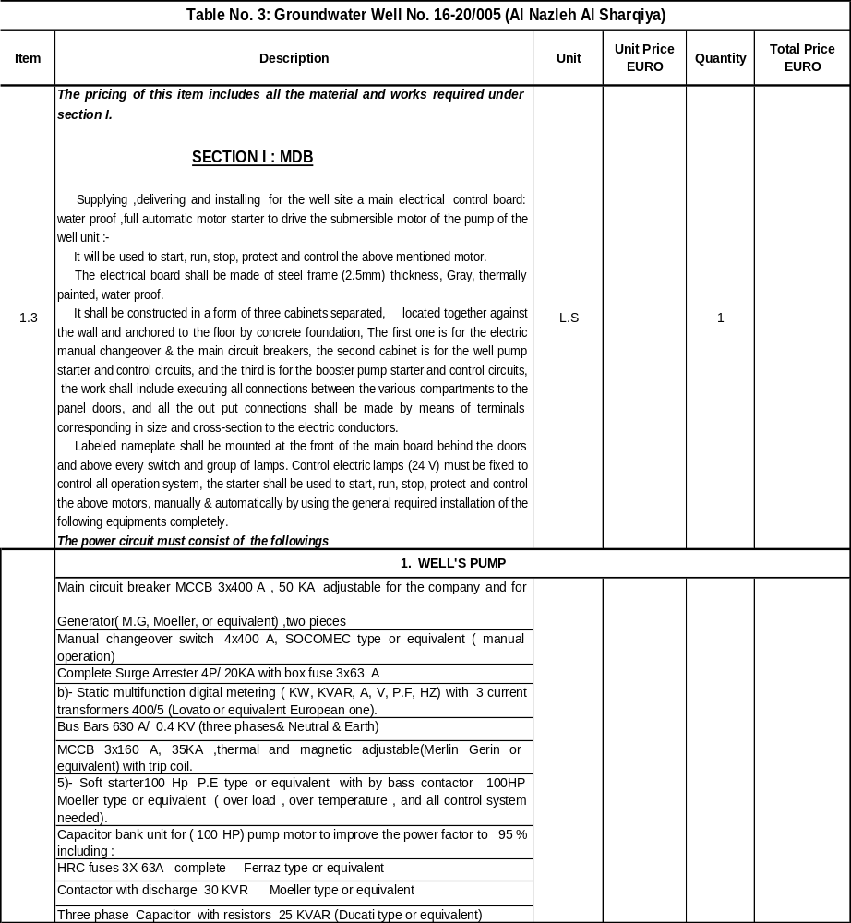

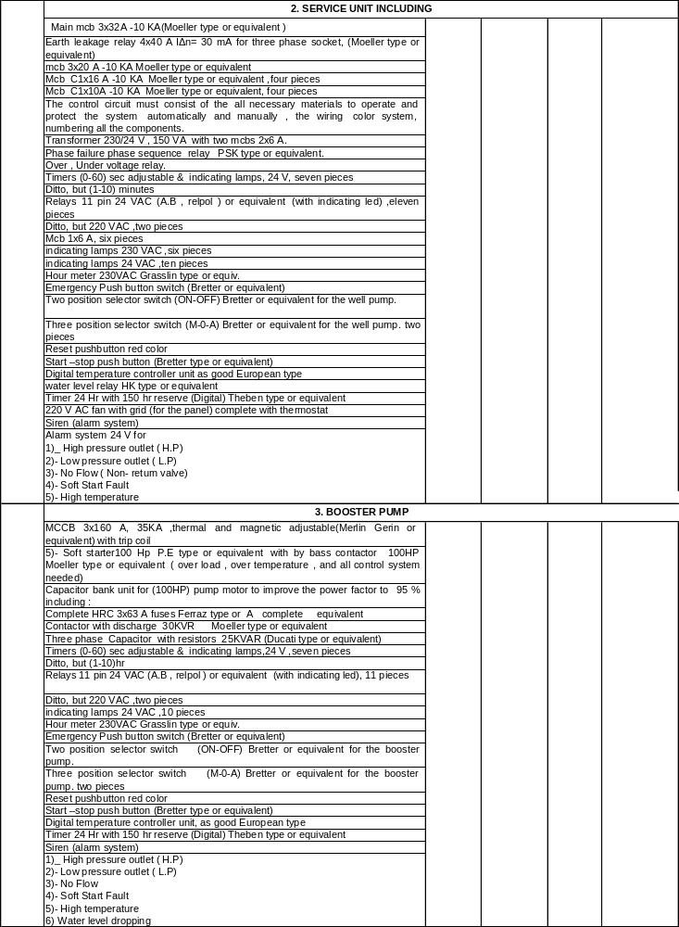

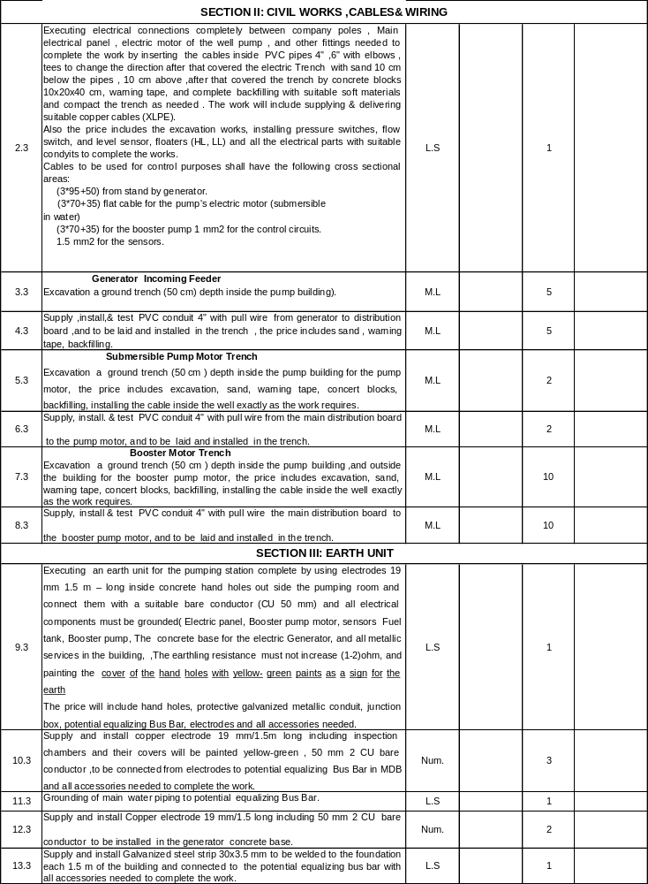

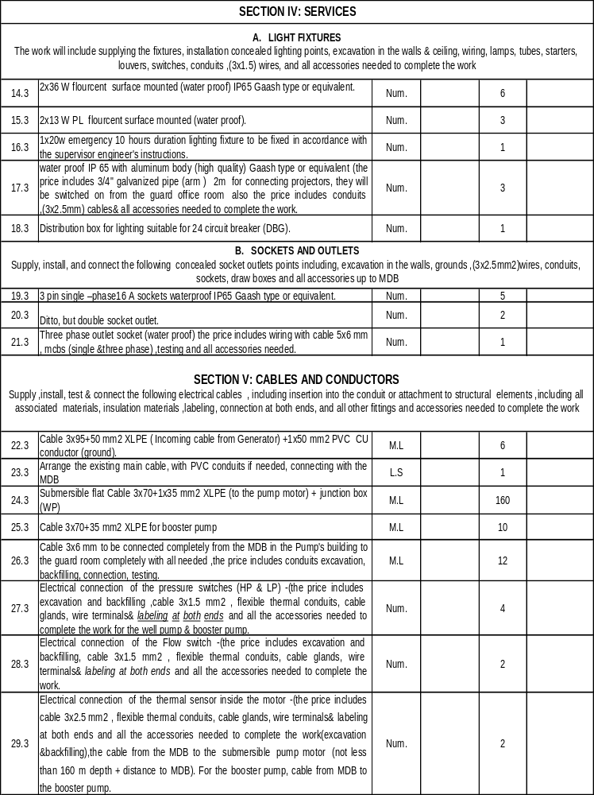

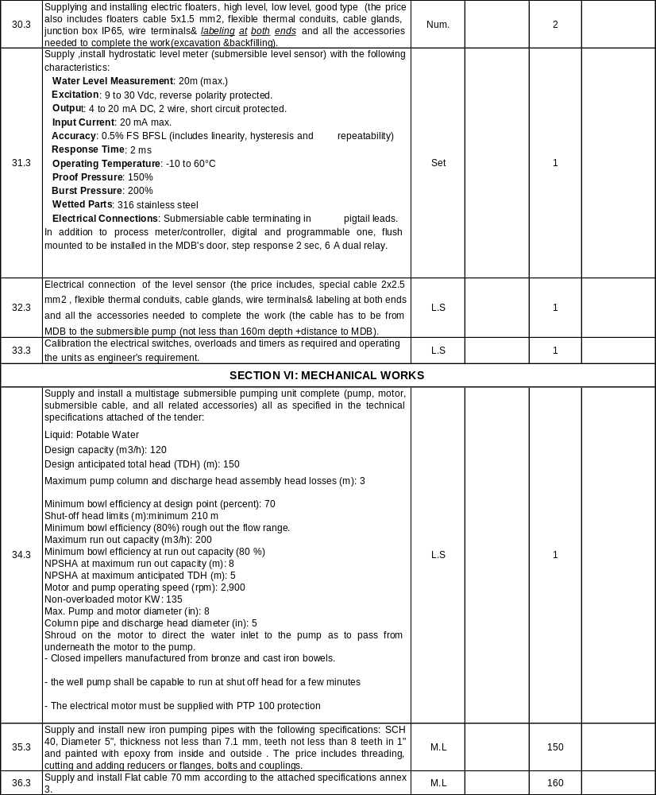

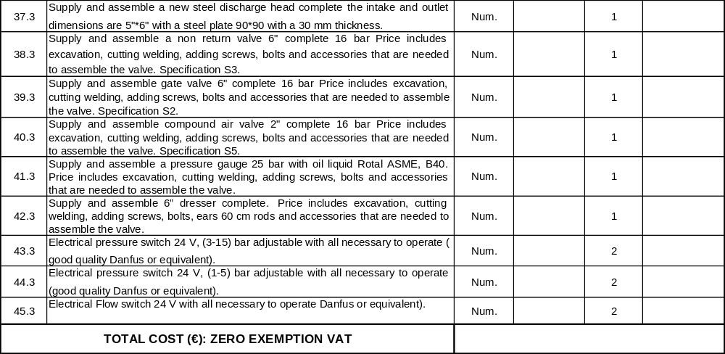

Notes

- The contactor must prepare shop drawings for the control panel, and all trenches and connections and earth path.
- Submittals, Catalogues must be given for the supervision before starting any electrical part so as to obtain the approval for these items.
- As built drawing must be prepared after finishing executing, and testing all the stages in the electrical sections.

Control Scheme and operation

The well pump shall operate on both automatic and manual modes, as needed:

- The control scheme shall utilize one flow switch, one high, low pressure switches, Floaters (high level, Low level sensors).
- The well pump will start working when Low Level floaters indicates there is no water in the tank, and it will stop working when high floater indicates high level, where the booster pump will start working when high level floater indicates high level in the tank ,and the booster pump will stop working when the low level floater indicates low level water in the tank.
- The (well &booster) pumps shall stop working in a time delay from (1-60) sec. when the flow switch indicates that there is no flow. The pump shall not be permitted to go into operation again (after the no flow situation) without reset.
- The booster pump shall stop working immediately when the high pressure switch indicates that the pressure on the delivery side exceeds a prescribed value in a time delay form (1-60) sec. In this case the pump shall be permitted to go automatically into operation in a time delay from (1-10) hours.
- The (well &booster) pumps shall stop operation automatically in a time delay (1-60) sec. and it should not be permitted to operate again without manual reset in the following cases:

  - The water level sensor in the well indicates that the dynamic water level (D.W.L) is below the critical limit (well pump only).
  - In the case of current overload of the electric driving motor.
  - In the case of motor overheating.

In these cases, the control scheme shall utilize an audio and visual alarm system as an additional precaution.

- The inside and outside lighting on the station should utilize a single phase power supply available from the generator to the control panel.
- All terminals shall be carefully protected to provide good electrical insulation.
- Switches, measuring instruments, and warning lights shall be installed on the front side of the panel.
- All circuits and electric devices must be numbered using special number for each wire, every circuit must have different colors for the wires (24 v must have colors different from 220 V).
- Just two wires from the same size are allowed to be connected on one bolt in the electric circuits.

Table No 4: Groundwater well No. 15-17/004 in Azzoun

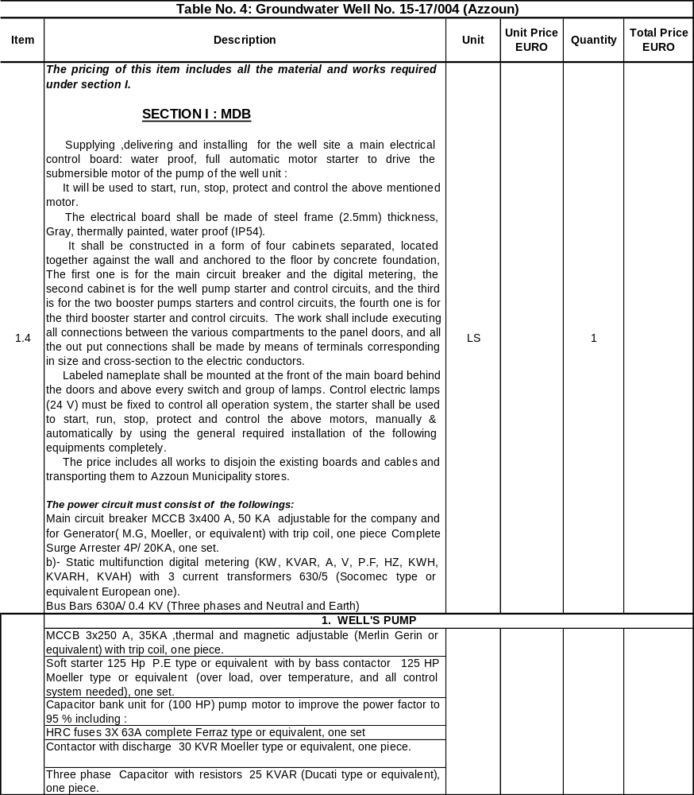

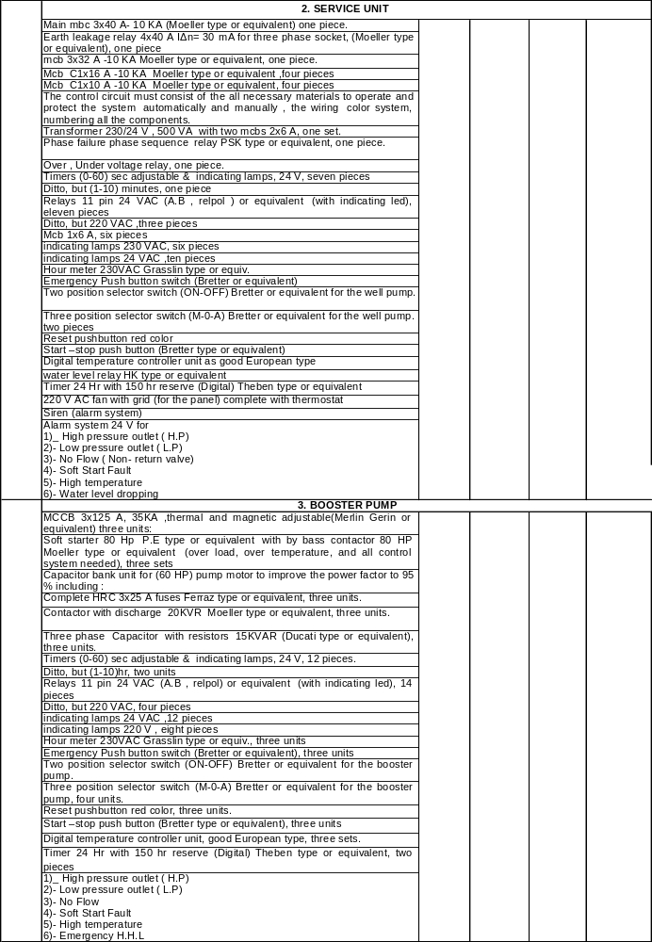

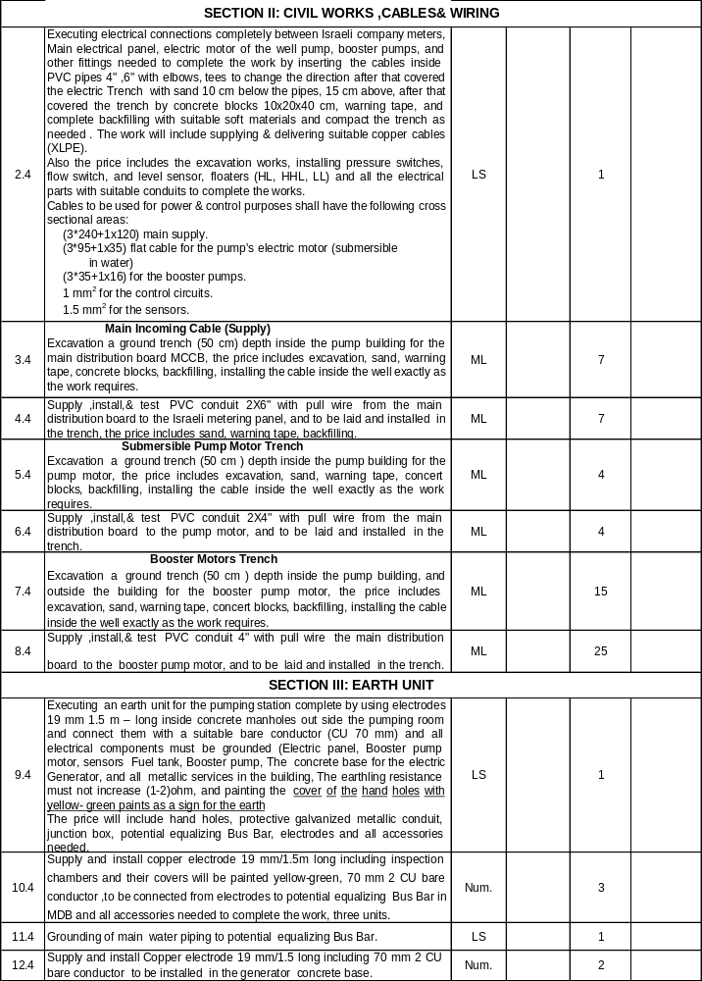
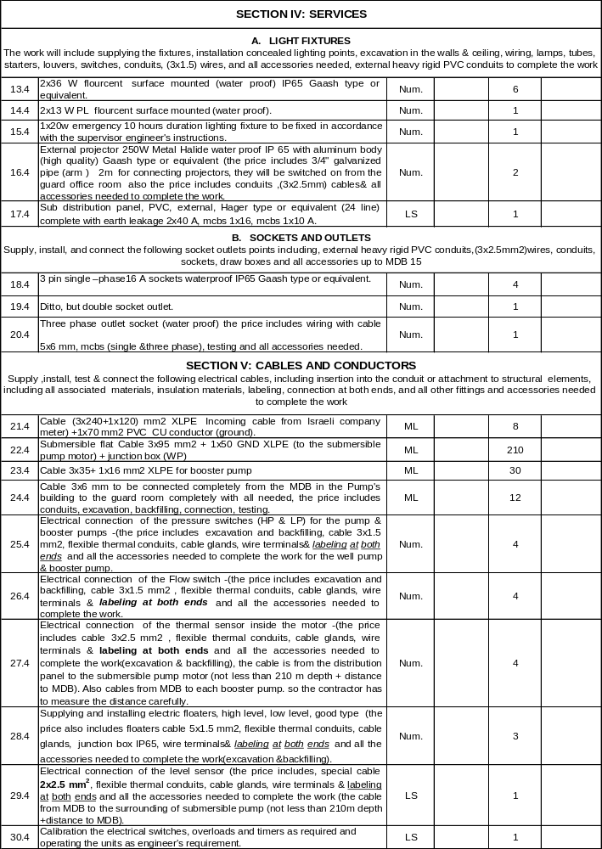
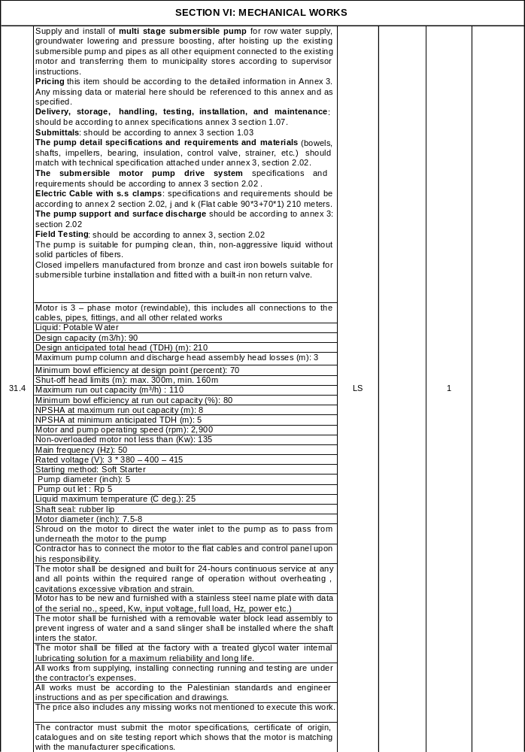
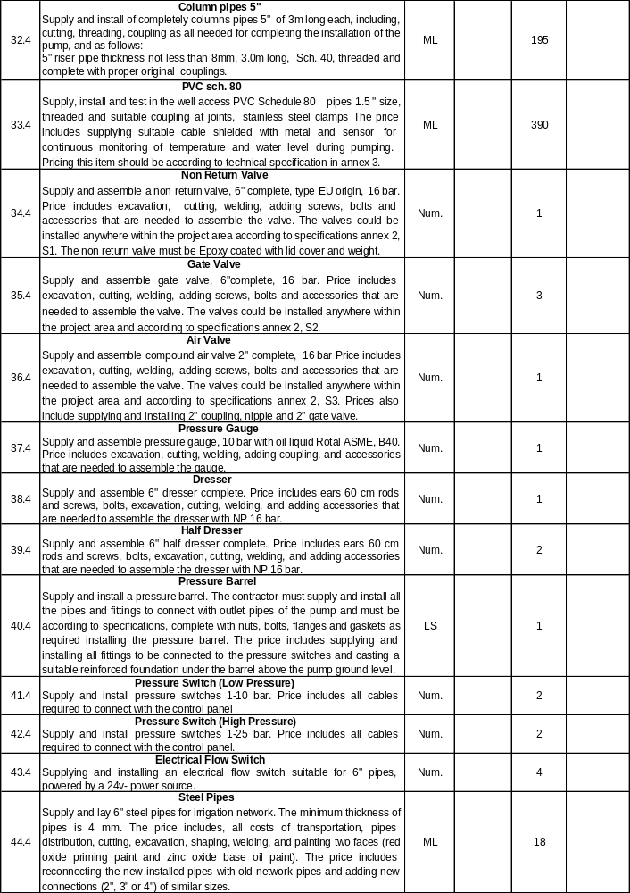

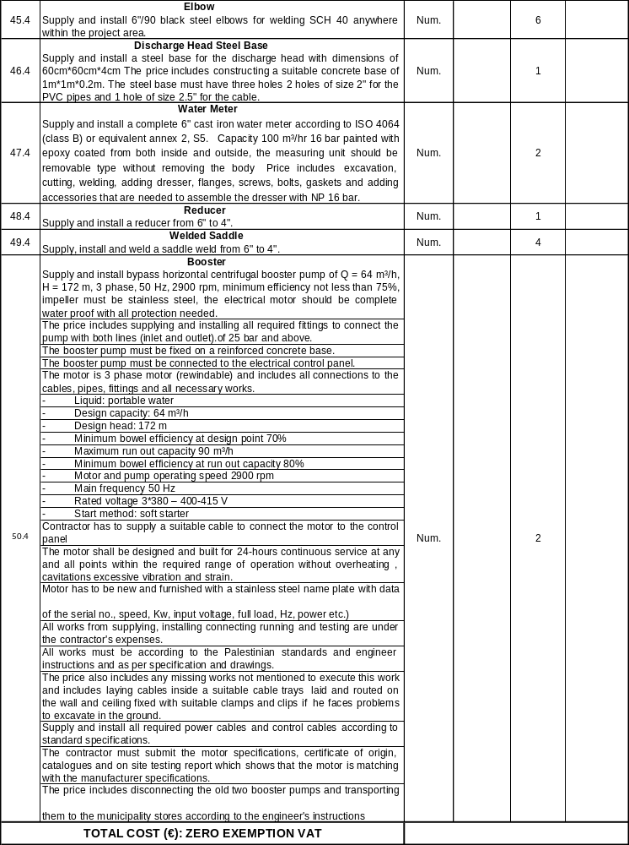

Control Scheme and Operation

- The contactor must prepare shop drawings for the control panel, and all trenches and connections and earth path.
- Submittals, Catalogues must be given for the supervision before starting any electrical part so as to achieve the approval for these items.
- As built drawing must be prepared after finishing executing, and testing all the stages in the electrical sections.
- The well pump shall operate on both automatic and manual modes, as needed.
- The control scheme shall utilize one flow switch, one high, low pressure switches, Floaters (high level, Low level sensors).
- The well pump will start working when Low Level floaters indicates there is no water in the tank, and it will stop working when high floater indicates high level, where the booster pumps will start working when high level floater indicates high level in the tank, and the booster pumps will stop working when the low level floater indicates low level water in the tank, The emergency high level will act as an alarm.
- The (well &booster) pumps shall stop working in a time delay from (1-60) sec. when the flow switch indicates that there is no flow. The pump shall not be permitted to go into operation again (after the no flow situation) without reset.
- The booster pump shall stop working immediately when the high pressure switch indicates that the pressure on the delivery side exceeds a prescribed value in a time delay form (1-60) sec. In this case the pump shall be permitted to go automatically into operation in a time delay from (1-10) hours.
- The (well &booster) pumps shall stop operation automatically in a time delay (1-60) sec. and it should not be permitted to operate again without manual reset in the following cases:
  - The water level sensor in the well indicates that the dynamic water level (D.W.L) is below the critical limit.(well pump only)
  - In the case of current overload of the electric driving motor.
  - In the case of motor overheating.

In these cases, the control scheme shall utilize an audio and visual alarm system as an additional precaution.
- The inside and outside lighting on the station should utilize a single phase power supply available from the generator to the control panel.
- All terminals shall be carefully protected to provide good electrical insulation.
- Switches, measuring instruments, and warning lights shall be installed on the front side of the panel.
- All circuits and electric devices must be numbered using special number for each wire, every circuit must have different colors for the wires (24 v must have colors different from 220 V).
- Just two wires from the same size are allowed to be connected on one bolt in the electric circuits.
Summary of BOQ
Bill | Description | Amount  EUR
(Table No.1): Groundwater well No.15-18/003 (Falamyeh) | Total work cost in number (Zero Exemption VAT)
(Table No.2): Groundwater well No.15-19/031 (Attil) | Total work cost in number (Zero Exemption VAT)
(Table No.3): Groundwater well No.16-20/005 (Al Nazleh Al Sharqiya) | Total work cost in number (Zero Exemption VAT)
(Table No.3): Groundwater well No.15-17/004 (Azzoun) | Total work cost in number (Zero Exemption VAT)
SUB-TENDER TOTAL (ZERO EXEMPTION VAT):
Discount (___________ %):
TENDER TOTAL (ZERO EXEMPTION VAT):
TOTAL IN WORDS (ZERO EXAMPTION VAT FOR ALL WELLS):

NAME OF COMPANY /CONTRACTOR:

ADDRESS:

Telephone:
Fax:

DATE:

SIGNATURE AND STAMP:

APPENDIX: Tender form
TENDER FORM FOR A WORKS CONTRACT

Publication reference: < Publication reference >
Name of contract: < Name of contract>

<Place and date>

A: <Name and address of Contracting Authority >.

1 SUBMITTED BY

 | Name(s) of tenderer(s) | Nationality
Leader
Partner 2*
Etc … *
* add/delete additional lines for partners as appropriate. Note that a subcontractor is not considered to be a partner for the purposes of this tender procedure. If this tender is being submitted by an individual tenderer, the name of the tenderer should be entered as 'leader' (and all other lines should be deleted)

2 CONTACT PERSON (for this tender)
Name
Address
Telephone
Fax
E-mail

3 TENDERER'S DECLARATION(S)
To be completed and signed by the tenderer (including one from each partner in a consortium).
In response to your letter of invitation to tender for the above contract,
we, the undersigned, hereby declare that:
1 We have examined and accept in full the content of the dossier for invitation to tender No [……………………………….] of […./..../….]. We hereby accept its provisions in their entirety, without reservation or restriction.
2 We offer to execute, in accordance with the terms of the tender dossier and the conditions and time limits laid down, without reserve or restriction, the following works:
Lot No [….]: [description of works]
Lot No [….]: [description of works]
3 The price of our tender [excluding the discounts described under point 4] is:
Lot No 1: [……………………………………………..]
Lot No 2: [……………………………………………..]

4 We will grant a discount of [%], or […………..] [in the event of our being awarded Lot No ………].
5 This tender is valid for a period of […………] from the final date for submission of tenders, i.e. until [../../..].
6 If our tender is accepted, we undertake to provide a performance guarantee of [………..], as required by Article 13 of the General Conditions.
7 Our firm/company [and our subcontractors] has/have the following nationality:
[……………………………………………………………………]
8 We are making this application in our own right and [as partner in the consortium led by < name of the leader / ourselves > ]* for this tender [Lot No]. We confirm that we are not tendering for the same contract in any other form. [We confirm, as a partner in the consortium, that all partners are jointly and severally liable by law for the performance of the contract, that the lead partner is authorised to bind, and receive instructions for and on behalf of, each member, that the performance of the contract, including payments, is the responsibility of the lead partner, and that all partners in the joint venture/consortium are bound to remain in the joint venture/consortium for the entire period of the contract's performance].
9 We are not in any of the situations excluding us from participating in contracts which are listed in Clause 3 of the instructions to tenderers. In the event that our tender is successful, we undertake to provide the proof usual under the law of the country in which we are established that we do not fall into the exclusion situations listed in section 2.3.3 of the Practical Guide to contract procedures financed by the general budget of the European Communities in the context of external actions. The date on the evidence or documents provided will be no earlier than 180 days before the deadline for submission of tenders and, in addition, we will provide a sworn statement that our situation has not altered in the period which has elapsed since the evidence in question was drawn up.
We also understand that if we fail to provide this proof within 15 calendar days after receiving the notification of award, or if the information provided is proved false, the award will be considered null and void.
10 We agree to abide by the ethics clauses in Clause 36 of the instructions to tenderers and, in particular, have no potential conflict of interests or any relation with other candidates or other parties in the tender procedure at the time of the submission of this application. We have no interest of any nature whatsoever in any other tender in this procedure.
11 We will inform the Contracting Authority immediately if there is any change in the above circumstances at any stage during the implementation of the contract. We also fully recognise and accept that any inaccurate or incomplete information deliberately provided in this application may result in our exclusion from this and other contracts funded by the European Communities.
12 We note that the Contracting Authority is not bound to proceed with this invitation to tender and that it reserves the right to award only part of the contract. It will incur no liability towards us should it do so.
Name and first name: […………………………………………………………………]
Duly authorised to sign this tender on behalf of:
[…………………………………………………………………………………………]
Place and date: […………………………………………………………….………….]
Stamp of the firm/company:

This tender includes the following annexes:

[Numbered list of annexes with titles]

APPENDIX TO TENDER FOR A WORKS CONTRACT
[………………..]

Publication reference: < Publication reference >
Title of contract: < Title of contract>

(Note: Tenderers are required to fill in the blank spaces in this Appendix)

 | Subclauses of General Conditions or Special Conditions
Name and address of the Contracting Authority. | To be completed by the Contracting Authority
Name and address of the tenderer | To be completed by the tenderer
Name and address of the representative of the Contracting Authority. | To be completed by the Contracting Authority
Financing authority | To be completed by the Contracting Authority
Deadline for notice to commence | ….
Period of performance | ….
Currency

Law of the contract

Language of the contract

Language for communications

Period of access to the site

Amount of performance guarantee

Deadline for submission of programme

Normal working hours
Period after the effective date during which the Contracting Authority's representative must issue notice to commence the works

Liquidated damages for the works

Limit of liquidated damages for delay
Percentage of retention monies
Minimum amount of interim payment certificates
Percentage for adjustment of provisional sums
Amount of insurance for design
Amount of third-party insurance |  | ………………per accident with the number of occurrences unlimited
Periods for submission of insurance

Subclauses of General Conditions or Special Conditions
Number of members of dispute-settlement committee
Member of dispute-settlement committee (if not agreed) to be nominated by
Arbitration rules
Number of arbitrators
Language of arbitration
Place of arbitration
…..

Signature __________________________________________

Capacity _____________________________________

duly authorised to sign for and on behalf of _______________________________________

AL-NAZLEH AL-SHARQIYA DRAWINGS

AZZOUN DRAWINGS

Not all the plant owned by the company.
Where the contracting party is an individual.
Where applicable.
Except where the contracting party is not VAT registered.
In the event of cofinancing, the Community contribution must normally be entered as a lump sum in euro.
If required by Community procedures.
This mention has to be inserted where the law applicable to the guarantee imposes a precise expiry date
This mention has to be inserted where the law applicable to the guarantee imposes a precise expiry date

